

FAO/GLOBAL ENVIRONMENT FACILITY
PROJECT DOCUMENT
PROJECT TITLE: Implementation of the National Biosafety Framework in accordance with the Cartagena Protocol on Biosafety (CPB)

PROJECT SYMBOL: GCP /SRL/066/GFF
Recipient Country: Sri Lanka |  |  | Resource Partner: Global Environment Facility (GEF)
FAO project ID: 628897 |  |  | GEF Project ID: 5720
Government /other Counterpart(s): Ministry of Mahaweli Development and Environment
Expected OED (starting date): , May 1, 2016
Expected NTE (End date): April 30, 2020
Contribution to FAO’s  Strategic Framework | This project will strengthen Sri Lanka’s capacity for biosafety, which refers to the safe adoption and use of agricultural biotechnologies, including Living Modified Organisms (LMOs), as described in the Cartagena Protocol on Biosafety to the Convention on Biological Diversity. Supporting Sri Lanka in strengthening its biosafety capacity contributes to the outputs of FAO’s work relating to sustainable agriculture. More specifically, it contributes to the strategic objective (SO) of supporting stakeholders in enhancing the recognition and consideration of agricultural sectors in international instruments, governance mechanisms, processes, and partnerships that are relevant to FAO’s mandate (i.e. SO2.3.2).
GEF Focal Areas:  Biodiversity |  | GEF Strategic Objectives: [GEF-5]  BD-3: Build Capacity for the Implementation of the Cartagena Protocol on Biosafety
Environmental Impact Assessment Category (insert √): A B C √
Financing Plan: GEF allocation (USD):  Co-financing (USD): |  |  |  | 2,365,964  2,958,327
Ministry of Mahaweli Development and Environment |  |  |  | 85,714
Ministry of Health Nutrition and Indigenous |  |  |  | 8,571
Department of Animal Production and Health |  |  |  | 357,143
Department of Agriculture |  |  |  | 405,714
National Plant Quarantine Services |  |  |  | 291,143
Department of Fisheries and Aquatic Resources |  |  |  | 36,143
Department of Wildlife Conservation |  |  |  | 285,714
Sri Lanka Customs |  |  |  | 382,471
University of Colombo |  |  |  | 300,000
University of Peradeniya |  |  |  | 300,000
National Science Foundation |  |  |  | 105,714
FAO |  |  |  | 400,000
Total Budget: |  |  |  | 5,324,291

EXECUTIVE SUMMARY
Sri Lanka possesses a wealth of biological diversity. The country is classified as one of the global “biodiversity hot spots” based on its hosting a large number of endemic plants and vertebrates. Sri Lanka depends heavily on its biological resources to sustain its economy, making it very important to take note of any threats to biodiversity. The country has adopted a proactive approach to formulating environmental policy and has been one of the first countries to ratify the Convention on Biological Diversity (CBD) in 1994. Sri Lanka also ratified the Cartagena Protocol on Biosafety (CPB) in 2004, which aims to address the safe transfer, handling, and use of living modified organisms (LMOs). The Biodiversity Secretariat of the Ministry of Mahaweli Development and Environment acts as the national focal point for the CBD & CPB and is responsible for the coordination and promotion of national efforts to conserve the nation’s biodiversity, manage the country’s biological wealth, and oversee biosafety related activities.

Although the advancement of modern biotechnology is still at an early stage in the country, the Government of Sri Lanka has been taking several steps to ensure the safe use of LMOs. Recognizing the need for ensuring the regulation of biotechnology research and development activities, the Biodiversity Secretariat implemented the National Biosafety Framework Development Project in 2005, which led to the formulation of the National Biosafety Framework (NBF) in 2005. As part of the project, a National Policy on Biosafety was prepared to renew the commitment of the government to ensure adequate levels of protection in the safe use of modern biotechnology based on the precautionary principle, within the overall framework of sustainable development for the benefit of present and future generations. The Cabinet of Ministers approved the Policy in 2005. In order to implement the NBF, the Biosafety Act was drafted in 2014 and is presently being reviewed at the Legal Draftsman’s Department in the Ministry of Justice. The Government of Sri Lanka, through its concerned Ministries, has been promoting biotech research, creating awareness on key issues relating to biosafety and putting in place regulatory systems/requirements for LMOs. Despite this, lack of capacity has limited progress and thus there is an urgent need to build Sri Lanka’s capacity to make a greater use of the benefits of modern biotechnology in a safe and sustainable manner.

The project was developed in order to strengthen the implementation of the National Biosafety Framework. Component 1 of this project focuses on: (i) strengthening policy, institutional, and regulatory frameworks for biosafety, especially for the immediate enactment of the Biosafety Act and the endorsement of the Master Plan; (ii) re-establishing the information management and sharing system on biosafety; and (iii) strengthening the national Biosafety Clearing House. Component 2 aims to strengthen the technical capacity of the relevant institutions to conduct risk assessments, risk management, and risk communication. Component 3 focuses on helping to upgrade the infrastructure of key laboratories so that they can effectively carry out biosafety-related activities required for the reliable identification and detection of LMOs, in line with Sri Lanka’s obligations under the CPB. Component 4 focuses on supporting targeted education and outreach campaigns to raise awareness about biosafety and enhance public participation in decision-making. Under Component 4, increasing awareness will be pursued across the country in order to garner the political will needed to incorporate biosafety into national development plans and programmes. In addition, the curriculum, syllabus, and course materials for a post-graduate course on biosafety will be reviewed and elaborated to train and build sufficient human resources to address the nation’s biosafety needs.

Overall, the expected outcomes should strengthen the requisite human, technical, and institutional capacities as well as regulatory and policy regimes, which, together, will permit policy planning, drafting of regulations and guidelines, enforcement of laws, the ability to carry out scientific evidence-based risk assessment and risk management, while at the same time enhancing public knowledge and participation. The project conforms to the GEF focal area objective BD-3 on Building Capacity for Implementation of CPB, and thereby will contribute to the overarching goal of GEF to enable CPB Parties to comply with their international obligations under this legal instrument.

Table of Contents

S. No. Title Page

Executive summary ii
Acronyms and Abbreviations vi

SECTION 1: GENERAL CONTEXT 1

1.1 Background and situation analysis 1
1.2 Institutional, sectoral and policy context 3
1.3 Stakeholder mapping and analysis 7
1.4 Threats affecting to the country’s biosafety system 11
1.5 Remaining barriers to the removal of the threats 12
1.6 Baseline analysis and incremental reasoning 17
1.7 Global significance 20
1.8 FAOs comparative advantage 21
1.9 Linkages with other GEF and non GEF intervention 22

SECTION 2: PROJECT FRAMEWORK AND EXPECTED RESULTS 24

2.1 Project rationale and policy conformity 24
2.2 Project goal and objective 24
2.3 Project components and expected results 25
2.4 Interventions logic and key assumptions 40
2.5 Risk analysis and risk management measures 42
2.6 Consistency with national priorities and plans 43
2.7 Global Environmental Benefits 43
2.8 Cost effectiveness 44
2.9 Innovativeness 45

SECTION 3: PROJECT IMPLEMENTATION ARRANGEMENTS 46

3.1 Government partners roles and responsibilities 46
3.2 FAO’s role and responsibilities, both as the GEF Agency and as an executing
agency, including delineation of responsibilities internally within FAO 50

SECTION 4: STAKEHOLDER PARTICIPATION 54

SECTION 5: SUSTAINABILTY OF RESULTS 59

5.1 Sustainability of results 59
5.2 Replicability and Scaling up 60
5.3 Communication and Visibility 60
5.4 Regional/Sub regional Cooperation 61

SECTION 6: MONITORING, EVALUATION AND REPORTING 62

6.1 Oversight and monitoring responsibilities 62
6.2 Evaluation 63
6.3 Reporting 64
6.4 Provisions for evaluation 67

SECTION 7: FINANCIAL PLANNING AND MANAGEMENT 68

7.1 Financial planning 68
7.2 Financial management and reporting 70
7.3 Procurement 72

S. No. Title Page

APPENDICES

Appendix 1: Results Framework
Appendix 2: Work plan and timetable
Appendix 3: Results based budget
Appendix 4: Incremental cost analysis
Appendix 5: Terms of Reference of Project Steering Committee
Appendix 6: Proposed project implementation arrangements and draft Terms of References
Appendix 7: Experts to be hired for the project
Appendix 8: GEF BD Tracking Tool
Appendix 9: Co-financing commitment letters from project partners

ACRONYMS AND ABBREVIATIONS

AgBC Agricultural Biotechnology Centre
APLAC Asia Pacific Laboratory Accreditation Corporation
BCAP Biodiversity Conservation Action Plan
BCH Biosafety Clearing House
BH Budget Holder
CARP Council for Agriculture Research Policy
CBD Convention on Biological Diversity
CI Conservation International
COSTI Coordinating Secretariat for Science and Technology Innovation
CPB Cartagena Protocol on Biosafety
DEX Direct Execution Modality
DNA Deoxyribonucleic acid
FAO Food and Agriculture Organization of the United Nations
FAO-FLO Food and Agriculture Funding Liaison Officer
FAO-LTO Food and Agriculture Organization Lead Technical Officer
FAO-PTF Food and Agriculture Organization Project Task Force
FAO-R Food and Agriculture Organization representative in Sri Lanka
FFP Food or feed or for processing
FPMIS Field Program Management Information System
GCU GEF Coordination Unit in FAO Technical Cooperation Division Investment Centre
GDP Gross Domestic Product
GEF Global Environment Facility
GEB Global Environment Benefits
GMOs Genetically Modified Organisms
GoSL Government of Sri Lanka
IAF International Accreditation Forum
ITI Industrial Technology Institute
ILAC International Laboratory Accreditation Cooperation
LMOs Living Modified Organisms
LoA Letter of Agreement
MoA Ministry of Agriculture
MoASW Ministry of Agrarian Services and Wildlife
MoTCCA Ministry of Trade, Commerce and Consumer Affairs
MoFARD Ministry of Fisheries and Aquatic Resources Development
MoH Ministry of Health, Nutrition and Indigenous Medicine
MoIC Ministry of Industry and Commerce
MoJ Ministry of Justice
MoLRCD Ministry of Livestock and Rural Community Development
MoMDE Ministry of Mahaweli Development and Environment
MoTR Ministry of Technology and Research
M&E Monitoring and Evaluation
MRA Mutual Recognition Arrangement
NASTEC National Science and Technology Commission
NBF National Biosafety Framework
NCA National Competent Authority
NCCBS National Coordinating Committee on Biosafety
NEA National Executing Agency
NGO Non-Governmental Organization
NSF National Science Foundation
NPD National Project Director
NPM National Project Manager
PAC Pacific Accreditation Council
PGIA Postgraduate Institute of Agriculture
PIR Project Implementation Report
PMU Project Management Unit
PSC Project Steering Committee
PPR Project Progress Report
RA Risk Assessment
RM Risk Management
RC Risk Communication
SCAs Sectoral Competent Authorities
SLAB Sri Lanka Accreditation Board for Conformity Assessment
SLCARP Sri Lanka Council for Agricultural Research Policy
SOPs Standard Operating Procedures
SWEDAC Swedish Board of Accreditation and Conformity Assessment
TEG Technical Expert Group
UNDP United Nations Development Programme
UNEP United Nations Environment Program
UNESCO United Nations Educational, Scientific and Cultural Organization
WP/B Work Plan and Budget

SECTION 1: GENERAL CONTEXT

  - Background and situation analysis

- Sri Lanka is a small island country but possesses a wealth of biological diversity. Sri Lanka’s unique biodiversity has a very high global significance. It has been classified by Conservation International (CI) as one of the “biodiversity hot spots” (together with the Western Ghats in India) based on the diversity of endemic plant and vertebrate species found in the country. Sri Lanka has several distinct climatic zones, each with their own characteristic forests. These include rainforests, montane cloud forests, dry zone monsoon forests, and arid thorn scrub forests. Sri Lanka’s wetlands are also diverse, comprising 103 major rivers with their associated marshes and about 12,000 irrigation tanks that harbour many globally important wetland species. Being an island, it has rich marine and coastal biodiversity along its 1,620 km coastline including coral reefs, mangroves, sea grass beds, salt marsh vegetation, dunes, and beaches.

- The conservation and sustainable use of biological diversity is of special significance to Sri Lanka because of its predominantly agrarian economy and its high dependence on agricultural biodiversity, including the use of many plant species for food, medicine, and domestic products. Its agricultural sector, comprised of food and plantation crops, livestock, forestry, fisheries, and aquaculture, provides livelihood to at least 40 percent of the country’s population. The agricultural sector contributes to 10.8 % of the national GDP.

- Similar to many other countries, Sri Lanka has high expectations on leveraging the applications of biotechnology tools for the increased food production needed for its increasing population. The Government of Sri Lanka (GoSL) identified biotechnological applications in agriculture as a key priority for enhancing agricultural productivity and national food security in its National Agricultural Research Policy (2012-2016), which was prepared by the Sri Lanka Council for Agricultural Research Policy (SLCARP). The National Biotechnology Policy developed by the National Science Foundation of Sri Lanka (NSF) also identified biotechnology interventions as key to enhancing agricultural productivity and rural livelihoods.

- Modern biotechnology has also been identified as a promising technology with immense potential for enhancing agricultural productivity, food and nutritional security, rural livelihoods, environmental quality, and economic growth in Sri Lanka in various other documents. These documents include: the Report to World Summit on Sustainable Development (2002); National Agriculture Policy for Food and Export of Agriculture and Floriculture (2007); National Programme for Food Security (2008); National Science and Technology Policy (2008); National Agriculture Research Policy (2012-2016); National Biotechnology Policy (2010); and now recently in the National Research and Development Framework for 2015-2020.

- The NSF established a steering committee for biotechnology in 1992 to promote biotechnological research and developmental activities in universities and research institutions. Efforts were also made to develop infrastructure and human resources capacities in selected university and research institutions by the Ministry of Technology and Research in 1997 through a loan from the Asian Development Bank. The research and development activities in biotechnology were carried out in the country primarily with funding from the NSF, SLCARP and National Research Council.

- Sri Lanka was, as early as 21 June 1994, one of the first countries to ratify the Convention on Biological Diversity (CBD). As a first step in the implementation of the CBD, Sri Lanka prepared the Biodiversity Conservation Action Plan in 1999. This Action Plan recommended the gathering of information on the benefits as well as risks associated with the application of modern biotechnology in the conservation and use of biodiversity. The Addendum to the Biodiversity Conservation Action Plan was published in 2007 with a chapter on biosafety, wherein biotechnology was identified as a priority for future development.

- Sri Lanka ratified the Cartagena Protocol on Biosafety (CPB) on 28 April 2004 and it consequently entered into force on 28 July 2004. The Biodiversity Secretariat in the Ministry of Mahaweli Development and Environment is responsible for the coordination and promotion of national efforts to conserve the nation’s biodiversity, manage the country’s biological wealth, and oversee biosafety related activities.

- Sri Lanka also plans to sign and ratify the Nagoya - Kuala Lumpur Supplementary Protocol on Liability and Redress to the CPB, as recommended by the National Coordinating Committee on Biosafety (NCCB). The process towards this aim is currently underway.

- As a signatory country to the CBD and CPB, Sri Lanka recognizes that the country is under obligation to take action for the conservation of biological diversity, sustainable use of its components, and fair and equitable sharing of the benefits arising out of the utilization of genetic resources. It is also obligated to ensure an adequate level of protection for the safe transfer, handling and use of LMOs/GMOs resulting from modern biotechnology.

- Recognizing the importance of establishing credible and effective safeguards for LMOs/GMOs to maximize the benefits and legitimacy of modern biotechnology by minimizing its potential risks, the GoSL implemented the UNEP/GEF funded “National Biosafety Framework Development Project” (2003-2005). The National Biosafety Framework (NBF) is a system of legal, technical, and administrative mechanisms to ensure that biotechnology research and development activities are guided by a process of prudent decision-making that safeguards both biodiversity and human health with adherence to the highest ethical standards. The NBF is comprised of five sections: (i) Government policy on biosafety; (ii) Regulatory regime, system to handle notifications or requests for authorizations; (iii) Mechanisms for public awareness; (iv) Education and participation; and (v) System of monitoring and enforcement.

- The National Policy on Biosafety has been available since 2005 as a result of the NBF. The National Policy on Biosafety underscores the commitment of the government to ensuring adequate levels of protection in the safe use of modern biotechnology based on the precautionary principle, within the framework of sustainable development for the benefit of present and future generations. The major policy objective is the implementation of biosafety measures to ensure that there will be no significant adverse effects on human health, the environment, and biodiversity.

- As per recommendations in NBF and National Policy on Biosafety, the Biodiversity Secretariat initiated the process for the development of the draft Biosafety Act in 2012. At that time, it was also recognized that the country needed a consolidated law to regulate LMOs derived from modern biotechnology. The Ministry of Mahaweli Development and Environment (MoMDE) subsequently formulated the draft Biosafety Act in 2014, which is currently being reviewed at the Legal Draftsman’s Department. The draft Act designates a National Competent Authority (NCA) with the power to ensure biosafety and bioethical considerations, which are accounted for in the development and application of modern biotechnology. It also envisages a permit process in relation to LMOs/GMOs. The permit process outlined in the draft Act requires any exporter to notify the NCA in writing prior to any transboundary movement of LMOs/GMOs. The Act, once enacted, subjects the import and export of LMOs/GMOs to a permit issued under its terms.

- The NBF proposes that the NCA for biosafety be established under the MoMDE. The NCA will have to be established by a framework law or Act of Parliament. The responsibility of the National Competent Authority (NCA) will be to: (i) Screen the application for completeness and forward the application to the relevant Sectoral Competent Authorities (SCA); and (ii) Make the application available for public comment. The application would then be sent to more than one agency, where concurrent approval would be required.

- The NCA requires Sectoral Competent Authorities (SCAs) to carry out risk assessments on a case by case basis, if it is deemed necessary. The draft Act stipulates that the release of LMOs or GMOs should be undertaken in a manner that prevents or reduces risks to biological diversity and human health. SCAs will authorize the provision of relevant legislation to regulate GMOs. The proposed authorities include, for example, the: Department of Agriculture under Ministry of Agriculture (MoA), Department of Health under Ministry of Health, Nutrition and Indigenous Medicine (MoH), Department of Animal Production and Health under Ministry of Livestock and Rural Community Development (MoLRCD), Department of Wild Life Conservation under Ministry of Agrarian Services and Wildlife (MoASW), and Department of Fisheries and Aquatic Resources under Ministry of Fisheries and Aquatic Resources Development (MoFARD). The SCAs will have their own mechanism to undertake risk assessment and reporting to the NCA, as per the agreed procedures.

  - Institutional, sectoral and policy context

- Biosafety is a multi-sectoral issue. Biotechnology applications span across various sectors like agriculture, fisheries, healthcare, process industry, environmental management, etc., and, accordingly, different ministries concerned are involved in the regulation of products and processes of modern biotechnology in Sri Lanka.

- As in other countries, the regulation of modern biotechnology is presently covered under several Acts and rules that regulate various aspects of plant protection and the environment. Major Acts and rules are listed in Table 1.

Table: 1. Summary of existing national laws having a bearing on the regulation of Living Modified Organisms and Genetically Modified Organisms (LMOs/GMOs)
 | Name of Law | Overview | Responsible agency
1. | Animal Diseases Act, No. 59, 1992 | Control and prevention of contagious diseases in animals. Control of import and export of animals, animal products, veterinary drugs and veterinary biological products. Establishment of the Veterinary Drug Control Authority. Defines Veterinary Biological Product as including vaccines, sera, micro-organisms, whether living or dead, and their extracts or by-products intended for use in the diagnosis, treatment or prevention of disease in animals. | Department of Animal Production and Health, Ministry of Livestock and Rural Community Development
2. | Animal Feed Act, No. 15, 1986 | Regulate, supervise and control the manufacture, sale and distribution of animal feed including the issuance of a license, labelling, appointment of the Animal Feed Advisory Committee and continuous studies and reporting by the Committee. | Department of Animal Production and Health, Ministry of Livestock and Rural Community Development
3. | Animals Act, No. 29, 1958 | Slaughter and removal of animals, trespassing animals, castration and breeding, regulation of transport. The animals addressed include ox, buffalo, sheep, goat, pig or poultry. | Department of Animal Production and Health, Ministry of Livestock and Rural Community Development
4. | Consumer Affairs Authority Act, 2003 | Establishment of Consumer Affairs Authority. Protection of Consumers. | Ministry of Trade, Commerce and Consumer Affairs
5. | Control of Pesticides Act, No. 33, 1980 | Licensing of Pesticides, regulating the import, packing, labelling, storage, formulation, transport, sale and use of Pesticides. Appointment of the Pesticides Formulary Committee | Department of Agriculture, Ministry of Agriculture
6. | Customs Ordinance, No. 2, 2003 | Customs. Regulation of import and export, prohibitions and restrictions of import and export, warehousing of goods, smuggling seizures and prosecutions, onus probandi as to lawfulness of import or export etc. | Sri Lanka Customs
7. | Fauna and Flora Protection Ordinance, No. 2, 1937 | Protection of Fauna and Flora, import or import and release of mammal, bird, amphibian, fish, reptile, invertebrate etc., export of mammal, bird, amphibian, fish, coral or invertebrate. | Department of Wildlife Conservation
8. | Fisheries and Aquatic Resources Act, No. 2, 1996 | Management, regulation, conservation and development of fisheries and aquatic resources. Prohibit or regulate the export and import of any species of fish including live fish, egg, roe or spawn. | Department of Fisheries
9. | Food Act, No.26 1980 | Regulation of the manufacture, importation, sale, storage and distribution of food. Labelling, packaging, treating, processing, selling and advertising. Appointment of a Food Advisory Committee. Chief Food Authority and Food Authorities. | Food Commissioner's Department
10. | Food (Control of Import, Labelling and Sale of Genetically Modified Foods) Regulations, 2006 | Regulate import, store, transport, distribute, sell or offer for sale of genetically modified organism as food for human consumption and/or food containing or consisting of genetically modified organisms and/or food produced from or containing ingredients produced from genetically modified organisms. Approval of the Chief Food Authority in respect of above. | Ministry of Health, Nutrition and Indigenous Medicine
11. | Food Control Act, 1950 | Regulation and Control of the distribution, transport and supply of food. | Ministry of Health, Nutrition and Indigenous Medicine
12. | Forest Ordinance, 1907 | Regulate the import and export of timber and forest produce. | Forest Department
13. | National Environmental Act, 1980 | Protection, management and enhancement of the environment. The regulation, maintenance and control of the quality of the environment. The prevention, abatement and control of pollution. | Central Environmental Authority
14. | Plant Protection Act, No 35, 1999 | Prevent the introduction into Sri Lanka and the spread of organisms harmful or destructive of plants and for the sanitation of plants. | Department of Agriculture
15. | Quarantine and Prevention of Diseases Ordinance, No. 12, 1952 | Provisions for the prevention of the introduction of the plague and other contagious or infectious diseases into Sri Lanka and preventing their spread outside of the Country. | Department of Agriculture/ Department of Animal Production and Health
16. | Seed Act, No. 22, 2003 | Regulate the quality of seed and planting material. Establish National Seed Council. Registration of seed handlers. Seed certification service. | Department of Agriculture
17. | Sri Lanka Accreditation Board for Conformity Assessment Act, No. 32, 2005 | Establishment of Sri Lanka Accreditation Board for Conformity Assessment. Accreditation of laboratories and certification and inspection bodies. | Sri Lanka Accreditation Board and Ministry of Science, Technology and Research
18. | Science and Technology Development Act, No. 11, 1994 | Development of science and technology, Establishment of the National Science and Technology Commission / National Science Foundation / Council for Information Technology of Sri Lanka / the Industrial Technology Institute / Arthur C. Clerk Institute for Modern Technologies. | National Science Foundation
19. | Water Hyacinth Ordinance, No. 09, 1909 | Provisions to prevent the introduction into and dissemination in Sri Lanka of the Water Hyacinth. The Minister may by-order extend the provisions to any noxious weed or plant specified in the Order and to the seed or any part of such plant. | Department of Agriculture

- The National Coordinating Committee on Biosafety (NCCB) formed by the MoMDE consists of members from relevant ministries and representatives from Non-Governmental Organizations (NGOs). The NCCB oversees and coordinates all matters related to biosafety including risk assessment. Proposed government organizations serve as the Sectoral Competent Authorities (SCAs). These SCAs are the Department of Agriculture, Department of Animal Production and Health, Department of Fisheries and Aquatic Resources, Department of Wildlife Conservation, and the Ministry of Industry and Commerce. Qualified personnel from the departments and organizations conduct a risk analysis when an application is submitted for the importation of LMOs/GMOs.

- The Ministry of Technology and Research (MoTR) is responsible for the formulation of policies, programmes, and projects in the area of technology and research. The Ministry also deals with policies on the popularization and advancement of science and technology. Their work includes scientific research and technological development and transfer to promote activities, which are essential for the economic and social development of Sri Lanka. The National Science Foundation of Sri Lanka (NSF) is a state funded institution under the MoTR, mandated to strengthen science and technology sectors in Sri Lanka. The NSF aims to facilitate research, development, and innovation in all fields of science and technology including modern biotechnology. The NSF made national guidelines available for the safe use of recombinant DNA technology in the laboratory in 2003. The NSF also provides scientific and technical support to the formulation process of an effective biosafety regulatory framework that takes into account the balance of benefits and risks of genetic engineering.

- After the Government of Sri Lanka signed the CPB in 2004, several new regulations related to biosafety were formulated. For example, the NSF and National Science and Technology Commission (NASTEC) jointly formulated the National Biotechnology Policy in 2009. The Cabinet of Ministries then adopted it in July 2010. The Policy highlighted the need for the promotion of biotechnology and support for Research & Development (R&D) in various government institutions. It targets the development of biotechnology products for the enhancement of food production, greater opportunities for local industries, and the use of biodiversity in a sustainable manner. The National Biotechnology Policy recommended the establishment of a National Council for Biotechnology. The Cabinet of Ministers first established the Coordinating Secretariat for Science and Technology Innovation (COSTI). The COSTI then set up the National Council for Biotechnology in August 2013. The National Council for Biotechnology promotes the conservation and use of biological diversity using modern biotechnology, bearing in mind safety aspects at all times. The role of the Council is to plan, coordinate, monitor, and evaluate all activities related to biotechnology including facilitating and supporting bio-industries, while ensuring safe and ethical practices.

- Food (Control of Import, Labelling and Sale of Genetically Modified Foods) Regulations 2006 came into effect from January 2007. The regulation exempts food that contains or has less than half a percent (0.5%) of GMOs, from the provisions of these regulations. The Ministry of Agriculture established a National Committee on Agricultural Biotechnology in 2009, whose mandate is to identify, formulate policies and strategies related to agricultural biotechnology. The Committee facilitates the biotechnology application to improve agricultural production for the contribution to food security and nutrition and livelihoods in the country.

- The Agricultural Biotechnology Centre at the University of Peradeniya (AgBC) carries out regular workshops on biosafety, mainly on risk assessment and management. The Centre also conducts workshops on the detection procedures of GMOs in collaboration with International Centre for Genetic Engineering and Biotechnology (ICGEB). The Board of Study in Agricultural Biology of the Postgraduate Institute of Agriculture (PGIA) at the University of Peradeniya provides a postgraduate course on Biosafety. University of Peradeniya is proposing to develop a postgraduate Diploma course on Biosafety in the future. In addition, local experts are available in universities and other institutes such as the Tea Research Institute, Rubber Research Institute, Coconut Research Institute, and Rice Research and Development Institute. As resource persons, the experts are involved in the regular risk assessment and management workshops supported by the MoMDE and NSF.

- The National Plant Quarantine Service in the Ministry of Agriculture is responsible for enforcing the implementation of the Plant Protection Act No. 35 of 1999 and Regulations that relate to plant quarantine activities. The provisions include the regulation of the introduction and/or spread of organisms that are harmful or destructive to plants and hence cover LMOs/GMOs.

- The Sri Lanka Accreditation Board for Conformity Assessment (SLAB) is the National Accreditation Authority for Sri Lanka established under the Act No. 32 of 2005. The main objectives of SLAB are to strengthen the Quality Infrastructure and conformity assessment procedures in Sri Lanka, and enhance the recognition and acceptance of products and services in international and domestic markets. Accreditation signifies an endorsement of an organization’s competence, credibility, impartiality, and integrity in carrying out its conformity assessment activities. SLAB is a full member and signatory to the Mutual Recognition Arrangement (MRA) of the Asia Pacific Laboratory Accreditation Corporation (APLAC), International Laboratory Accreditation Cooperation (ILAC), and Pacific Accreditation Council (PAC). The MRA ensures that an accreditation obtained in one country is also recognized in other member countries. SLAB is also in the process of seeking membership of the International Accreditation Forum (IAF). It has established a technical cooperation program with the Swedish Board of Accreditation and Conformity Assessment (SWEDAC). These international accreditation bodies have adapted ISO standards for GMO detection in addition to ISO 17025.

  - Stakeholder mapping and analysis

- As described in the previous section on the institutional, sectoral, and policy context, a number of departments, agencies, and institutions are involved in the area of biosafety. Therefore, decision-making processes of all matters related to biosafety need to be determined through stakeholder involvement to maintain transparency in the process.

- The National Policy on Biosafety identifies transparency and public participation in decision-making processes within its regulatory regime. The policy principles describe the participatory approach as follows:

  - Public awareness, education, and participation in the decision-making processes should be essential for ensuring the judicious use of modern biotechnological applications, practices, and products for socio-economic development, without jeopardizing the environment, biodiversity, and human health;
  - Public awareness of modern biotechnology and potential risks/benefits, and risk assessment and management techniques should be enhanced with the involvement of the community at large, including policy makers, legislators, administrators, and the private sector and biotechnology industries; and
  - The labelling of genetically modified products should be made mandatory such that consumer demands for free and informed choices regarding food are fulfilled.

- The National Policy on Biosafety proposes a regulatory mechanism for application and review procedures shown in the flowchart below:

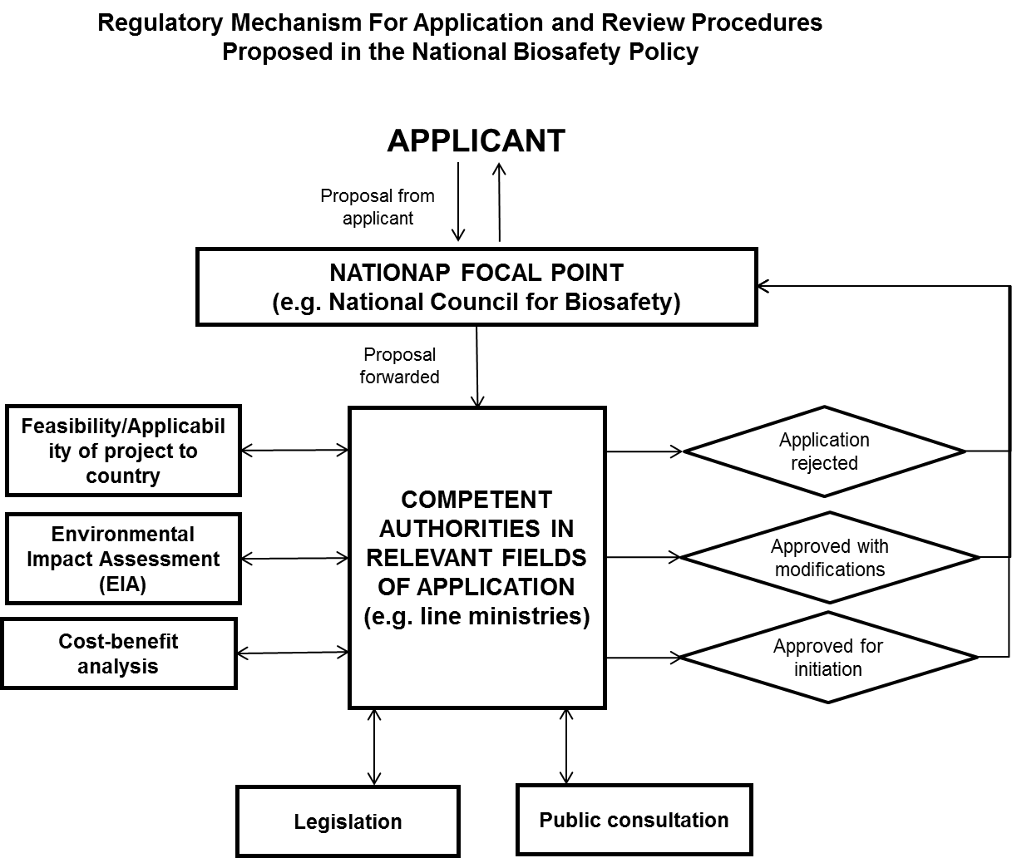

- The Policy also states that material being forwarded to seek approval should be made available for public inspection and comment with a mandatory period for public comments to be given by law. The Policy has a separate chapter on mechanisms for promoting and facilitating public awareness, education, and participation.

- In addition, the draft Biosafety Act recognizes public participation in decision-making more extensively. A notice will be gazetted and also featured in one newspaper in all three languages for comments on risk assessment, risk management reports, and whenever a permit is issued. If considered necessary, opportunity for a public hearing would be given before decision-making.

- The Biodiversity Secretariat of the Ministry of Mahaweli Development and Environment, as the Competent National Authority for CPB and nodal agency for biosafety regulations in the country, is the key body for ensuring the coordination mechanism with relevant ministries, agencies, and other organizations at the national level for their active involvement in project activities. The MoMDE plays a key role in engaging various stakeholders in the project development process with FAO. The following procedures were identified for stakeholder involvement throughout the project:

- Stakeholder identification: Biosafety is a crosscutting theme which relates to several sectors, including the environment, agriculture, health, science and technology, industry, trade, education, and customs. Major stakeholders for the project will be the policy makers, scientists/technical experts, legal experts, students, agricultural extension workers, and enforcement agencies such as plant quarantine and customs, as well as Civil Society Organizations (CSOs), private sectors, and mass media.

- Stakeholders’ participation in the project formulation: Various stakeholder groups participated in a series of consultative stakeholder meetings convened by the Biodiversity Secretariat during the project preparation process. The consultation process also helped in identifying the potential project partners and creating momentum of action. Stakeholders will continue to be involved throughout the project cycle. They were also participated in a national consultation workshop for reviewing the results framework, setting priorities, and refining the work plan of the project.

- Information dissemination and consultation with stakeholders during project implementation: The dissemination strategy and mechanism will be prepared for knowledge sharing among stakeholder groups. The national Biosafety Clearing House (nBCH) will serve as a knowledge platform for public feedback and participation. In addition to the nBCH, project progress and public outreach material will be regularly circulated through various extension networks among stakeholders.

- The assessment results of concerned stakeholders are given in the table along with the function in the NBF and its relevance in the subject:

Stakeholders | Functions as per the NBF | Relevance for the subject
Biodiversity Secretariat (MoMDE) | NCA | - Overall focal point office of CBD & CPB matters for Sri Lanka;  - Key actor of NBF as NCA;  - Nodal ministry of Biosafety Act submission;  - Expertise in CPD and related matters on biosafety and coordination;
Parliamentarians and Legal experts from Legal Draftsmen Department (MoJ) | National Coordinating Committee | - Related to the process of examination, adopting and enactment of the Biosafety Act;  - Group of experts for finalizing guidelines, administrative procedures, SOPs etc.;
Department of Agriculture (MoA), Department of Animal Production and Health (MoLRCD), Department of Health (MoH), Department of Fisheries and Aquatic Resources (MoFARD), Department of Wildlife Conservation (MoASW), and MoIC | SCA | - Authority of regulatory and other relevant administrative documents;  - For RA, RM and RC;  - Group of experts on the specific subject matters;
Enforcement officials (Customs, Plant quarantine); | National Coordinating Committee | - Enforcement of sampling, detection, inspection and monitoring;  - Group of experts for sampling, detection, inspection and monitoring;
Seed inspectors, scientists/technical experts from research laboratories | n/a | - Enforcement of sampling, detection, inspection and monitoring;  - Group of experts for sampling, detection, inspection and monitoring;
Sri Lanka Accreditation Board for Conformity Assessment | n/a | - Conformity Assessment and Accreditation of laboratories;
National Science Foundation | National Coordinating Committee | - Group of experts for development of guidelines for RA, RM and RC, outreach materials for different target groups;  - Research activities related to biosafety issues;  - Capacity development and awareness;
Other scientific Agencies (CARP, National Research Council, COSTI) | n/a | - Group of experts for development of guidelines for RA, RM and RC, outreach materials for different target groups;  - Research activities related to biosafety issues;  - Capacity development and awareness;
University and research institutions (e.g. University of Peradeniya, University of Colombo, Tea Research Institute, Rubber Research Institute, Coconut Research Institute and Rice Research and Development Institute and Horticultural Crop Research and Development Institute) | National Sub-Committee | - Group of experts for the provision of technical support for RA and LMO detection, regulations and guidelines,  - Provision/support of training, diploma and integration;  - Sector-specific source of knowledge;
Private sector, NGOs, CSOs, Media and local communities | National Coordinating Committee | - Representation of sectors for the policy planning and implementation;  - Awareness creation and knowledge dissemination to broader stakeholder groups through the network;  - Advocacy and grassroots knowledge networking for national biosafety issues;  - Consensus building on biosafety agenda;  - Application of legitimacy in the new business opportunity;

  - Threats affecting to the country’s biosafety system

- Under the current context, Sri Lanka’s people and natural resources (especially its globally important biodiversity) are under potential threats from import of LMOs due to weak legal, institutional, individual capacity as well as general low awareness on biosafety issues. In addition, although Sri Lanka has undertaken limited work on LMOs, the current work could also pose a threat to its people and the natural environment, as well as to the global community and global environment.

- The GoSL developed the NBF to set up systems necessary for the safe transfer, handling and use of LMOs; however, it is not yet fully operational and the draft Biosafety Act is also under review. Absence of an adequate biosafety regulatory system could pose a serious threat to biodiversity in Sri Lanka and, therefore, needs to be addressed urgently by enhancing institutional and human resource capacity to enable the operationalizing of an efficient biosafety regulatory system.

- Political achievement will be threatened by the lack of inter-ministerial coordination and decision-making capacity with respect to the implementation of biosafety regulations. In the present implementation arrangements, the nodal ministry for CBD and CPB has a strong role for the successful implementation of biosafety policy. In addition, the NBF and the proposed Biosafety Act require the active involvement of a number of stakeholder groups including ministries, CSOs, and industry. As such, the lack of coordination in decision-making processes will lead to considerable delays in policy achievements for the CPB compliance.

- Furthermore, the agricultural sector in Sri Lanka is faced with challenges of low production, loss of cultivable land area due to increased land utilization for urban development and shelter creation for a growing population, and the high cost of cultivation and post-harvest losses. The present need is to increase food production and ensure food security through economically viable, environmentally sound, and socially acceptable agricultural research practices with a strong inter-institutional collaboration in Sri Lanka, as indicated in the National Agriculture Research Policy (2012-2016). The use of biotechnology has been recognized as one of the ways to boost agriculture production and related research activities are underway accordingly.

- It is very likely that these research activities will be the main entry points for genetically modified (GM) crops, seeds, and livestock in future. The institutions engaged in agriculture research and the introduction of new varieties would also be responsible for carrying out field trials of new LMOs imported from outside prior to release to farmers. The import of LMOs and derived products may also be required to meet immediate needs in the country. In the absence of functional biosafety regulatory framework, these activities could pose a serious threat to the rich biodiversity of both native ecosystems and species and to plants and animals of agricultural importance.

  - Remaining barriers to the removal of the threats

- Sri Lanka’s biosafety systems will not be fully functional due to the persistence of existing barriers such as an inadequate legal and regulatory framework, limited technical, institutional, and human resource capacity for implementing the biosafety framework, and lack of public awareness and information sharing mechanisms, etc. These barriers need to be addresses in the GEF intervention because of the following reasons:

Barrier 1: Weak policy, institutional and regulatory frameworks for biosafety:

- The NBF was developed as an initial step towards a more permanent legislative framework for biosafety in Sri Lanka. A National Policy on Biosafety was prepared as part of the NBF project and approved by Cabinet of Ministers in 2005. The Biodiversity Secretariat initiated the process to develop the draft Biosafety Act in 2012 as per recommendations in the NBF and National Policy on Biosafety.

- Although the NBF was formulated, there is no legal backing for its implementation, because the Biosafety Act is still in a draft stage. Under existing laws, the regulations are not yet operational and the risk analysis system is not yet in place for many of the SCAs. The lack of effective legal and regulatory frameworks and guidelines to conduct risk assessment and management of LMOs constitutes a major barrier to the implementation of NBF. The capacity for sound decision-making processes and law enforcement is limited.

- For example, Food (Control of Import, Labelling and Sale of Genetically Modified Foods) Regulation came into effect from January 2007. Under the regulation, food containing or having less than nought decimal five per cent (0.5%) of GMOs are exempt from the provisions of these regulations. A request was made to import three GM maize varieties for making animal feed for poultry. Three SCAs conducted risk assessments. The decision was made that permission for import would not be granted, given the risk assessment reports and global maize market. This decision required almost two years to make and it was finally given in 2009.

- Another request was made by the Ministry of Health in 2013 to import a larvicide to conduct a dengue control pilot project in the country. The SCAs (Ministry of Health, Ministry of Agriculture, Department of Animal Production and Health, Department of Fisheries and Aquatic Resources) formed a team and conducted the risk assessment. The risk assessment team was asked to provide further details to the Ministry of Health to make the decision. The research proposal was submitted by Industrial Technology Institute (ITI) to determine the environmental impact and efficient vector control strategiesm, including novel control agents in controlling dengue vector mosquitoes. The National Biosafety Committee decided to grant approval to import the bacteria from Australia, only for laboratory testing for research purposes. The Committee also instructed that further decisions for confined field trials and large-scale applications would be made later, once the impact was determined through the laboratory testing. It took about two years to make the decision.

- Based on the experience of the actual cases of legal and regulatory procedures, the country needs an effective implementation of the National Biosafety Framework, National Policy on Biosafety, National Science and Technology Policy, and National Biotechnology Policy. The country also requires transparent and efficient decision-making processes for biosafety-related regulatory mechanisms including the National Committee on Agriculture Biotechnology, National Council for Biotechnology, the NCCB, SCAs, and the Working Committee on Biotechnology of the NSF.

- Moreover, the country needs urgent assistance for the enactment of the draft Biosafety Act and for the formulations of the biosafety regulations and the National Biosafety Master Plan. The current draft Biosafety Act states that no person shall import, store, transport, distribute, sell or offer for sale, any GMO as food for human consumption, any food containing of GMOs or any food produced from ingredients produced from GMOs without approval of Chief Food Authority. The related regulations will need to be reviewed and further harmonized for the draft Act.

- In addition, as per the First, Second, and Third National Reports on the Implementation of the Cartagena Protocol on Biosafety, Sri Lanka has never received information concerning occurrences that led, or may have led, to unintentional transboundary movement(s) of one or more LMOs to or from territories under its jurisdiction. Therefore, the country has not yet undertaken measures to require that LMOs subject to transboundary movement are handled, packaged, and transported under conditions of safety, taking into account relevant international rules and standards. The country recognizes that there is lack of capacity to establish and maintain appropriate measures in the event of an unintentionally released LMO. One of the reasons is that the country does not have robust infrastructure, such as laboratory facilities for monitoring or managing LMOs.

Barrier 2: Limited system for Risk Assessment (RA), Risk Management (RM) and Risk Communication (RC)

- The regulatory mechanism of biosafety requires consolidated technical and administrative capacities, but also familiarity with an effective inter-ministerial coordination as well as a transparent institutional decision-making process under the law. The intervention will need to establish and implement Sri Lanka’s biosafety system with strengthening the relevant stakeholders’ capacities to make the NBF, National Policy on Biosafety and the draft Act operational.

- The Ministry of Mahaweli Development and Environment (formerly Ministry of Environment) implemented UNEP-GEF projects including the National Biosafety Framework Development Project (2003-2005) and effective participation in the Biosafety Clearing House (2006–2009). Several trainings and workshops were conducted by the Ministry to raise awareness, train, and identify the status of biosafety in the country:

  - "Training Programme on Risk Assessment and Management of GMO/FFP” including regional experts;
  - "Training Programme on Risk Assessment and Risk Management on GMO/FFPs and use of Clearing House Mechanism of Biosafety Protocol". Several workshops were conducted with available local expertise and the participation of BCH/CP and IT Regional advisors. In addition to human resources development, institutional strengthening was in the focus. Computers and relevant equipment were provided to the six SCAs for capacity development (Department of Agriculture, Department of Animal Production and Health, Department of Health, Department of Fisheries and Aquatic Resources, Department of Wildlife Conservation, and Ministry of Industries);
  - "National Training Programme on Risk Assessment and Management and Detection of Genetically Modified Foods" in 2007;
  - "Workshop on Bio-Safety: Status Verification and Risk Assessment at National Level" was conducted in 2009 to establish the baseline on biosafety, need assessment, and for development of skills on Risk Assessment and Management;
  - "From Green Revolution to Gene Revolution" Biotechnology Regulator/Scientist Conference was organized with many foreign speakers in 2011.

- The nation’s biosafety capacity was strengthened through the previous awareness and training activities. The GoSL through its concerned ministries (i.e., MoMDE, Ministry of Technology and Research, Ministry of Agriculture) and scientific agencies like the NSF has been making efforts to promote biotech research, create awareness regarding key issues related to biosafety, and put regulatory systems/requirements in place for LMOs/GMOs. Despite this, limited progress has been made. There is an urgent need to intensify capacity building efforts to establish adequate biosafety systems that will enable Sri Lanka to take advantage of the benefits of modern biotechnology in a safe and sustainable manner.

- According to the Second and Third National Reports on the Implementation of the Cartagena Protocol on Biosafety, the country still needs capacity building in the following subjects:

  - Risk assessment, risk management, and other scientific and technical expertise;
  - Information exchange and data management including participation in the Biosafety Clearing House;
  - Scientific, technical and institutional collaboration at sub-regional, regional, and international levels;
  - Implementation of the documentation for the Protocol;
  - Handling of confidential information;
  - Measures to address unintentional and/or illegal transboundary movements of LMOs;

- Risk assessment processes for genetically modified plants and products, microorganisms, animals, and products are specified in the NBF. One priority project recognized is the need to develop rules for risk management. The NBF also identifies the National Focal Point and NCA for the issues related to biosafety, as well as the SCAs. Risk Assessment Committees were established in these institutions. Under the mechanism, when the National Focal Point receives an application, it will be forwarded to the respective SCAs or Authorities for risk assessment. The SCAs have experience in the risk assessment for deciding on the import of GM Maize as animal feed.

- The draft Biosafety Act recognises a similar decision-making process to the one proposed in the NBF. The draft Act requires any exporter to notify the NCA in writing prior to a transboundary movement of any LMOs/ GMOs. The NCA requests that the SCAs conduct a risk assessment, if necessary, on case-by-case basis. Final decisions are communicated to applicants by the NCA. The draft Biosafety Act also recognizes that SCAs should prepare the risk management report based on the risk analysis. Decisions on applications should be based on risk assessment and risk management reports.

- A series of training programs on risk assessment were conducted in 2006, 2008, and 2009 at the university level. Over 100 people have been trained in risk assessment (RA), monitoring, management (RM), and control (RC) of LMOs. Although a number of people were trained, the national capacity for RA, RM and RC are still limited. In addition, current training materials and technical guidance on risk assessment and risk management of LMOs are not sufficient. The institutional and regulatory mechanism for RA, RM and RC must also be aligned with the final Biosafety Act to be enacted.

Barrier 3: Limited technical capacity for detection and identification of living modified organisms (LMOs) and strengthening biosafety-related infrastructure

- In the past, a number of capacity development projects and activities were conducted in the area of biosafety in Sri Lanka. As mentioned in the previous section, the country implemented the National Biosafety Framework Development Project funded by UNEP-GEF (2003-2005). The project conducted about 40 awareness and training workshops during the project period. Some of national training activities were as follows:

  - "Regional Training Programme on Detection of GMO, FFP" at Biotechnology Centre, including members from the South Asia region;
  - "Laboratory safety" programmes for institutional coordinators;

- There is increasing pressure for the application of biotechnology to enhance agricultural production and promote food security and the import of LMOs into the country. Staff capacity of government agencies, including SCAs, monitoring and enforcement agencies, and other relevant public and private research institutions, are insufficient to conduct risk analysis and detection of LMOs. Minimal experience of risk assessment, lack of clear administrative procedures, as well as lack of technical guidelines and manuals on RA, RM, and RC represent major impediments to the implementation of the NBF.

- Besides the institutional and regulatory framework currently in place, the inadequate infrastructure and lack of accredited public laboratories for risk assessment, LMO detection, and monitoring are also other critical barriers for ensuring safeguards to meet Sri Lanka’s obligations to the CPB. For example, the National Plant Quarantine Station at Colombo has a mandate to conduct LMO detection and has basic laboratory facilities and manpower; however, the facility has not yet met with international standards and the capacity of detection needs to be strengthened. On behalf of National Plant Quarantine Station, the Industrial Technology Institute (ITI) and a private laboratory (Genetech) have carried out the LMOs detection despite their work capacity also being limited. Although there are certified laboratories in the country, they are not internationally accredited for the risk assessment and detection for LMOs and/or GMOs. The accreditation of laboratories and strengthening of capacities of public laboratories through technology transfer are urgently required;

Barrier 4: Limited knowledge development, public awareness, education and participation:

- A project on “Building capacity for effective participation in the Biosafety Clearing House (BCH-I, 2006-2009)” was implemented by the Biodiversity Secretariat with support from UNEP/GEF to fully participate in and benefit from the international BCH and to comply with its obligations of CPB.

- The past activities on awareness creation targeted broad public stakeholders such as farmers, consumer organizations, NGOs, private sector, government sector, scientists, teachers, teacher trainers, university students, public health inspectors, doctors & lawyers, etc. covering the whole country. Some awareness workshops were also conducted for school children:

  - Regional workshop on South Asia and the Cartagena Protocol on Biosafety "Sharing of Experiences with National Biosafety Frameworks";
  - "National Training Programme for Capacity Building of Convention on Biological Diversity and Biosafety Protocol through Clearing House Mechanism";
  - "Workshop on Genetically modified foods" on genetically modified food regulations conducted for relevant officials, focusing mainly Health Ministry, when the Food Regulations 2006 came into force;
  - "Workshop on Biosafety: Risk Assessment and Management of Genetically Modified Organisms, Food, Feed and Processed Products" in 2010 and 2011;

- While awareness raising programmes were conducted during past projects, only a few activities have been organised by the research institutions since then. In the country, there is still low level of awareness of both the potential benefits of biotechnology and the need for efficient biosafety systems among stakeholders, including the public, thus increasing the risk of unauthorized and unintended release of LMOs into the environment. The lack of awareness, particularly among the decision-makers and the public, could hamper successful implementation of the policy. Awareness of biosafety to the target stakeholders needs to be raised more strategically. Public awareness raising activities will need to be strengthened, at the very least, in the areas of: (i) Socio-economic considerations in biosafety, and (ii) Considering risks to human health.

- The country established a national Biosafety Clearing House (BCH), which can be found here: http://www.biosafety.lk. The MoMDE conducted a few workshops on the BCH and the national website in order to build awareness. Though there were several training programmes conducted on the BCH, its uses, and updating information, capacity is still lacking in collecting, processing, and managing the information required to effectively run the national BCH. Information should be updated in a timely manner on the national website, which could be linked with the central BCH portal. At present, there are no staff specifically handling biosafety data and national BCH with in the competent authorities. Capacity is also lacking in the collecting, processing, and managing of information required to effectively run the national BCH.

- In some cases, relevant biosafety information simply does not exist. These cases are due to lack of national action or decisions on LMOs, or lack of a biosafety law. Prior to the information collection, sectoral policies need to be reviewed and harmonized to mainstream biosafety. Based on the review in various countries, it is also suggested that both focal points (the Cartagena Protocol and BCH FPs) should be in the same Ministry. More than one person should have responsibility for the BCH and this should be at the technical rather than administrative level.

- The constraints for the BCH will be technical, bureaucratic-administrative, political, and information-related. These constraints are inter-dependent, meaning that a particular constraint can often be placed in more than one category of constraints. Based on the analysis on the identification of possible impediments of BCH operation and on the past activities in Sri Lanka, the followings aspects will be especially critical to remove barriers that hamper the management of the national BCH:

  - Coordination across government departments in place to make data available for collection through, for example, an interdepartmental body for better coordination;
  - Appropriate information gathering and exchange policies;
  - A framework for collecting and clearing information for publication;
  - Sensitization of all stakeholders about the importance of sending information to the BCH;
  - Appointment of IT manager;
  - Training for data input into the BCH for several appointed person, who are authorized to provide appropriate information to BCH;
  - Detailed Terms of Reference (TORs) for staff responsible for BCH; and
  - A sustainable budget source by mainstreaming the BCH budget into a national budget system for the long-term operation and maintenance.

  - Baseline analysis and incremental reasoning

- Through the situation analysis, the following categories of incremental reasoning have been identified. They are expected to be addressed through this project:

Strengthening of the regulatory regime for biosafety:

- Sri Lanka is still in the process of implementing the requirements of the CPB and the draft Biosafety Act is yet to be approved by the Parliament. This project is expected to facilitate the process for the enactment of the Biosafety Act and it would be supplemented with the preparation of biosafety regulations to establish a legal system for biosafety. The draft Biosafety Act also has provisions to perform risk assessments by NCCB and SCAs, as required on a case-by-case basis.

- In-country research and development of LMOs is at a young stage but is expected to grow rapidly due to the identification of biotechnology as one of the key areas in several policy documents. The country imports agricultural commodities such as soybean, corn in the form of animal feed, and cotton. Some of these commodities are traded globally as LMOs. Sri Lanka, therefore, requires an efficient biosafety regulatory system to regulate activities involving research and the transboundary movement of LMOs.

- Overall existing regulations and ordinances related to GMO/LMO do not cover the whole scope of CPB. Therefore, the NBF and the National Policy on Biosafety are proposed to draft and enact the Biosafety Act including the following detail to regulate and monitor the applications of modern bio-technologies including all GMOs /LMOs and products:

  - Approving authority (Its composition, powers and duties);
  - Procedure for granting approval;
  - Monitoring mechanism and powers vested in;
  - Enforcement power;
  - Offences and related aspects; and
  - Power to make regulations to enforce the provisions of the Act;

- The project intervention can strengthen policy, institutional and regulatory framework, which are required for the immediate enactment of the Biosafety Act and the other requirements such as Master Plan indicated in the NBF and National Policy on Biosafety. The implementation of the CPB will be supported by the country’s regulatory mechanism, which consists of the National Biosafety Framework, the Biosafety Act, and the Master Plan.

Administrative systems for making biosafety fully functional:

- The Biodiversity Secretariat under the MoMDE has been designated as the focal point for CPB and the lead authority for implementing NBF as NCA. The Secretariat has a wide range of responsibilities, wherein the biosafety review process involves a large volume of documentation, movement of documents and tracking of inputs and responses from many stakeholders prior to permits. Moreover, there are requirements for securing confidential business information as well as the legal nature of the decisions that will be derived from these biosafety reviews.

- This project will help in clearly defining administrative systems for handling biosafety processes in the country, development of biosafety regulations, training of the concerned staff and engagement of relevant stakeholders. It will also support the other functional bodies such as SCAs and NCCBs by defining their roles as well as enhancing their administrative and operational capacity.

- Trained decision-makers and staff in the agencies will be involved in the administrative processes within the regulatory framework strengthened. The implementation of the CPB will be supported by an operational mechanism for handling requests including administrative processing, risk assessment and decision-making.

Enhanced scientific capacities and procedural requirements for risk analysis:

- Risk analysis includes assessment, management, and communication of risk associated with LMOs/GMOs that are regulated at all steps along their development pathway. It is essential to identify, assess, and manage the potential risks to human health and environment at all these steps. Detailed guidelines for risk assessment of LMOs should be in place to provide scientific support to the regulatory authorities in decision-making.

- Risk mitigation strategies to be adopted will be incorporated using an inclusive approach, so that greater ownership is created among key partners and counterpart Ministry of the project. This will not only address barriers to success, but will also ensure the sustainability in the risk mitigation measures.

- Creating awareness among various sectors of society (media, farmers, industry, CSOs, local communities etc.) will help in addressing the abovementioned risks. Extensive training and capacity building would also help in building critical mass of human resources to work on various aspects of biotechnology and biosafety.

- The project could assist in updating current methodology and developing guidelines through consultative processes and training of regulators and scientists in risk analysis. Capacity building activities will facilitate introduction of biosafety regulation and systems for risk assessment (RA), risk management (RM) and risk communication (RC) regarding LMOs.

- After the project, risk mitigation measures for biosafety will be in place and trained officers and scientists will conduct RA, RM and RC regarding LMOs. A science-based risk assessment process will also be established according to agreed international principles and methods. Developed risk management and emergency response plans will minimise damage to the environment and biodiversity. All decisions will be made within the defined timelines.

Institutional capacities for LMO detection:

- To support the system for inspection and control of LMOs/GMOs during transboundary movement, it is essential to have adequately staffed and equipped laboratories for LMOs/GMOs detection. The intervention can help the government in its efforts to develop a network of referral detection laboratories and institutional and human capacities for an effective regulatory system. Relevant institutions could be strengthened by providing training and adequate equipment.

- Through the intervention, trained technical staff in the institutions will be able to deal with requests for LMOs, including administrative processing, risk assessment, and decision-making for detection and identification of LMOs. Laboratories will be properly equipped with upgraded facilities for LMO detection studies and they will become operational with the necessary infrastructures to carry out risk assessment, and detection of LMOs, which will allow Sri Lanka to meet its obligations under the CPB during transboundary movement of LMOs. The strengthened institution will serve as centre of excellence for the region.

Scientific and technical human resources:

- The risk analysis as well as the safety assessment process and the monitoring and enforcement mechanism for LMOs/GMOs require multi-disciplinary knowledge, for which scientists need to be trained. Therefore, it is essential to impart an advanced level of training in key areas for a core group of scientific and technical experts. It is also important to have trained designated legal experts, administrators, and professionals in the area of legislation and regulatory affairs.

- Several activities will be directed towards addressing the identified gaps in these areas. The NBF is in place, but it is still not fully functional. The intervention will identify the areas for cooperation, mechanisms and formats for information exchange through consultation with NCAs in other countries, especially in the South Asia Association for Regional Cooperation (SAARC) countries. It will ensure the harmonization of prepared national guidelines, manuals, application formats and procedures with those in other countries of region, especially those of SAARC countries.

Systems for information sharing and public awareness:

- The BCH is an effective mechanism to facilitate the exchange of information on LMOs and assist the Parties to better comply with their obligations under the CPB. It is necessary for each Party to the CPB to actively participate in this. The intervention can support capacity building in providing the country’s information on BCH and for the effective usage of the national BCH amongst stakeholders.

- The public sector research institutions and universities have conducted most of the biotechnology research in Sri Lanka. There are several institutions engaged in research on traditional biotechnology, such as cell biology and molecular genetics. However, research activity related to LMOs is still limited to only two universities in the country.

- A strategic plan for public education, awareness, participation, and access to information will be formulated and implemented. The national website for biosafety will be operational and updated regularly. Information materials will be disseminated to generate public awareness for the national biosafety agenda. Training tools and outreach material will be utilized or replicated in similar projects in the region. Awareness raising activities can help promote biotechnology in the region.

- Overall, limitations in institutional and technical capacity as well as knowledge and awareness about biosafety will significantly impede the success of the baseline activities without GEF’s incremental investment. Without GEF support, it would be very difficult for Sri Lanka to be able to safeguard its biodiversity and its vulnerable ecosystems from the potential risks of LMOs/GMOs. This will result in an irreversible loss of biodiversity and ecosystems of significant national and global importance. The intervention will target these baselines and catalyse the achievement of Global Environmental Benefits by building on the baseline situation.

- With GEF support, it will be possible to greatly expedite the strengthening of a biosafety related regulatory regime in Sri Lanka and it will allow for greater participation from all the relevant sectors to ensure strong ownership and knowledge of the new regulations. GEF investment will also ensure that Sri Lanka strongly considers international dimensions of biosafety in its regulatory framework and is able to learn from international best practices and contribute its learnings to the global community. Thus, GEF investments will enable Sri Lanka to fulfil its international obligations more effectively.

  - Global significance

- Sri Lanka, with its varied climate, topography, and soils, has a rich diversity of flora and fauna. It is one of the most biologically diverse countries in Asia. In fact, Sri Lanka’s biodiversity is considered to be the richest per unit area in the Asian region with regard to its species of mammals, reptiles, amphibians, fish, and flowering plants, overtaking other several mega diverse countries such as Malaysia, Indonesia, and India. The global importance of Sri Lanka’s biodiversity is indicated by the fact that, despite having a small land area, it has four forests recognized as Natural World Heritage Sites, four Biosphere Reserves identified within the UNESCO World Network based on their exceptional biodiversity value due to high endemism, and six Ramsar sites identified showing the importance of wetlands. Biotechnology offers many opportunities to convert these biological resources into economic wealth and employment opportunities within a framework established for sustainable utilization.

- One of the major constraints in the governance of biosafety today is the lack of capacity, particularly in developing countries like Sri Lanka. One of the operational principles of the Global Environment Facility (GEF) is that it will be the catalyst to maximize global environmental benefits (GEB). The proposed project outcomes will catalyse the achievement of Global Environment Benefits (GEB) by building on the baseline situation. Capacity building in biosafety to comply with CPB will ultimately contribute to global benefits through the conservation and sustainable use of Sri Lanka’s biodiversity.

- It is significant to strengthen the institutional, regulatory, and technical capacities which would involve policy-planning, drafting of regulations & guidelines, enforcement of laws, and the ability to carry out risk assessment and risk management, as per the best available scientific basis and to enhance public knowledge and participation. The GEF intervention will therefore ensure the legitimacy on the biosafety agenda and provide legal backing for the public and stakeholders within the country.

  - FAOs comparative advantage

- The country of Sri Lanka, formerly known as Ceylon, became a member nation of the Food and Agriculture Organization of the United Nations in 1948, and development support to the country’s agriculture and livestock sectors dates back to 1953. Since then, FAO has played an active role through trust fund arrangements and with the Technical Cooperation Programme to address national needs and priorities within the sectors of agriculture, animal husbandry, fisheries, and forestry. The government and the people of Sri Lanka have significantly benefited from the technical expertise and support provided by FAO over time.

- FAO has worked to assist the people of Sri Lanka by supporting the government in policy planning and legislation, while implementing projects and programmes across different sectors. FAO has assisted in the collection, analysis, interpretation, and dissemination of information related to food, nutrition, agriculture, forestry, and fisheries, thereby providing the farmers, scientists, policymakers, and the private sector with the information required to make rational decisions on planning, investment, marketing, research, and training.

- Regarding the technical aspects of this project, FAO has been assisting its member countries in biosafety since 1999 by providing policy advice, technical assistance, and through capacity building activities (including training, workshops, and seminars). FAO has enhanced access to science-based information and this access has been furthered by upgrading the laboratory facilities of some of its member countries. Recognizing the need to establish mechanisms for assessing and managing the potential environmental risks associated with GM crops under the CPB, the FAO, with funding support from the government of Japan, implemented a project on “Capacity building in biosafety of GM crops in Asia (Asian Bio-Net)” together with its national partners in selected countries in Asia, including Sri Lanka. The project supported institutional and capacity building in several developing countries in this crucial endeavour of ensuring biosafety, while embracing the full benefits derived from the new technologies.

- Biosafety is an integral component of FAO Biosecurity Framework, which promotes a strategic and integrated approach (also encompassing policy and regulatory frameworks) for analysing and managing relevant risks to human, animal and plant life and health, and the associated risks to the environment. At FAO, the priority is to assist member countries in building necessary technical, institutional, and information sharing capacities for biosafety and the safe use of modern technologies. As a global forum, FAO has taken the lead in expanding the knowledge base in areas such as post-release monitoring, environmental and socio-economic impacts, and consumer issues of modern biotechnology. FAO’s knowledge management support includes the development of various training materials for biosafety issues such as “Biosafety Resource Book” and “Laboratory Manual for the Regional Training Course on Detection of Genetically Modified Organisms and Biosafety for Food and Agriculture”. All of these activities have been carried out in full partnership with national agencies, international agriculture research centres, donors, other UN bodies, and civil societies.

- FAO hosts the Secretariats of the Codex Alimentarius Commission and of the International Plant Protection Convention. These international standard-setting bodies are responsible for the development of globally recognized principles, guidelines and standards for the safety assessment of foods derived from biotechnology and for analysing the environmental risks of LMOs for quarantine measures.

- FAO’s comparative advantage in implementing the proposed project also derives from its involvement in the ongoing and related regional initiative, “Strengthening Regional Cooperation and National Capacity Building on Biosafety in Asia (2013)”, which aims to support 15 Asian countries to develop and implement biosafety regulatory frameworks that would facilitate the rapid adoption of modern biotechnology for agricultural development.

- The proposed FAO/GEF project also draws on lessons learned from the completed capacity development projects concerning biosafety for which FAO provided technical leadership and oversight: (i) “Regional Biosafety Workshop (2009)”; and (ii) “Capacity Building in Biosafety of GM Crops (GCP/RAS/185/JPN: 2002-2005)” implemented with funding support from the Government of Japan. Through these projects, FAO has been supporting the establishment and operationalization of a coordinated network “Asian Bio-Net” for participating countries to enhance collaboration and exchanges of information. FAO continues to support institutional capacity building in member countries for the implementation of science-based and functional biosafety systems.

- The convergence of its competence in the technical and regulatory aspects of biodiversity, biotechnology and biosafety gives FAO a natural comparative advantage in formulating and implementing the proposed project that takes into account crosscutting issues and national development goals.

- This project, aimed at strengthening Sri Lanka’s capacity for the safe adoption and use of agricultural biotechnologies including LMOs, also aligns entirely with FAO’s new Strategic Framework. This provision of support to the country contributes to the priority of FAO’s mandate in sustainable agriculture, especially regarding the objective of supporting stakeholders to enhance recognition and consideration of the agricultural sectors in the international instruments, governance mechanisms, processes, and partnerships.

  - Linkages with other GEF and non GEF interventions

- The proposed project will permit the fostering of linkages with a range of on-going initiatives in Sri Lanka related to the conservation of biodiversity. The UNDP/GEF project “Strengthening capacity to control the introduction and spread of alien invasive species in Sri Lanka” (2010-2015) aims to build capacity across sectors to control the introduction and spread of invasive species in Sri Lanka, to safeguard globally significant biodiversity. The UNEP/GEF project “Mainstreaming agro-biodiversity conservation and use in Sri Lankan agro-ecosystems for livelihoods and adaptation to climate change” (2012-2017) focuses on conservation and sustainable use of biodiversity in agricultural production system. In addition, the UNEP/GEF/FAO project “Mainstreaming biodiversity conservation and sustainable use for improve human nutrition and wellbeing (2012-2016) aims to enhance the nutritional status, well-being, livelihoods and food security of the populace. The proposed FAO/GEF project on “Implementation of the National Biosafety Framework in accordance with the CPB”, complement these other ongoing interventions through the mutual stakeholders that would leverage the obvious synergies.

- The proposed project also provides opportunities for collaboration with another ongoing UNDP/GEF Project “National Biodiversity Planning to Support the Implementation of the CBD 2011-2020 Strategic Plan” that aims to update the National Biodiversity Strategy and Action Plan of Sri Lanka through a reviewed and participatory biodiversity planning and strategizing process in line with the CBD Strategic Plan 2011-2020. The activities to be implemented under this proposed FAO/GEF project will complement the UNDP/GEF project and, together, will contribute to strengthened and effective implementation mechanisms for biodiversity conservation and use in Sri Lanka.

SECTION 2: PROJECT FRAMEWORK AND EXPECTED RESULTS

- Project rationale and policy conformity

- Sri Lanka had, as early as the 1970s, made commercial use of biotechnology by initiating the production of orchids through tissue culture; however, the potential of modern biotechnology is still greatly under exploited. The Application of biotechnology in agricultural and industrial sectors needs research, investment and regulatory support. Furthermore, the private sector in Sri Lanka is yet to leverage the use of agricultural biotechnology to contribute to the economic development.

- Biotechnology could potentially address some specific problems and constraints in agriculture that may not be possible to overcome entirely through conventional approaches. Having recognised the importance of biotechnology for productivity enhancement, for instance, most of the research institutes in Sri Lanka have initiated biotechnology research programs with funds from CARP and NSF. A five year National Agricultural Biotechnology R&D Programme and Investment plan, which sets out clear direction and priorities, was prepared by CARP with support from FAO.

- As a Party to the CPB, the Government of Sri Lanka needs to ensure that biotechnology R&D is guided by a process of prudent decision-making that safeguards both biodiversity and human health with adherence to the highest ethical standards. Furthermore, as the neighbouring countries, like India and Bangladesh, have approved GM crops, it is imperative that Sri Lanka complies with the transboundary requirements of LMOs under CPB.

- Additionally, the project also conforms to the GEF focal area objective BD-3 on Building Capacity for Implementation of CPB. It contributes to Outcome 3.1: Potential risks of LMOs to biodiversity are identified and evaluation is carried out in a scientifically sound and transparent manner. The project will help to fully implement the NBF and biosafety policy, build and enhance systems for RA, RM and RC through developing methodologies/guidelines, develop capacity for detection and identification of LMOs and promote sharing of information ensuring conformity with the obligations as Party to CPB. The project is also in line with the requirement, which was suggested in the National Report on the Implementation of the Cartagena Protocol on Biosafety.

- Project goal and objective

- The project objective is to strengthen Sri Lanka’s regulatory, institutional and technical capacities for the effective implementation of the NBF in conformity with the Cartagena Protocol on Biosafety. The proposed project will build on baseline activities to establish and implement the national biosafety system.

- The expected project goals that are to be achieved at the end of the four-year project can be categorised as follows:

- Immediate goals: The immediate goal is that at the end of four years of capacity building, there will be sufficient capacity in the country and effective coordination between the responsible agencies to assess and manage risks associated with LMOs/GMOs, specifically in transboundary movement. This will be achieved through strengthening of regulatory regime for biosafety management in the country; enhancing scientific, technical and institutional capacities, including for enforcement and monitoring; and managing information and coordination networks. These will be achieved through the enactment of the draft Biosafety Act; fully implementing the National Policy on Biosafety; and the strengthening of the biosafety framework by having the necessary regulations and having the adequate levels of human and institutional capacities in place.

- Development goals: To assist Sri Lanka to fully implement her obligations under the CPB related to the transboundary movement of LMOs. These include the establishment of rules and procedures for risk analysis, safe transfer, handling and use of LMOs/GMOs, with a special focus on ensuring the safe trans-boundary movement of LMOs/GMOs. The project outputs will include strategies and processes for the assessment, management and communication of potential risks that the introduction of LMOs pose to the conservation and sustainable use of biodiversity and to human health.

- Project components and expected results

- The proposed project seeks to address the barriers identified in the previous section through the following four project components, which are further detailed in the results framework (Appendix-1) and work plan and timetable (Appendix-2).

- The project will address the barriers mentioned above through activities under four main components aimed at strengthening policy, regulatory frameworks and institutional infrastructures (Component 1); putting in place systems for RA, RM and RC (Component 2); development of technical capacity for LMO detection (Component 3); and information dissemination (Component 4). It will build further on the ongoing initiatives by the GoSL to establish and implement effective national biosafety system.

- The information and knowledge collected in each component will be relevant for the other components. The barrier removal strategy to achieve the project objective will be an integration of information and knowledge among the components. The barrier removal strategy is described in the flowchart below. It highlights the structure of inter-linkages among components and their information flow in an integrated manner:

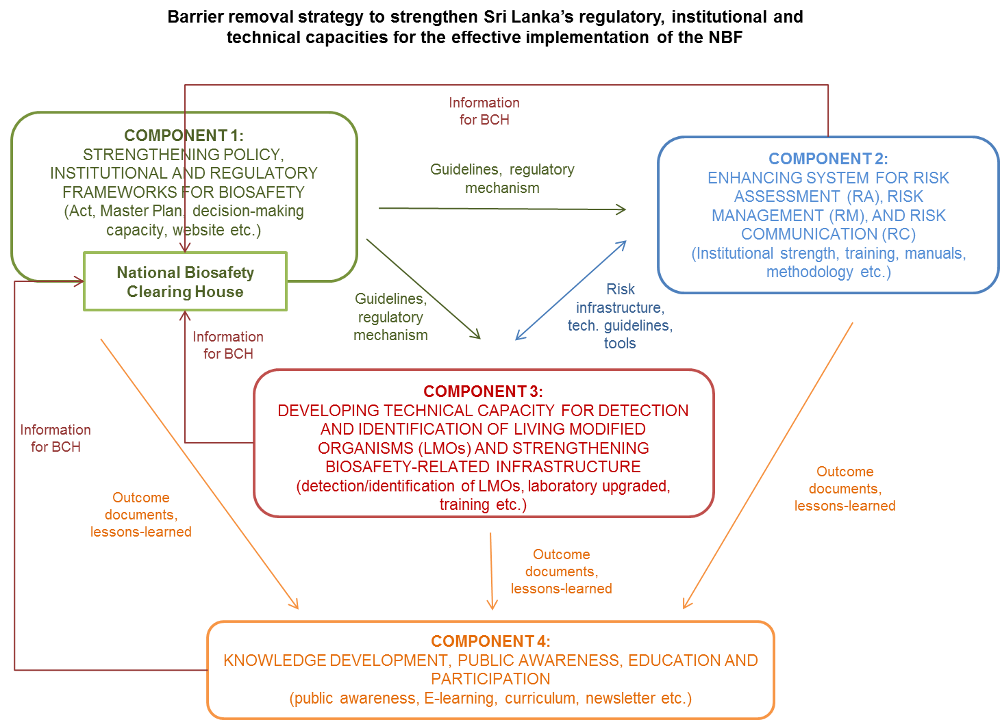

- The outlines of components to achieve overall project objectives are as follows:

- Component 1: “Strengthening policy, institutional and regulatory frameworks for biosafety” will help Sri Lanka to address the gaps in existing regulatory and institutional frameworks to implement the NBF and to support the establishment of sound decision-making processes and law enforcement on biosafety. This would be achieved by providing technical support such as awareness building and training workshops for the enactment of the draft Biosafety Act presently under legal review by national authorities, followed by preparation of relevant regulations. GEF incremental resources will also enable stakeholders to develop the National Biosafety Master Plan, which defines the strategies and steps needed to achieve the objectives outlined in the National Policy on Biosafety. Also under this component, an information management and sharing system on biosafety will be re-established by setting up a website and the national BCH strengthened. This component will help to collect, generate and share up-to-date national biosafety information in a manner that will promote transparency and accountability in decision-making. This strengthened information management system will provide regulatory bodies and stakeholders access to the latest information on biosafety. policy guidelines and mechanism on risk developed in this component will be used for Component 2 and 3. The outcomes from all components will be collected in the national BCH. The related outcomes and outputs will be shared with the other components.

- Component 2: “Enhancing system for risk assessment (RA), risk management (RM), and risk communication (RC)” will strengthen the technical capacity of the existing institutions and competent authorities to conduct RA, RM and RC. This work will enable Sri Lanka to execute sound, transparent and science-based analysis and decision-making in biosafety consistent with international state-of-the-art practices and standards. Sufficient scientific and technical capacities will be created within competent authorities by training and preparing technical guidelines and manuals, as well as decision-making tools, for RA, RM and RC. Lesson-learned and knowledge gained on risk infrastructure will be exchanged between this component and Component 3, as they are both a part of entire risk-related infrastructure in the country.

- Component 3: “Developing technical capacity for the detection and identification of LMOs and strengthening biosafety related infrastructure” will strengthen the technical capacity and make fully operational the key laboratories by upgrading necessary infrastructure for carrying out the required identification and detection of LMOs and thereby enable Sri Lanka to meet its obligations under the CPB. Outcomes and lesson-learned will be used for knowledge management activities in Component 4. In addition, the technical capability will be coupled with the regulatory systems to be established in other components. It will increase their operational efficiency and allow the country enhancing public confidence in use of LMOs. The project will support to empower active participation in global and regional trade systems of LMOs based on their own needs assessment along with the legitimate framework for biosafety.

- Component 4: “Knowledge development, public awareness, education and participation” will support targeted education and outreach campaigns to create awareness of biosafety and to enhance public participation in decision-making. Under this component, enhancement of awareness among policy makers will be pursued to establish political will to incorporate biosafety into national development plans and programmes. In addition, curriculum, syllabus and E-learning course materials for a post-graduate course will be reviewed and elaborated to build sufficient human capacities to address the biosafety needs of the country. Training outcome documents (e.g. training materials, guidelines, reports) and lessons-learned from other components will be collected in this component. Relevant information such as manuals, guidelines, lessons-learned collected in each component will be used for this component.

- These components will address the issues of policy enactment and remove barriers for policy enforcement strategically. One of the key action will be immediate enactment of draft National Biosafety Act in the high-level inter-ministerial coordination mechanism. It will be achieved together with the preparation of the National Biosafety Master Plan through the multi-stakeholder decision-making process. Each component will work closely with multi-stakeholders indicated in Section 3. The project will endeavour to achieve gender balance by ensuring participation by all stakeholders including both men and women. All project activities consider gender aspects, as indicated in Section 5.1 (social safeguards) as well as Results Framework in Appendix 1.

- Along with the technical assistance for the law enactment, the country’s institutional capacity will be strengthened for the implementation and monitoring of policy. The project will support national institutions to enable formulation and implementation of biosafety regulatory mechanisms that are required for RA, RM and RC coherently. Also, the project will strengthen laboratory capacity to ensure the detection and identification of LMOs as well as related technical infrastructure in the country.

- Developed guidelines, manuals and tools etc. will be disseminated through the national Biosafety Clearing House, which will make operational by this project. A series of awareness raising events will be organized to enhance awareness of biosafety issues and to transfer appropriate knowledge to the target stakeholder groups.

Component 1: Strengthening policy, institutional and regulatory frameworks for biosafety

- Under this component, GEF support will focus on creating enabling environment for the law enactment and the functioning of institutional implementation mechanism for national biosafety activities. The component will enhance capacity on biosafety legislations and regulations (Outcome 1.1), develop administrative and operational mechanism for the Biosafety Act (Outcome 1.2), and make the national Biosafety Clearing House operational (Outcome 1.3).

Outcome 1.1: Enhanced capacity to develop, implement and coordinate biosafety legislations and regulations

- This outcome will support the enactment process of draft Biosafety Act and related legal documents including Master Plan (Strategy and Action Plan) by the relevant decision makers. The project will closely work with relevant ministries, Members of Parliament, Attorney General Department, legal experts, members of regulatory committees, enforcement agencies, scientists, industry and NGOs. The outcome will target the implementation of policy with enhanced framework of evaluation, management and monitoring of LMOs.

- The National Execution Agency will ensure the legal and administrative actions for the enactment of draft Act and endorsement of Master Plan as well as relevant regulations. The legislations and regulations for biosafety will be better coordinated and implemented based on the capacity strengthened through the project. At the end of the project, it is expected that Act, Master plan and support regulations for national biosafety will be enforced by the enhanced decision-making mechanism. The country will be able to implement at least five cases of evaluation, management and monitoring of LMOs in the enhanced framework.

Output 1.1.1: National Biosafety Act enacted

- As described in the previous section, the draft Biosafety Act is still under review by the Legal Draftsman’s Department. Awareness and training are required for the sound decision-making process and law enforcement.

- This output will conduct awareness workshops and training to the key decision makers such as relevant ministries, legal authorities, Members of Parliament in the process towards the enactment of the draft Biosafety Act. The experts will support the decision-making process and coordinate stakeholder consultation to ensure the compatibility of the draft Biosafety Act with the relevant national regulations, policies and procedures. The project will support at least four workshops with about 20 decision-makers to ensure the enactment. Gender balance will be considered for the selection of workshop participants.

Output 1.1.2: National Biosafety Master Plan (Strategy & Action Plan) elaborated and endorsed

- Following the recommendation in National Biosafety Framework (2005) and National Policy on Biosafety, the project will develop a National Biosafety Master Plan and facilitate the validation and adoption process.

- The project will form a working group from relevant ministries, departments, scientific agencies, and experts. A series of working group meetings will be organized to identify and prioritize the contents of Master Plan, regulations and procedures. International policy development expert will support key elements of action plan based on international best practice experiences. The expert will support the preparation of draft biosafety master plan as a policy paper in conformity with the national requirements and international obligations in cooperation with Legal Department.

- Along with each outcome of working group meetings, the project will have two consultative meetings with broad stakeholder groups such as policy makers, regulators, enforcement officials, research scientists, SCOs, industry etc. Once the Master Plan has been prepared, the host ministry will post it on the webpage for public consultation.

Output 1.1.3: Relevant regulations reviewed, drafted and endorsed

- As listed in Table 1 of the previous section, several existing laws have relevant clauses, which need to be carefully reviewed and reflected to the regulatory mechanism of biosafety. This work will include the review, update and modification of biosafety related policies, programs and plans, and the elaboration of regulations and administrative procedures for risk analysis of LMOs.

- The constitution of working group will be identified accordingly to prepare a set of biosafety regulations. Technical and legal experts, representatives of concerned ministry departments etc. will be the member of working group.

- Several stakeholder consultation meetings will be supported, especially with members of regulatory committees, until ministries adopt the regulations for further promulgation. Country-wide sensitization/awareness workshops on the biosafety regulatory regime will be organized for relevant stakeholders such as scientist, exporters, industries etc.

Outcome 1.2: Administrative systems for making biosafety fully functional

- Administrative and operational procedures will make consistent with the requirements of CPB among relevant ministries and authorities in this outcome. The inter-ministerial coordination will be strengthened to enable formulation and implementation of integrated and coherent biosafety regulatory mechanisms. The target stakeholder groups to be involved will be ministries, officers of National Competent Authority (NCA), members of regulatory committees and scientific agencies. Procedures for handling of requests, roles and covering area will be defined. Administrative procedures will be outlined and documented to ensure the efficient implementation of biosafety regulations in a transparent manner. The guidelines and manuals for administrative procedure mechanism will be developed.

Output 1.2.1: Administrative and operational procedures for biosafety reviewed and updated

- The mechanism for handling applications related to GMOs/LMOs is described in the draft Biosafety Act. The country has such mechanism, for example, in the Food (Control of Import, labelling and sale of Genetically Modified Foods) Regulations. The administrative and operational procedures of existing biosafety related regulations will be reviewed in consistent with the requirements of CPB under this output. The project also review the operational procedures of existing committees and bodies dealing with various aspects of biotechnology matters such as National Coordination Committee on Biosafety (NCCB), Sectoral Competent Authorities (SCAs).

- The activity will support for the establishment of a dedicated committee that is required to administer biosafety management system along with the national regulatory requirements. Once the committee is formed, at least four committee meetings will be organized. The committee member will prepare the administrative and operational procedures for biosafety management in Sri Lanka with the support of experts. Functional biosafety administrative systems will be reviewed by analysing the cases of other countries.

- The committee will further define roles and responsibilities of various committees and departments as well as rules for appointment of members and experts in a transparent manner. The committee will also consider gender aspects for mainstreaming it in the sector. The committee will prepare a manual on procedures for implementing biosafety act and regulations in relevant government agencies.

Output 1.2.2: Guidelines developed to support the tasks of National Competent Authority (NCA) and Sectoral Competent Authorities (SCAs)

- Some draft formats for application will be reviewed to support NCA and SCAs. The activity will develop a comprehensive guideline for handling applications related to GMOs/LMOs and products, and formats for application and communicating decisions.

Output 1.2.3 Staff of NCA, SCAs and related organizations trained

- Officers of NCA and members from regulatory committees and scientific agencies will be trained for the administrative and operational procedures updated in Output 1.2.1, which needs to be followed for implementing biosafety framework. The experts will design a 3-day training program on the administrative processing and decision-making using case studies/applications. At least forty committee members and operational staff will be trained (at least 30% women).

Outcome 1.3: National Biosafety Clearing House (BCH) operational

- The national BCH is an effective mechanism to facilitate the exchange of information on LMOs and assist the Parties to better comply with their obligations under the Protocol in the country. The national BCH will be re-established and made operational as the country’s information platform on Biosafety. This outcome will enhance the level of awareness in the potential benefits/risks of biotechnology and efficient biosafety systems in the country. It is expected that strengthened awareness among decision-makers and public could reduce the risk of unauthorized and unintended release of LMOs.

- This outcome will improve the web-based information infrastructure and make it available for public. In addition, required training and information material for the contents management will be provided to the dedicated National Focal Point of BCH, IT team and technical officers in Biodiversity Secretariat, and scientific agencies. The capacity building activities under this outcome will target the information sharing on biosafety in the country and the effective usage of national BCH amongst stakeholders. The project expects at least five hundred individual accesses to the BCH at the end of the project implementation with 70% of satisfaction rate received from multiple stakeholders.

Output 1.3.1: An enhanced website established

- The project will make a dedicated website for biosafety operational for Sri Lanka. In addition, the project will streamline the web page of concerned ministries to provide information related to biosafety. The activities will focus on establishing national biosafety IT infrastructure linked to the national BCH as well as the central portal of CBD that includes a roster of biosafety experts in the country and has a database of globally approved LMOs.

- The project will ensure the establishment of a dedicated national biosafety website with assistance from IT and technical expert. Required IT infrastructure of host ministry will be technically reviewed for the long-term contents management of the website. A system will be in place for collecting, uploading and storing the relevant information for the country’s biosafety issues. The modality of operation and maintenance of webpages will be clarified with annual budget implication.

- During the project implementation, timely biosafety information will be uploaded to the content management system of the website. In addition, regulatory decisions on LMOs in the national BCH will be posted and linked with the central portal of SCBD (international CBD Secretariat website). The roles and responsibilities of national BCH and the central portal will be clarified during the IT infrastructure designing.

- The project will help to prepare the roster of experts in association with agencies such as NSF, CARP and develop an online database of globally approved LMOs especially countries with whom Sri Lanka has trade ties (regular update of the database).

Output 1.3.2: The BCH focal point trained to collect and manage information

- The output will assist to familiarize the BCH focal point with the process for the collection and management of information with the provision of manual. IT expert and technical expert will provide training sessions to BCH focal point, associate staff in NCA and nodal officers in SCAs and other scientific agencies in collecting and uploading information (at least twenty individuals). At least four training sessions will be organized to about ten designated IT staff for the management of IT infrastructure including website, roster system and online database. Gender balance will be considered in the selection of participants.

- A procedural manual will make available for collecting, uploading and managing information on the BCH. Dedicated personnel will be identified for trainings/ Training of trainers. They will participate in the BCH training workshops conducted by the CBD Secretariat.

Output 1.3.3: Stakeholders trained to access and share information through BCH

- The project will develop at least three training modules for accessing information on the national BCH for the different target groups of stakeholders. The target stakeholder for such training will include officers and associate staff of NCA, members from regulatory committees, scientific agencies, enforcement officials (customs, plant quarantine, food, and feed inspectors), exporters/importers and research scientists from scientific agencies, universities and research institutions of tea, rubber, coconut, rice etc. The modules will be developed for the following stakeholder groups:

- Enforcement officials, and customs and plant quarantine officials;
- Scientists and regulators; and
- Exporters/importers and industry;

- At least four training workshops will be organized during the project implementation with at least thirty participants for each module. The project will ensure strong participation of women in such training events (at least 30% women participants).

Component 2: Enhancing the system for Risk Assessment (RA), Risk Management (RM) and Risk Communication (RC)

- Overall target of this component will be the strengthening of technical capacity of the relevant national institutions in order to conduct Risk Assessment (RA), Risk Management (RM) and Risk Communication (RC) systematically.

- As described in detail in Section 1, the country experienced receiving requests of GMOs/LMOs import in the past (e.g. import of three GM maize varieties for poultry feed, import of larvicide for dengue control pilot project). Based on the past cases experienced in the country, the institutional mechanism and its capacity will be strengthened in this component (Outcome 2.1). These subjects are, especially as follows:

- To formulate and implement integrated and coherent biosafety regulatory mechanisms;
- To develop reports on the risk assessment results are still lacking for the submission to the central BCH; and
- To take appropriate measures in the event that an LMO is unintentionally released. One of the reasons is the country does not have robust infrastructure such as laboratory facilities for monitoring or managing LMOs.

- They will be strengthened with a clear methodological basis that will be defined within a series of new guidelines, which will be developed in the project. The project will also develop a decision-making tool to strengthen the institutional mechanism. The project will provide institutionalized training to all members of regulatory committees, regulatory bodies and relevant agencies to familiarize with the enhanced RA, RM and RC framework. The information and knowledge collected in this component will be shared with other components and activities related to the risk infrastructure in the project.

Outcome 2.1: National institutions strengthened for RA, RM and RC including monitoring and enforcement

Output 2.1.1: Methodologies for RA, RM and RC reviewed, refined and updated

- The project will review existing guidelines and methodologies, which are relevant to update the institutional mechanism for the RA, RM and RC. For example, the Guideline for the safe use of Recombinant DNA technology under restricted conditions is available. Institutional mechanism and the condition for the application will be reviewed and modified for e.g. inclusion of green house, net house condition. The project will support the adoption of "Risk Assessment of GMO/FFPs – A Practical Guide" by regulatory agencies.

- The work supported by the project will also include the preparation of a risk analysis framework covering approach to RA, RM and RC. Members of regulatory committees and scientists from scientific agencies and national research institutions will be engaged in the analysis and development of risk analysis framework. Concerned ministries, farmers, industry, NGOs will be additional stakeholders for Risk Analysis Framework.

Output 2.1.2: Technical guidelines and manuals on RA and RM developed

- The current institutional mechanism will be reviewed, along with existing guidelines, procedures, institutional capacities, and lesson-learned, in line with requirements for appropriate RA, RM, and RC. Roles and responsibilities of concerned institutions, decision-making steps, timeline of decision-making etc. will be clarified to ensure practical institutional mechanism.

- Rules, procedures and protocols for RA, RM and RC will be elaborated through a series of workshops and consultation meetings. The project will also establish a procedure for identifying and developing a roster of experts to conduct risk assessment. A strategy to sustain biosafety training program during and beyond GEF support will be developed. The project will build human capacity of the relevant national institutions, including customs and quarantine services, through training courses and programmes, and networking with other biosafety initiatives in other countries, especially those in the SAARC Region.

- The project will develop guidelines for dealing with key issues in risk assessment such as food and feed safety, environmental risk assessment, conduct of confined field trials, laboratory research for practical use by the competent authorities and identified stakeholders. At the end of the project, the following guidelines will be available to regulate the activities involving GMOs/LMOs for RA and RM:

- Guidelines for Institutional Biosafety Committees;
- Guidelines for risk assessment of GM food and feed;
- Guidelines for environmental risk assessment of GE plants;
- Guidelines for conduct of confined field trials of regulated GE plants/crops; and
- Guidelines for testing and release of GE insects such as mosquitoes;

- These guidelines will contain modality of committee, ToRs, roles and responsibilities of committee members, procedures of risk assessment, trials, testing, and format/procedure for the management of released GMOs/LMOs.

Output 2.1.3: Decision-making tools prepared for RA, RM and RC

- The decision-making process will be reviewed with the past experience and examples from other countries to identify the opportunity for improvements. A decision-making toolkit will be developed to strengthen the capacity of regulatory agencies and also to streamline the decision-making process with required formats for each RA, RM and RC. It is expected that this work will also ensure transparency of the process amongst stakeholders. The members of regulatory committees (NCCBS, SCAs), scientific agencies, and scientists from national research institutions will be engaged in the activity.

- The toolkit will contain at least the following information:

- Format of risk assessment summaries;
- Conditional items to be stipulated for RM and RC;
- Format of RM and RC modality for use by the SCAs;
- Format for decision-making by the national coordination committee on biosafety

Output 2.1.4: Training strategy for RA, RM and RC developed

- The training strategy will be developed based on the available national capacity as well as lessons-learned gained from the past training programs on risk assessment, monitoring, management and control of LMOs. The national capacity for RA, RM and RC will be strengthened along with the strategy. In addition, the project will review and improve currently available training materials and technical guidance on risk assessment and risk management of LMOs.

- This output will focus on developing training manuals and a strategy for RA, RM and RC to strengthen the national capacity for risk issues. The project will undertake an assessment of existing materials, lesson learned, update of training needs, identification of potential participants, and planning of training programs. Then training manual for RA and RM will be prepared with assistance from international and/or regional experts. A risk communication (RC) strategy will be prepared with assistance of experts.

Output 2.1.5: Staff of relevant institutions trained on RA, RM and RC

- While several training programs were conducted on RA in the country, no trainings have been specifically conducted for RM and RC. Training modules of RA, RM and RC will be developed coherently to sustain the developed capacity of the concerned stakeholders during and beyond GEF support. Human resource capacity will be built in the national institutions by providing training courses and programmes and networking with other biosafety initiatives in the region.

- The target in this activity will be at least one hundred individuals including the members of NCCB, SCAs and other potential members/experts in RA (food and feed safety and ERA) to conduct RA, RM and RC properly. At least fifteen trainings for the members of IBSCs as well as for confined field trials of GE plants (conduct and monitoring) will be organized. The participation of women is encouraged in the series of training activities (at least 30% women participants). In addition, the members/experts responsible for RA and RM will participate in international conferences, workshops and/or training programs.

Output 2.1.6: National and regional institutional networks strengthened to implement National Biosafety System

- The project will identify key areas for cooperation, mechanisms and formats for information exchange through consultation with NCAs in other countries including SAARC countries. It will ensure the harmonization of prepared national guidelines, manuals, application formats and procedures with those in other countries of region, with especially those of SAARC countries.

- The guidelines, manuals, application formats and procedures followed within SAARC countries will be carefully reviewed during the formulation of various national documents. The project will invite regulators and scientists from SAARC countries as resource person for training activities, as required.

- In consultation with NCAs in SAARC countries, the project will host regional harmonization initiatives/activities such as international regional conferences and workshops. At least, an international conference will be organized to harmonize national guidelines, manuals, application formats and procedures with those followed by other countries in the region - especially those of SAARC countries.

Component 3: Developing technical capacity for the detection and identification of LMOs and strengthening biosafety related infrastructure

- This component aims to strengthen and make the key laboratories fully operational by upgrading necessary infrastructure for carrying out the required identification and detection of LMOs and thereby enable Sri Lanka to meet its obligations under the CPB.

- It will also help to enhance institutional, technical and human capacities in the areas of monitoring, inspection, detection and identification of LMOs, in particular those unauthorized or unintentionally released into the environment (Outcome 3.1). The proposed project will enable the country to put in place and implement an effective monitoring and enforcement system to analyse, detect and identify LMOs in the context of national regulatory frameworks (Outcome 3.2). It will be done by assisting in establishing, upgrading and accrediting reference laboratories.

Outcome 3.1: Improved capacity for detection and identification of LMOs

- This outcome will assess: (i) the capacity needs in LMO detection, (ii) requirements for the accreditation of laboratories, and (iii) technical capacities of selected public sector laboratories. These capacities will be enhanced in such a manner that a network of laboratories is created to provide services for enforcement agencies at points of entry (for imports and exports), scientists, agricultural extension officials, etc. One of the laboratories will be responsible for adopting newer techniques, validation of sampling and detection methodologies and other advisory services. This laboratory will also be responsible for continuous training and capacity building of concerned stakeholders. This laboratory will also have enhanced capacity for risk analysis, containment, storage and testing of LMOs in field assessments.

- The activities will also help to develop sampling and analytical methodologies and procedures to identify and quantify LMOs, which will assist in establishing a scientific basis for resolving legal disputes on LMO labelling and non-compliance. Manuals, tools and Standard Operation Procedures (SOPs) for different sampling and detection techniques will be developed, and make available for use by laboratories and regulatory authorities. Access to DNA sequence information and reference materials will also be improved.

- At the end of the project, the project expects at least, 70% of trained staff capable to detect and identify LMOs using upgraded instruments. In addition they can detect/identify at least 20 cases exampled processed using improved facilities.

Output 3.1.1: Testing needs and capacities for LMO detection assessed and key public laboratories identified for up-grading and accreditation

- Based on the past training on detection methodology conducted by University of Peradeniya and other related activities, gaps and opportunities for further capacity development will be further assessed. A stocktaking assessment report will be prepared based on their capacity needs, testing requirements, facilities, infrastructure, human resources and level of expertise required for LMO detection to be carried out for Sri Lanka.

- This work will include an assessment of the testing needs and capacities for LMO risk analysis, detection, and formulation of accreditation policies, procedures and requirements for biosafety laboratories as per international norms. For example, National Plant Quarantine Station at Colombo has a mandate to undertake LMO detection and has basic lab facilities and work force. The facility has not yet met with international standard and the capacity of detection needs to be strengthened. Up to now, Industrial Technology Institute (ITI) and a private lab, Genetech have carried out limited LMOs detection work.

- The project will also support activities such as identification and accreditation of at least three public sector laboratories. Their laboratory facilities will be established or upgraded with necessary critical instruments, so that the laboratories have appropriate competences for LMO analysis, and that they can issue official international standard risk assessment and detection reports.

Output 3.1.2: Inspection plan prepared and inspectors trained

- Food inspectors, seed inspectors, custom officials and plant quarantine officials are mandated to carry out inspection in the draft Biosafety Act. In this activity, at least 50 staff from enforcement agencies (customs, plant quarantine, food, feed inspectors) and members from regulatory committees will be trained for inspection and monitoring of GMOs/LMOs. The participation of gender balance will be considered to identify the participants.

- Training modules will be developed for the inspection and monitoring of GMOs/LMOs with guidelines and operational procedures. About ten training workshops will be conducted for the officials from the enforcement agencies and regulatory committees. Identified food/feed and seed inspectors and plant quarantine will also be trained through participating in international events (gender balance considered).

Output 3.1.3: Personnel trained on LMO detection and identification

- Core staff members and scientists from identified laboratories will be trained as trainers for LMO analysis and detection as well as for operation and maintenance of detection instruments. The project will ensure the critical mass of scientific and technical personnel, who can sustain the national reference laboratories, implement the risk assessment, and maintain the LMO detection and monitoring systems. Active participation of women will be encouraged for the training (at least 30% women).

- Staff of customs and other regulatory authorities will also be trained for the accreditation process of risk assessment. The subject of the training will also include LMO detection and the corresponding LMO certificates to test presence of LMOs as well as to seek the laboratory confirmation. A network of control authorities will be established for the purpose. Exchange of experiences with other countries in the region in the development and use of easy to use, reliable and cost-effective sampling and detection techniques for LMOs will be promoted. An on-site training in an accredited GM detection laboratory will also be organized in outside of Sri Lanka.

Outcome 3.2: Laboratories fully operational with the necessary infrastructures to carry out risk assessment, and detection of LMOs, which allow Sri Lanka to meet its obligations under the CPB

- This outcome will focus on making three identified laboratories fully operational with the necessary infrastructures as per international norms. With such infrastructure, Sri Lanka will be able to carry out risk assessment and detection of LMOs, which allow the country to meet its obligations under the CPB as well as to ensure environmental impacts. The capacity of identified laboratories and facilities will be strengthened for the accreditation.

- The project will also target that two public laboratories for LMO detection will serve as central biosafety LMO research and detection laboratory equipped with state-of-the-art LMO detection system. One of the identified laboratories will be upgraded as an analytical laboratory for compositional and nutritional analysis with state-of-the-art analytical services equipment. Three labs will be established with international standards.

Output 3.2.1: Key government laboratories identified, established, strengthened and appropriately equipped for risk management and detection of LMOs

- The identified laboratories and facilities will be strengthened along with the outcome of stocktaking assessment survey on laboratory equipment, chemicals and reagents, manpower, and improved infrastructure and facility with guideline.

- Main functions of the laboratories and institutions to be identified and their needs for infrastructures and equipment are as follows:

  - Two laboratories to serve as central LMO biosafety research and detection laboratory fully equipped with state-of-the-art LMO detection equipment such as multiplex qualitative or quantitative real-time PCR, ELISA readers, high-throughput DNA-analysis equipment. The purpose of these laboratories can be divided into two: one laboratory to focus on development, adoption and validation of protocols and techniques for DNA detection and monitoring and provide services for DNA detection and monitoring needs of other partner institutions in biosafety implementation. The other laboratories will focus on development and validation of molecular characterization dossier required for risk assessment and to serve as back-up service laboratory for DNA detection and monitoring. Both laboratories will be involved in providing training in biosafety-related activities, DNA detection and monitoring techniques to risk assessors and other concerned agencies and in providing technical resource person on DNA detection and monitoring for public awareness and outreach activities;

  - One upgraded analytical laboratory for compositional and nutritional analysis with state-of-the-art analytical services equipment such as HPLC-MS, amino acid analyser and related-analytical instruments. The purpose of this laboratory is to develop/adopt protocols and techniques and provide services for development of regulatory dossier to comply with food and feed safety assessment required by the country's biosafety regulations. The laboratory will also be involved in training and outreach activities on LMO food and feed safety assessments;

Output 3.2.2: Laboratories accredited by SLAB for risk assessment, LMO detection and identification based on ISO and ISTA standards

- Sri Lanka Accreditation Board for Conformity Assessment (SLAB) is a member of the Mutual Recognition Arrangement (MRA) and currently in the process of seeking membership of the International Accreditation Forum (IAF). They have established ISO standards for GMO detection in addition to ISO 17025.

- The activity will support to develop and institutionalize a training program for the staff of the accreditation body i.e. SLAB through the participation in international workshops and information exchange with other accreditation bodies. After familiarization of accreditation standards, guidelines, and SOP etc., the upgraded laboratories in Output 3.2.1 will be applied for the accreditation as per SLAB/ISO standards. The project will target to the accreditation of two laboratories for SLAB/ISO standards.

Component 4: Knowledge development, public awareness, education and participation

- Information and knowledge from the project activities will be used to design and implement national awareness campaigns on biosafety issues. One of the essential topics of campaigns will be the benefits of modern biotechnologies and biosafety systems. The knowledge generated through the project will be systematically collected and integrated in all relevant project activities to improve efficiency and sustainability. Collected information will be fed into the national BCH. It will then be widely disseminated for the wide range of stakeholders including farmers, students, representatives of NGOs, community based organizations and the public in general through public awareness campaigns, dissemination of guidelines and workshops (Outcome 4.1). These activities will address the important gaps in knowledge and awareness needed to support the enhancement of public access to the information on LMOs.

- An effective project monitoring and evaluation system, including the mid-term review and final evaluation, will be put in place to ensure the effectiveness of the project management process and timely implementation of the planned activities.

Outcome 4.1: Enhanced awareness, education and public participation in decision-making on biosafety

- Under this Outcome, the project will gather all technical/institutional knowledge and lessons-learned during the project implementation. It will also disseminate information to the broad stakeholders strategically to enhance the awareness on biosafety issues.

- Increasing public awareness will be an important aspect of project’s work. Together with the dedicated website and national BCH (to be established with project support), and a series of training activities will be undertaken, a communication strategy will be developed and implemented for broader groups of stakeholders. The target stakeholder groups will include regulators, scientific agencies, communication units of relevant ministries, enforcement agencies, industry (and other private sector stakeholders), the mass media, farmers, students from universities/institutions and the civil society. Efforts will be made to take into account socio-economic impact on all sectors of society, including both men and women, while preparing campaign/events, guidelines and outreach material.

- Over twenty awareness raising events will be organized in this outcome. The events will be conducted along with the strategy. After the set of events were conducted, the feedback and comments will be collected from participated stakeholders.

Output 4.1.1: Public awareness and participation strategy developed

- A risk communication strategy including public outreach will be designed and implemented to promote awareness, public participation, and communication in biosafety issues. Communication materials will be produced in English and local languages, and made publically available in digital and printed formats.

- The project will develop a mechanism for public consultation through IT infrastructure and other processes to collect feedback for public awareness. The activity will also establish a database of concerned stakeholders to manage public consultation process.

Output 4.1.2: Targeted awareness-raising activities implemented

- To increase public awareness but also to ensure long term communication strategy, the following activities will be conducted:

- Develop a E-learning tool on guidelines and procedures for biosafety regulations;
- Prepare primers/brochures/booklets/FAQs/calendars, glossary of terms and other outreach material in local languages and disseminate two thousand copies;
- Develop a set of audio visual educational material on awareness of biotechnology and biosafety issues for stakeholders;
- Conduct about forty awareness workshops on biosafety for relevant stakeholders. Gender balance is also considered in the selection process of participants;

Output 4.1.3: Curriculum, syllabus and course materials prepared for post-graduate course for biosafety, and the gaps in primary (Ordinary Level), secondary and university level education for biosafety filled through improvement of curricula

- The Postgraduate Institute of Agriculture (PGIA), University of Peradeniya, conducts the postgraduate course on Biosafety and now intends to start a postgraduate Diploma course on Biosafety. Curriculum, syllabus and course materials for a post-graduate course on biosafety will be reviewed and elaborated to develop sufficient human capacity to work on biosafety in Sri Lanka. Existing gaps in primary, secondary and university level education for biosafety will also be addressed through the improvement of curricula. The project will provide a set of modules and course materials for higher levels of education incorporation in syllabus of O and A level. At the end of project, it is expected that the university will ensure annual budget allocated for the new course.

Output 4.1.4: Information materials developed and disseminated through various media

- The activity will establish an editorial board for preparing a Biosafety Newsletter on 6-month basis and a database for circulating newsletter. Information material including E-learning tools will be regularly posted on the dedicated website. During the project implementation, at least, eight issues of Biosafety Newsletter will be circulated and update the information materials of website.

Output 4.1.5: Monitoring & Evaluation system established to measure project progress and impact

- Project implementation report prepared and submitted; any support documents prepared for M&E.

Output 4.1.6: Mid-term and final evaluations carried out

- The activity will carry out Mid-Term Review and Final Evaluation of the project.

- The results based budget is presented in Appendix-3.

- Interventions logic and key assumptions

- The main objective of this project is to fully operationalize the NBF by strengthening the institutional, regulatory and technical capacities. This project will expedite the implementations of the initiatives being undertaken by Sri Lanka in the area of biosafety.

- As indicated, the draft Biosafety Act has been prepared and is presently under review. Implementation of provisions of proposed Act require participation of line ministries as Sectoral Component Authorities. The GEF intervention would help in improving the institutional capacity and human resources to be able to operationalize the NBF in Sri Lanka. The country needs to strengthen its existing systems to effectively implement the new regulations, including system for handling of applications, risk assessment, decision-making, monitoring, enforcement and public participation in decision-making.

- As shown in the project results framework (Appendix-1), Sri Lanka has relatively low base lines for most of the key outcomes. The most important intervention through the project is capacity building in scientific, technical, legal and administrative areas of biosafety. Strengthening of sufficient national capacity will facilitate to put in place all the necessary outcomes for safe handling and use of LMOs as per the provisions of the CPB. Therefore, the key assumption is that without GEF intervention, Sri Lanka will be not be able to build the necessary human and institutional capacity in its national institutions for the safe use of biotechnology.

- Although, small number of individuals have been trained in biosafety and awareness programmes undertaken under the NBF project, further training on more specific areas like RA, RM and RC, administrative and decision-making procedures, monitoring and enforcement are required. Capacity building of legal personnel in dealing with biosafety matters is also necessary for ensuring progress in drafting and notifying of required regulations and guidelines. Without this key intervention on scientific and technical training, the critical group of national experts cannot be created and effective implementation of biosafety system will not be possible. The lack of capacity leads to delays in processing of applications for LMOs within timeframe stipulated by the CPB. This in turn lead to delays in decision-making, hampering the research initiatives and disruption in the international trade and the country is not able to benefit from safe and responsible use of modern biotechnology. Without the GEF intervention, the development of regulations and necessary administrative systems would occur only at a slow pace (Table 3).

Table 3: Intervention logic and key assumptions

Intervention Logic | Key Assumptions
- Strengthening of policy, institutional and regulatory frameworks for biosafety:  - Within 18 months, the draft Biosafety Act will be passed;  - Within 36 months, specific biosafety regulations will be prepared;  - Within 36 months, the national BCH re-established and operational by the designated staff; | - Presence of an institutional framework with concerned ministries to implement biosafety policy with smooth coordination;  - Enactment of the draft Biosafety Act by the Cabinet and Parliament;  - Active involvement of all concerned in consultation process for relevant regulations as scheduled (Master Plan, amended regulations);  - Ministry has information for collection and proper IT infrastructure for BCH;
- Enhancing system for risk assessment, risk management and risk communication:  - Within 30 months, at least 4 sets of guidelines for risk assessment and risk management will be prepared;  - Within 30 months, a risk communication strategy will be prepared;  - Within 36 months, an international harmonization conference will be hosted for standardization of format, procedures, methodologies etc.; | - Active involvement of all concerned institutions and ToRs available;  - Institutionalized training approach developed based on national/ international knowledge and experience with scientific capacities;  - Training program designed for institutional nominees at different levels to mitigate risks due to staff attrition and change in personnel;  - Strong government leadership available for the harmonization process at international/ regional levels;
- Development of technical capacity for detection and identification of LMOs and strengthening biosafety related infrastructure:  - Within 36 months, at least 2 public laboratories with improved infrastructure and facilities for LMO detection as per international norms and serve as central LMO research and detection laboratory;  - Within 36 months, trained staff capable to detect and identify LMOs using upgraded laboratories; | - Legal backing available for the cooperation with identified laboratories and enforcement agencies but also capacity development;  - Successful system demonstration with sufficient trial operations for international accreditation;  - Workshop program developed with national and international expertise;
- Knowledge development, public awareness, education and participation:  - Within 18 months, a system for seeking inputs from public on regulatory documents will be in place;  - Within 18 months, course material for post graduate diploma in biosafety will be in place;  - Within 48 months, at least 20 events for enhancing awareness about LMOs and biosafety issues will be conducted in all provinces in the country; | - Awareness events conducted along with the needs of target stakeholder groups;  - Replication mechanism in place to continue awareness raising after the project including potential funding support for the capacity building of biotechnology professionals;  - Strong government and public/private sector support for increasing public awareness;
- Project Management  - Smooth stakeholder coordination with building momentum of actions by the project partners; | - Availability of required expertise for project management;  - Build on experience gained from implementing other GEF projects;  - Strong leadership of national executing agency;

- Risk analysis and risk management measures

- The possible indicative risks factors are listed in table below (Table 4):

Table 4: Indicative risks factors

Risk | Rate/ Risk Status | Mitigation Strategy
Delay in approval of the Draft Biosafety Act due to the lack of decision-making and coordination capacity but also the lack of active involvement of concerned ministries/ departments/ agencies; | L | The project will ensure timely inter-ministerial consultation, submission and follow up approval processes of the draft Act. It will enhance awareness on biosafety agenda among the parliament members with media involvement.
Lack of effective linkages between Sectoral Competent Authorities to effectively implement the project due to the different level of capacities and involvement; | L | Project partners will be actively involved in the project from the project design phase and are also apprised of their roles as per draft Biosafety Act. This arrangement will ensure the operation of the coordination mechanism, and the roles and responsibilities in project implementation, resulting in their commitment and effective project execution.
Low level of awareness on biosafety may make it difficult to gain support, especially from senior government officials and policy makers for the project; | L | Awareness raising activities will be built into the project to secure the commitment of key person as well to raise awareness.
The capacity of stakeholders to conduct risk analysis and detection of LMOs is weak and therefore cannot support the full operationalization of the NBF; | L | The project will implement a capacity building program for SCAs engaged in risk analysis and organizations that are responsible for the detection of LMOs by strengthening the relevant institutional and human resource capacities. Training programs using actual risk analysis case studies will enable technical officers to build their knowledge and skills of risk analysis effectively. Both national and international knowledge and expertise will be collected to develop strategy and training program.
Climate change threatens biodiversity and impacts ecosystem functions of Sri Lanka. Potential harm arising from LMOs may worsen those vulnerabilities. | L | The project, by helping to implement the NBF, will minimize greatly the chances of any negative impacts of the introduction of LMOs on Sri Lanka’s ecosystems.

- Consistency with national priorities and plans

- This project is part of ongoing initiatives by the GoSL to ensure effective implementation of CPB and also its efforts to fully implement the NBF. It aims to strengthen institutional, regulatory and technical capacities for the effective implementation of the NBF in conformity with the CPB. The project is also in line with the needs, policy objectives, principles and statements of the National Policy on Biosafety (2005).

- This GEF funded project will complement and reinforce the ongoing national capacity building initiatives, integrate international experiences/best practices and promote regional cooperation with view to strengthen the national capacity to fulfil commitments under CPB especially in the critical areas of risk assessment and risk management, identification and detection of LMOs and the creation of public awareness.

- The government’s broad vision for environmental conservation in the development policy framework has been transformed into a detailed action plan called ‘National Action Plan for the Haritha Lanka (Green Lanka) Programme’ in 2009. It has set 10 missions namely, Clean Air-Everywhere; Saving the Fauna; Flora and Ecosystems; Meeting the Challenges of Climate Change; Wise Use of the Coastal Belt and the Sea Around; Responsible Use of the Land Resources; Doing Away with the Dumps; Water for All and Always; Green Cities for Health and Prosperity; Greening the Industries and Knowledge for Right Choices.

- Under the second mission of biodiversity conservation, four strategies relevant to Biosafety have been developed namely “Strengthen policy, legal and institutional framework for biodiversity conservation”, “Wise use of genetic resources for agriculture in sustainable manner”, “Integrate and promote research and development on bio-diversity conservation in all sectors” and “Integrate agenda on biodiversity into education and agendas of other related sectors”. To implement the strategies and actions in the Haritha Lanka programme, the government has established a National Council for Sustainable Development (NCSD) which is chaired by the President.

- The Second and Third Regular National Report on the Implementation of the Cartagena Protocol on Biosafety (2012 and 2015) provides the list of capacity needs, including institutional and human resources capacity, which the proposed project aims to address.

- Global Environmental Benefits

- As stated in its Policy Statement 1, GEF support is intended to “improve the global environment or advance the prospect of reducing risks to it”. In the absence of quality baseline data for biodiversity and the rate of change in biodiversity arising from other causes, it is very difficult, if not impossible, to provide measureable indicators of the impact of biosafety on biodiversity – these would arise only as a “decline-avoided” by the rejection of an unsafe application of biotechnology. An adequate biosafety regulatory system thus fits well with “advancing the prospect of reducing risks to the global environment”.

- The Global Environmental Benefits (GEB) from this project would include the successful implementation of the Cartagena Protocol on Biosafety in Sri Lanka, as a ratified country of the international norm. The project will contribute to the conservation and sustainable use of Sri Lanka’s biodiversity of global significance through strengthening capacities to manage potential risks arising from transboundary movement of LMOs. Implementing NBF will allow Sri Lanka to ensure that potential risks of LMOs are properly assessed and managed before environmental release, thereby generating significant global environmental benefits.

- The GEB that would be derived from the operational efficient management system of biosafety in the country is the avoidance of harm to traditional varieties including wild relatives. These GEB accruing from the protection of Sri Lanka biodiversity are highly significant but most of these potential benefits are intangible and will be apparent only in the long term, particularly as this Biosafety project will contribute to several cross-cutting areas, such as environment, agriculture, health and good governance.

- The project will provide opportunity for information and knowledge exchange regarding national biosafety agenda with other countries and region, especially those of SAARC countries. The project would identify the area for cooperation for the harmonization process of national guidelines, manuals, application formats and procedures, but also for the dissemination of expertise enhanced through the project.

- Cost effectiveness

- Within the context of the project, the baseline includes the activities carried out at domestic level with respect to each specific project component, and the increment includes the activities proposed under this project proposal for the purpose of meeting the requirements of the CPB, to be financed through GEF contribution and national co–financing. An incremental cost analysis applied in the design of the project is summarized in Appendix-4.

- The country has still gaps in existing regulatory and institutional frameworks to implement the NBF. There are some developments and changes in the administrative and institutional status. The enactment of the Act is delayed because of the limited awareness and capacity of decision-making process. Without strengthened capacity for sound decision-making processes, the enactment will further delay. The most effective way for the earliest enactment of the Biosafety Act is to strengthen the country’s policy, institutional and regulatory framework. The project is expected to be cost effective, as biosafety activities are being mainstreamed into the national development plans and actions. These will be implemented in a comprehensive and holistic manner, utilizing existing government mechanism. With the GEF intervention, the country will be able to strengthen policy, institutional and regulatory frameworks for biosafety more effectively compared to the baseline situation.

- The cost-effectiveness will be promoted with an integrated approach of strengthening the country’s regulatory, institutional and technical capacities for the effective implementation of the NBF, as described in this section. The project components will address the barriers of considering biosafety infrastructure as a whole that consist of policy-institutional-regulatory framework, risk infrastructure, technical infrastructure of LMO detection and identification, and BCH infrastructure. The country goal will be achieved more effectively by this approach than that by strengthening each framework and infrastructure separately. The knowledge will also be more effectively managed through this project.

- The project implementation emphasizes on inter-agency coordination and collaboration, ensuring avoidance of duplication of work and thereby increasing cost effectiveness. The project includes regional networking in its design. Regional cooperation is a cost effective method to share regional expertise and project outputs, such as outreach materials.

- The project emphasizes that a team rather than an individual manages the project via establishing a project team within the Biodiversity Secretariat. This will help mitigate staff attrition from the project. This is also a prudent and cost effective way of project management.

- Innovativeness

- At both and international levels, the proposed project will be innovative, as it helps in an integrated manner to establish and implement Sri Lanka’s biosafety system. So far, the capacity building efforts in Sri Lanka have been limited and scattered to address the lack of overall capacity for the NBF operation. Sri Lanka being a country with limited expertise in biotechnology and biosafety, the project will provide a series of activities that make technical and human resources available in concerned ministries, agencies and institutions. The integration of individual project activities will ensure the country’s biosafety infrastructure as whole.

- The project will provide a knowledge management mechanism to remove barriers by the capacity development activities, the consolidation of institutional arrangement, and the assistance in establishment of necessary administrative and technical infrastructures. Such barrier removal strategy will be innovative but also cost effective approach to strengthen Sri Lanka’s regulatory, institutional and technical capacities for the effective implementation of the NBF.

- The project also takes account of information exchange with other countries, especially the countries in the SAARC region. The project will identify the areas for cooperation, mechanisms and formats with relevant authorities for biosafety in other countries. It will ensure the harmonization of prepared national guidelines, manuals, application formats and procedures in the project.

- The project will establish a network of laboratories to provide services for enforcement agencies at points of entry (for imports and exports), scientists, and agricultural extension officials. The role and responsibility of laboratories will be clearly defined in the project and their capacities will be strengthened accordingly. The project will also target to obtain the accreditation of upgraded laboratories for SLAB and ISO standards.

- The project will develop some innovative tools such as E-learning tool on guidelines and procedures for biosafety regulations, and audio visual educational material on awareness of biotechnology and biosafety issues for stakeholders. Another unique aspect of this project will be the support of a postgraduate Diploma course on Biosafety with the Postgraduate Institute of Agriculture (PGIA), University of Peradeniya. Curriculum, modules, syllabus and course materials will be developed for higher levels of education on biosafety. These project activities will ensure the long-term knowledge management in the country.

SECTION 3: PROJECT IMPLEMENTATION ARRANGEMENTS

- Government partners roles and responsibilities

- The project will be implemented by the GoSL, represented by the Ministry of Mahaweli Development and Environment through the Biodiversity Secretariat. The project work will be carried out over four years. The Biodiversity Secretariat will be the main government counterpart having the lead technical responsibility for the project, with FAO providing administrative and procurement support and technical oversight.

- The overall project supervision at the national level will be carried out as per the following institutional arrangements. The draft Terms of References (TORs) are as described in Appendix-5:

- National Executing Agency (NEA): The Biodiversity Secretariat of the Ministry of Mahaweli Development and Environment acts as the national focal point for the CBD & CPB and is responsible for the coordination and promotion of national efforts to conserve the nation’s biodiversity, manage the country’s biological wealth and oversee the biosafety related activities. The Biodiversity Secretariat is the NCA for CPB and will be the National Executing Agency (NEA) for this project. The agency will work on behalf of GoSL to manage the project and will take overall responsibilities for the implementation and execution of the project and achievements of its objectives. The NEA is responsible for the legal and administrative actions for the project - especially for the enactment of draft Act and endorsement of Master Plan as well as relevant regulations according to the work plan agreed with the Project Steering Committee (PSC). The NEA will establish the Project Steering Committee (PSC). The NEA will also provide the necessary scientific, technical, financial and administrative support to the project, working in close cooperation with relevant government agencies, the scientific community, other concerned stakeholders and FAO. The NEA will ensure a strong country ownership and commitment of the project activities.

- Project Steering Committee (PSC): A Project Steering Committee (PSC) will be established to periodically review and monitor project implementation progress, facilitate co-ordination between project partners, provide transparency and guidance, and ensure support and sustainability of the project results. The PSC will consist of high level representative from the lead government ministry, who will chair the PSC, and representatives from direct project stakeholders such as government departments, agencies, and FAO Representative. For this project, The PSC will be constituted by the NEA to advise and guide the project implementation. It will be chaired by the Additional Secretary, Ministry of Mahaweli Development and Environment and will be convened by the Director, Biodiversity Secretariat.

The members will comprise the following:

- Additional Secretary (NR /Planning)
- Member from National Planning Department/ External Resources Department
- FAO Representative in Sri Lanka (FAO-R)
- Participant from National Coordination Committee on Biosafety (NCCB);
  - Department of Agriculture,
  - Department of Animal Production and Health,
  - Department of Health
  - Department of Fisheries and Aquatic Resources
  - Department of Wildlife Conservation
- Legal officer, Ministry of Mahaweli Development and Environment

In addition, experts and organizations selected in the project in their personal capacity can also be invited to PSC meeting as and when PSC will be addressing technical and scientific issues arising from implementation of the project.

The PSC will provide the policy guidance, review results based on Annual Work Plans and Budget and provide recommendations for resolving any constraints faced by the project. The PSC will be critical to ensuring:

- Preparation of firm work plans and quality of outputs;
- Country ownership of the project;
- Close linkages between the project and other on-going projects and programmes relevant to the project;
- Sustainability of key project outcomes, including up-scaling and replication; and,
- Effective coordination of Government partner’s work under this project.
- Multi-stakeholder participation in decision-making, policy dialogue, and knowledge management;
- Gender mainstreaming in biosafety agenda;

The members of the PSC will each assure the role of a Focal Point for the project in their respective agencies. Hence the project will have a Focal Point in each concerned institution. As Focal Points in their agency, the concerned PSC members will: (i) Technically oversee activities in their sector, (ii) Ensure a fluid two-way exchange of information and knowledge between their agency and the project, (iii) Facilitate coordination and links between the project activities and the work plan of their agency, and (iv) Facilitate the provision of co-financing to the project.

A work plan developed clearly defines roles, responsibilities, and milestones for the execution of project activities, including monitoring and evaluation and deliverables for output. The work plan will be used as management and monitoring tool by Project Management Unit and FAO.

The PSC will meet at least once a year. The PSC members may communicate by email, skype and phone.

- National Project Director (NPD): The NPD will be a senior staff member designated by Ministry of Mahaweli Development and Environment and will be the lead person responsible for ensuring smooth execution of the project on behalf of the Government of Sri Lanka. The NPD will not be financed by the project.

The specific duties of the NPD include:
- Acting as the responsible focal point at the policy level within NEA
- Ensuring enactment and endorsement process of legislations;
- Ensuring country ownership during and beyond the project;
- Ensuring that all necessary support/input from Government are provided by NEA to enable the implementation of all of the proposed component activities; and
- Reviewing and providing input to work plan and budget consultation/collaboration with the FAO representative; and
- Participation in the selection or recruitment of consultants

- Project Management Unit (PMU): The PMU will be hosted by the Biodiversity Secretariat. The PMU will be led by a Project Manager, a full time project position. The PMU will also have a technical project assistant, administrative & finance assistant and Secretariat staff. The PMU staff will be recruited by the project and report to FAOR as the budget holder (BH). The PMU will carry out the functions in line with FAO rules and regulations. The following are some of the key functions of the PMU. The PMU will:

- Be responsible for day-to-day operation and monitoring of the project in line with the AWP;
- Ensure a results-based approach to project implementation, including maintaining a focus on project results and impact as defined by the RF indicators;
- Liaise with NPD, government agencies and to advocate regularly for the Project;
- Act as contact point for stakeholders and project partners;
- Act as Secretariat to the PSC meetings and be responsible for all logistical matters as well as providing PSC members all required documents for the PSC meetings such as draft AWP/B, independent scientific reviews of significant technical proposals or analyses, meeting minutes, and PSC meeting reports;
- Arrange project-related meetings and field visits;
- Technically identify, plan, design and support all activities;
- Coordinate project tasks with other ongoing activities;
- Be responsible for the preparation of the Annual Work Plan and Budget (AWP/B), PSC meeting reports, FAO Project Progress Reports ( PPRs) and the annual GEF Project Implementation Report (PIR), and;
- Be responsible for the filing and documentation of the project;
- Facilitate and support the midterm review and terminal evaluation of the Project.

The PMU will also be supported by a series of international consultants to provide short term inputs to the Project. These will be finalised during the project implementation, and are tentatively identified as experts on RA, RM and RC, LMO detection, legal aspects and regulatory issues.

- National Project Manager (NPM): The NPM will lead the PMU and work closely with the NPD. The NPM reports to the BH on operational issues and to the FAO LTO on technical issues. The NPM will liaise with the NDP closely. The NPM is a full-time position funded by this GEF project. The NPM will lead and organize the day-to-day operation of the project. The NPM will also take the lead in communications with government agencies and advocacy. The NPM will also be responsible for providing technical advice and guidance in his/her area of technical expertise. The NPM will report on Project progress to PSC meetings, and will develop and submit semi-annual PPRs and annual PIRs. In addition to technical and substantive duties, the NPM will:

- Ensure real-time monitoring of Project progress and the alerting of the NPD, BH and the LTO to potential problems that could result in delays in implementation;
- Oversee creation of a participatory monitoring system for the Project’s work;
- Help identify suitable candidates for consultants and work with the BH to ensure their timely recruitment;
- Ensure the Project’s effective and efficient work, including with stakeholders;
- Help organize and supervise consultant inputs;
- Oversee creation of the project’s approach to managing and sharing knowledge, and to identifying and disseminating lessons learned;
- Communicate, advocate and engage in policy dialogue; etc.

At the end of the project, NPD is responsible for the completion of the project closure procedures including timely submission of all technical/operational, financial and audit reports to FAO/GEF.

- Technical Expert Group (TEG): TEG will be constituted to provide technical support to PMU. TEG will be chaired by NPD and members would be experts or representatives of concerned ministries/scientific agencies and FAO representatives. The TEG will meet on a six monthly basis or whenever technical inputs are required. The TEG members would communicate mainly by email and phone for providing technical support on a continuous basis.

- The project implementation arrangements including coordination among agencies, funds flow and reporting requirements is described in Figure 1.

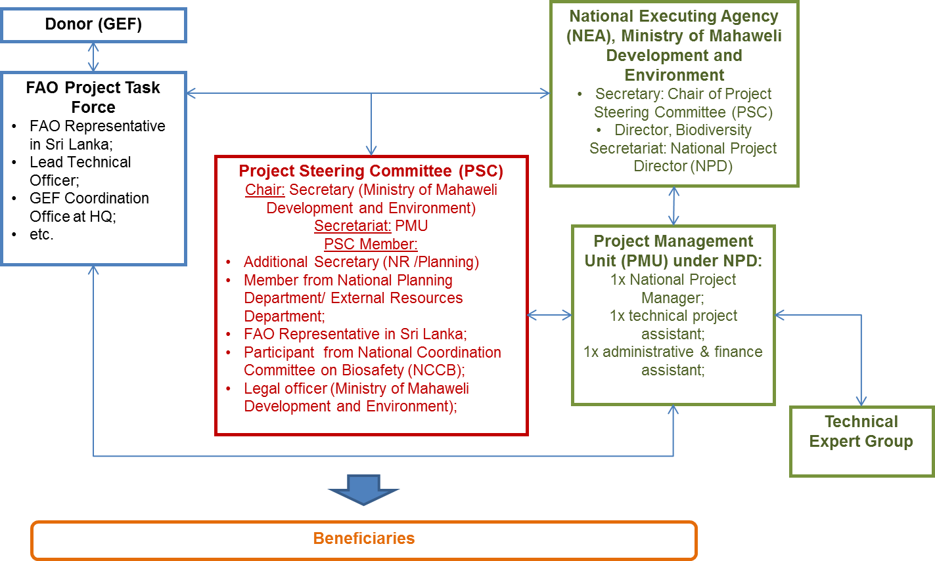

Figure 1: Project Organogram

- The project implementation arrangements are as described in Appendix-6. The consultants to be hired and their tasks are detailed in Appendix-7.

- FAO’s role and responsibilities, both as the GEF Agency and as an executing agency, including delineation of responsibilities internally within FAO

- FAO will be the GEF Agency of the Project as well as the financial and operational executing agency. At the request of the Government of Sri Lanka and the agreement with FAO, the project will be executed by FAO via its Direct Execution (DEX) modality in close consultation with Ministry of Mahaweli Development and Environment. FAO will be technically and fiduciarily accountable for the achievement of all expected project results under the DEX modality. FAO, in consultation with the NPD, will deliver procurement and contracting services to the project using FAO rules and procedures, as well as financial services to manage the GEF resources.

- As the GEF Agency, FAO will be responsible for project oversight to ensure that project implementation adheres to GEF policies and criteria, and that the Project efficiently and effectively meets its objectives and achieves expected outcomes and outputs as delimited in the Project document. FAO will hold the ultimate reporting responsibility to the GEF. FAO will report on Project progress to the GEF Secretariat and provide financial reporting will be to the GEF Trustee. FAO will closely supervise and provide technical guidance to the Project by drawing upon its capacity at the global, regional and national levels, through the concerned units at FAO-HQ, the Regional Office in Bangkok and the FAO Representation in Sri Lanka. In summary, FAO will:

- Administer funds from GEF in accordance with the rules and procedures of FAO;
- Oversee project implementation in accordance with the project document, work plans, budgets, agreements with co-financiers and the rules and procedures of FAO;
- Provide technical guidance to ensure that appropriate technical quality is applied to all project activities and outputs;
- Carry out at least one supervision mission per year; and
- Report to the GEF Secretariat and Evaluation Office, through the annual Project Implementation Review, on project progress and provide financial reports to the GEF Trustee.

- For more detail, please see description below.

- FAO Project Task Force (PTF) is a management and consultative body established for each FAO project. The PTF will be led by the BH and include the LTO, Funding Liaison Officer from FAO-GEF Coordination Unit (GCU), and Headquarter Technical Officer from relevant technical units supporting the project’s work. Other FAO experts may be invited to the Task Force as required. The main role of the task force is to provide guidance to the Budget Holder and the project manager/team for the implementation of the project, contribute to specific project activities as required and troubleshoot should implementation issues arise.

- Executive responsibilities (Budget Holder): The Budget Holder (BH) (FAO Representative for Sri Lanka) is the Chair of the PTF, and will ensure that activities are implemented in support of an approved results-based work plan, identifying and managing risks in consultation with the relevant expert units. The BH will be accountable for ensuring proper use of funds and overall coordination and direct management of the entire project cycle. Under FAO’s Direct Execution modality, the FAO Representation in Sri Lanka will hold the budget and operational responsibilities for this project. The FAO Representative will ensure timely operational, administrative and financial management of the Project’s GEF resources, including the disbursement of funds. As a first step in project start-up, the FAO Representation for Sri Lanka will establish an interdisciplinary Project Task Force (PTF) within FAO to guide the implementation of the project as noted earlier

- In consultation with the PTF, especially LTO, the BH will:

- Clear and monitor annual work plans and budgets;
- Schedule technical backstopping and monitoring missions of FAO Project Task Force (PTF) members etc.;
- Participate in project supervision missions;
- Authorize the disbursement of the project’s GEF resources;
- Give final approval of procurement, project staff recruitment, LoAs, and financial transactions in accordance with the FAO’s clearance/approval procedures;
- Review procurement and subcontracting material and documentation of processes and obtain internal approvals;
- Be responsible for the management of project resources and all aspects in the agreements between the FAO and the various executing partners;
- Provide operational oversight of activities to be carried out by project partners;
- Be responsible for budget matters such as budget revision, financial and monitoring reports etc.;
- Monitor all areas of work and suggest corrective measures as required;
- Submit to the GEF Coordination Unit, the TCID Budget Group semi-annual budget revisions that have been prepared in close consultation with the LTO;
- Be accountable for safeguarding resources from inappropriate use, loss, or damage;
- Be responsible for addressing recommendations from oversight offices, such as Audit and Evaluation; etc.

- Operations and reporting - including the procurement of goods and contracting of services for Project activities - will be done in accordance with FAO rules and procedures. As such, FAO will, in close coordination with the NPD, be responsible for the timely recruitment of key project posts listed above such as NPM. In accordance with FAO rules and procedures, final approval of the use of GEF resources rests with the FAO Representation in Sri Lanka.

- FAO Lead Technical Officer (LTO) will be the officer from the Regional Office for Asia Pacific (RAP), if available and will have the primary accountability for the timelines and quality of the technical services provided throughout project execution. The LTO will work in close collaboration with the BH but also NPD and Headquarter Technical Officer, as appropriate. The LTO will provide technical guidance to the project team to ensure delivery of quality technical outputs. The LTO will coordinate the provision of appropriate technical backstopping from all the concerned FAO units represented in the FAO Project Task Force. The Project Task Force is thus composed of technical officers from the participating units, operational officers, the Investment Centre Division/GEF Coordination Unit and is chaired by the BH. The primary areas of LTO support to the project include:

- Supported by the FAO Representation in Sri Lanka, ensure clearance of TORs for consultancies and contracts to be performed under the project and to CVs and short-listed for key project positions;
- Ensure clearance of the technical Terms of Reference, Letters of Agreement (LoA) and sub-contracts goods, minor works, and services to be financed by the project;
- Supported by the FAO Representation in Sri Lanka, review and clear final technical products delivered by consultants and contract holders financed by GEF resources before the final payment can be processed;
- In close collaboration with NEA and NPD, lead the selection of the project manager, consultants and other institutions to be contracted or with whom an LoA will be signed;
- Review and clear technically reports, publications, papers, training material, manuals, etc.;
- Monitor technical implementation as established in the project RF;
- Review and clear the Project Progress Reports (PPRs) and prepare the annual Project Implementation Review (PIR);
- Review TORs for the Mid-Term Review, participate in review mission including the mid-term workshop with all key project stakeholders, development of an eventual agreed adjustment plan in project execution approach, and supervise its implementation supported by the FAO-GEF;
- Review TORs for the final evaluation, participate in the final project closure workshop with all key project stakeholders and the development of and follow up on recommendations on how to insure sustainability of project outputs and results after the end of the project;
- Provide technical advice to the National Project Director and PSC;
- Review and clear final technical products delivered by consultants and contract holders financed by GEF resources before the final payment can be processed;
- Provide technical support to the PMU in preparing the AWP/B, with support from the Budget Holder and clearing it prior to submission to the PSC;

- GEF Coordination Unit in FAO Technical Cooperation Division Investment Centre (GCU) will review and clear PPRs, annual PIRs and financial reports and budget revisions. The GCU will undertake supervision missions, if considered necessary in consultation with the LTO and the BH. The PIRs will be included in the FAO GEF Annual Monitoring Review submitted to GEF by the GCU. The GCU will also participate in the Mid-Term Review and Final Evaluation and the development of corrective actions in the project implementation strategy in the case needed to mitigate eventual risks affecting the timely and effective implementation of the project.

The GCU will in collaboration with the FAO Finance Division request transfer of project funds from the GEF Trustee based on six monthly projections of funds needed.

Funding Liaison Officer (FLO) will be responsible for maintaining corporate relations with resource partners throughout the project cycle in GCU. The FLO will ensure an overall “help desk” function to the BH and other PTF members for resource partner matters, and ensure that visibility is given to resource partners in communication material. Especially, the FLO will ensure project documents, funding agreements, and progress reports to comply with the resource partner requirements, and assist BH and other PTF members in interpretation and implementation of terms and conditions as well as relevant FAO and GEF Rules and Regulations. FLO will monitor work plan and budget implementation as well as review PIR, GEF Tracking Tools, Mid-Term Review and the Final Evaluation.

- FAO Finance Division will clear budget revisions, provide annual Financial Reports to the GEF Trustee and, in collaboration with the GCU, call for project funds on a six monthly basis from the GEF Trustee.

- FAO Office of Evaluation will be responsible for ensuring the management and quality of the overall process for the project’s final evaluation. The evaluation will be conducted by a team of independent external consultants with appropriate evaluation experience and/or relevant technical skills. The independent team leader and evaluation team will be responsible for the final analysis, findings, conclusions and recommendations. FAO Office of Evaluation (OED) staff are the evaluation managers and, when appropriate, may also act as an evaluation team member or leader in the case of project/programme evaluations. Draft TORs will be sent to the OED for finalization, in accordance with FAO evaluation procedures and taking into consideration evolving guidance from the GEF Evaluation Office.

SECTION 4: STAKEHOLDER PARTICIPATION

- As biosafety relates to several sectors, including environment, agriculture, health, science and technology, rural development, industry, trade , as well as community based organizations, consumer associations, NGOs etc., the GoSL adopted a consultative approach at the preparation of NBF and other policy documents by involving concerned stakeholders. Based on the assessment, the key stakeholders in the project will be the Biodiversity Secretariat of the Ministry of Mahaweli Development and Environment, ministries that were proposed to serve as SCAs and other concerned government, and private institutions.

- These stakeholders have also been involved in the development of this project through meetings to discuss activities to be undertaken under different project components and giving comments on various draft documents. After approval of the PIF by the GEF CEO, the project document has been finalized by both the Ministry of Mahaweli Development and Environment and FAO-Sri Lanka through a consultative approach.

- The project activities and stakeholder involvement has been designed in line with the GEF policy on Gender Mainstreaming and taking also in account Sri Lanka’s national socio-economic priorities. The target audience towards implementation of various project activities would be inclusive of women scientists from research institutions of the National Agriculture Research System, local agriculture communities, farmers, students etc. The National Physical Planning Policy and Plan 2006-2030 identifies environmental protection and social integration as core components for continued economic growth and development.

- Since the use GMOs/LMOs would have direct impact on the livelihood of local groups/population, therefore representation of local communities will be involved in of sensitization and awareness programs.

- Adopting the consultative approach towards the project implementation, once the project is approved the key stakeholders that will be included as project partners are ministries that are proposed to serve as National Biosafety Committee and SCAs; enforcement agencies such as customs & national plant quarantine; scientific agencies such as NSF, CARP; research universities and research institutions and other private institutions. In addition, extensive efforts are proposed to be made for creating awareness across all provinces to concerned stakeholders including farmers, students, general public, representatives of NGOs, community based organizations etc. Efforts to reach out to all social segments would be made by translating outreach material in local languages. These are given below in the Table 5 and Table 6 with their respective role/type of involvement as well as corresponding project components. More detailed roles of project partners will be updated during the inception phase:

Table 5: Stakeholders and type of involvement identified
Stakeholders | Type of involvement identified
Ministry of Mahaweli Development and Environment through Biodiversity Secretariat | - The Additional Secretary of the ministry to chair the PSC that will coordinate and supervise the project as nodal ministry of CPB;  - Act the Biodiversity Secretariat as the NEA for implementation of the project;  - Ensure administrative processing for the Biosafety Act, rules and regulations;  - Implement the administrative procedures and technical guidelines developed as part of the project;  - Ensure enhanced public awareness through regular information dissemination about the project activities;  - Ensure setting up of information portal and managing nBCH;
Parliamentarians and Legal experts from Legal Draftsmen Department | - Facilitate the process of examination, adopting and enactment of the proposed Biosafety Act;  - Ensure consultative process for finalizing guidelines, administrative procedures, SOPs etc.
Department of Agriculture, Department of Animal Production and Health, Department of Health, Department of Fisheries and Aquatic Resources, Department of Wildlife Conservation and Ministry of Industry. | - Provide inputs on the development of regulatory and other relevant documents as SCAs;  - Participate in training programmes on RA, RM and RC;  - Participate in national and international events during the project;  - Provide technical inputs to awareness raising workshops;  - Ensure institutional mechanism for biosafety;  - Provide inputs as food safety inspectorate for the enforcement of biosafety regulations;
Enforcement officials including Customs, National Plant Quarantine Services, Seed Inspectors, scientists/technical experts from research laboratories involved in detection and monitoring | - Support strengthening of infrastructure and capacities for detection of LMOs;  - Provide inputs on the transboundary movement of GMOs/ LMOs and procedures/ guidelines for sampling, field trials inspection and monitoring etc.;  - Participate in training programs on procedures for sampling, detection, inspection and monitoring, and nBCH;  - Provide inputs on training modules for nBCH access;  - Participate in consultations on documents and training modules related to sampling, detection, inspection and monitoring;  - Assist in strengthening enforcement systems for effective biosafety regulations related to transgenic animals and animal feed;
Sri Lanka Accreditation Board for Conformity Assessment | - Assist in the process for accreditation of identified laboratories  - Participate in training programs/information exchange with other accreditation bodies at international level
Scientific Agencies including NSF, CARP, National Research Council, COSTI | - Review and draft guidelines for RA, RM and RC on biosafety;  - Develop outreach materials for different target groups;
University and research institutions such as University of Peradeniya and University of Colombo, Tea Research Institute, Rubber Research Institute, Coconut Research Institute and Rice Research and Development Institute and Horticultural Crop Research and Development Institute | - Provide technical support in enhancing capacity for RA and LMO detection;  - Provide technical inputs for the development of safety assessment guidelines and manuals for RA and RM of GMOs/LMOs, formats for RA summaries and conduct trainings;  - Provide technical inputs on the national biosafety master plan, website, E-learning tools on biosafety regulations etc.;  - Support consultative meetings for finalizing various biosafety regulations and guidelines;  - Provide technical inputs to training workshops;  - Coordinate post graduate diploma and integrate biosafety with other courses;  - Ensure upgrade and accreditation of laboratory for LMOs/GMOs detection;  - Provide technical support to regulatory authorities for risk assessment and management, and enforcement officials for detection of LMOs/GMOs;  - Develop capacities, curriculum and a post graduate course on biosafety;  - Ensure the establishment of post graduate course in consultation with Ministry of Education;
Private sector, NGOs, CSOs, mass media and local communities | - Support awareness activities to incorporate views and perspectives into the planning and implementation of the project;  - Support knowledge management on biosafety;  - Support and participate in workshops, particularly those related to communication and dissemination;  - Consensus building for the national biosafety issues;

Table 6: Proposed contribution of project partners to the project components

Project Partner | Project component support expected
Project Partner | Component 1 | Component2 | Component 3 | Component4
Ministry of Mahaweli Development & Environment | Outcome 1.1 (output 1.1.1, 1.1.2, 1.1.3); Outcome 1.2 (output 1.2.1, 1.2.2, 1.2.3); Outcome 1.3 (output 1.3.1, 1.3.2, 1.3.3) ; | Outcome 2.1 (output 2.1.1, 2.1.2, 2.1.3, 2.1.4, 2.1.5, 2.1.6) | Outcome 3.1 (output 3.1.1, 3.1.2, 3.1.3); Outcome 3.2 (output 3.2.1, 3.2.2) | Outcome 4.1 (output 4.1.1, 4.1.2, 4.1.3)
Ministry of Health Nutrition & Indigenous | Outcome 1.1 (output 1.1.1, 1.1.2, 1.1.3) ; Outcome 1.2 (output 1.2.1, 1.2.2, 1.2.3); Outcome 1.3 (output 1.3.2, 1.3.3) ; | Outcome 2.1 (output 2.1.1, 2.1.2, 2.1.3, 2.1.4, 2.1.5, 2.1.6) | Outcome 3.1 (output 3.1.2, 3.1.3); Outcome 3.2 (output 3.2.2) | -
Department of Animal production & Health | Outcome 1.1 (output 1.1.1 , 1.1.2, 1.1.3); Outcome 1.2 (output 1.2.1, 1.2.2, 1.2.3); Outcome 1.3 (output 1.3.2, 1.3.3) ; | Outcome 2.1 (output 2.1.1, 2.1.2, 2.1.3, 2.1.4, 2.1.5, 2.1.6) | Outcome 3.1 (output 3.1.1, 3.1.2, 3.1.3); Outcome 3.2 (output 3.2.1, 3.2.2) | Outcome 4.1 (output 4.1.1, 4.1.4 )
Department of Agriculture
National Plant Quarantine Services | - | - | Outcome 3.1 (output 3.1.2, 3.1.3); Outcome 3.2 (output 3.2.1) | -
Department of Fisheries & Aquatic resources | Outcome 1.1 (output 1.1.1, 1.1.2, 1.1.3); Outcome 1.2 (output 1.2.1, 1.2.2, 1.2.3); Outcome 1.3 (output 1.3.1, 1.3.2, 1.3.3) ; | Outcome 2.1 (output 2.1.1, 2.1.2, 2.1.3, 2.1.4, 2.1.5, 2.1.6) | Outcome 3.1 (output 3.1.1, 3.1.2, 3.1.3); Outcome 3.2 (output 3.2.1, 3.2.2) | Outcome 4.1 (output 4.1.1, 4.1.2, 4.1.3)
Department of Wildlife Conservation | Outcome 1.1 (output 1.1.1, 1.1.2, 1.1.3); Outcome 1.2 (output 1.2.1, 1.2.2, 1.2.3); Outcome 1.3 (output 1.3.1, 1.3.2, 1.3.3); | Outcome 2.1 (output 2.1.1, 2.1.2, 2.1.3, 2.1.4, 2.1.5, 2.1.6) | Outcome 3.1 (output 3.1.1, 3.1.2, 3.1.3); Outcome 3.2 (output 3.2.1, 3.2.2) | Outcome 4.1 (output 4.1.1, 4.1.2, 4.1.3)
Sri Lanka Customs | Outcome 1.3 (output 1.3.3) | Outcome 2.1 (Output 2.1.3) | Outcome 3.1 (output 3.1.2 ) | -
University of Peradeniya | Outcome 1.3 (output 1.3.3) | Outcome 2.1 (Output 2.1.1, 2.1.2, 2.1.4, 2.1.5) | Outcome 3.1 (output 3.1.1, 3.1.3); Outcome 3.2 (output 3.2.1, 3.2.2) | Outcome 4.1 (output 4.1.1, 4.1.2, 4.1.3)
University of Colombo | Outcome 1.3 (output 1.3.3) | Outcome 2.1 (Output 2.1.1, 2.1.2, 2.1.4, 2.1.5) | Outcome 3.1 (output 3.1.1, 3.1.3); Outcome 3.2 (output 3.2.1, 3.2.2) | Outcome 4.1 (output 4.1.1, 4.1.2)
National Science Foundation | Outcome 1.1 (output 1.1.1, 1.1.2, 1.1.3); Outcome 1.3 (output 1.3.1, 1.3.2) | Outcome 2.1 (Output 2.1.1, 2.1.2, 2.1.3, 2.1.4, 2.1.5, 2.1.6) | Outcome 3.1 (output 3.1.3) | Outcome 4.1 (output 4.1.2)

SECTION 5: SUSTAINABILTY OF RESULTS

  - Sustainability of results

- Factors affecting sustainability have been considered in the planning of the project and it is expected to be sustainable in regard to:

- Financial and political sustainability: With the draft Biosafety Act being steered by the Ministry of Mahaweli Development and Environment, the long term financial requirements to enhance biosafety activities in Sri Lanka shall follow the enactment. This project will further help the concerned ministries in the government to recognize the importance of biosafety issues particularly the obligations under the CPB and integrate the same in their plans, policies and strategies.

- Environmental sustainability: One of the key objectives of this project is to build national capacity in risk assessment and risk management to ensure safe use of LMOs taking into account protection of biodiversity, the environment and human health. Being a mega diverse country, environmental impacts need to be monitored even after the release of LMOs for long term effects. The availability of state of the art technical tools and a strong regulatory and monitoring regime will help in mitigating the risks and ensuring environmental sustainability to a great extent.

- Operational sustainability: The project activities have been planned in such a manner as to involve a network of multi-disciplinary experts and use a consultative approach. Therefore, a critical core of national experts would be available at the end of the project and the movement of project staff will not adversely affect the operational sustainability of the system. Furthermore, it is proposed to clearly define and document the functions, responsibilities and provide documents for implementing biosafety regulatory framework by various stakeholders so that biosafety management can be carried out beyond the project life. Further, operational sustainability will be addressed through using existing enforcement mechanisms and these will be strengthened by imparting appropriate trainings, so as to ensure cost effectiveness.

- Social safeguard: Social safeguards are incorporated into the project through empowering all citizens of Sri Lanka, irrespective of race, gender and creed. By developing a public participation strategy to enable the public participate and access biosafety related information, social concerns will also be voiced and responded to. This project will endeavour to achieve gender balance by ensuring participation by all stakeholders including both men and women. Efforts will be made to take into account socio-economic impact on all sectors of society, including both men and women, while preparing regulations, guidelines and outreach material. The project will also contribute to promoting good governance through the participation of all stakeholders in decision-making on LMOs. This has also been stipulated in the draft Biosafety Act under consideration Project staff recruitment, project activities and trainings will not discriminate against any particular group or gender. Target groups like farmers, local communities, general public, youth, particularly students and women will be involved in development of awareness raising materials and help enhance social sustainability. Translation of outreach material in local languages will further promote effective participation by all stakeholders.

v. Appropriateness of technology introduced: The set of technologies to be used for LMO detection and other technical aspects will be selected by the local government and scientists/technicians in the identified laboratories. International consultants and FAO project team shall provide guidance based on global expertise and experiences. However, the decision on the technologies and equipment to be used lies with the project stakeholders at a local level and in this way the project aims to achieve a high level of appropriateness of introduced practices both from global and local point of view.

  - Replication and scaling up

- Replication opportunity of the activities succeeded from this project and up-scaling of its impacts are ensured through strengthening of regulatory frameworks and enhancement of institutional and technical capacities of stakeholders including government officials, academics and the public at large. Outreach campaigns to create awareness on the importance of biosafety will ensure continuous knowledge development maximizing the project’s long-term impacts in the country.

- The ability for networking amongst stakeholders especially inter-departmental stakeholders to implement this project can be a model for cooperation in other similar situations such as in biodiversity conservation, ecosystems management and other multi stakeholder issues.

- The project will benefit from the development of technical tools such as guidelines, manuals, methodologies, training modules, risk communication and public participation strategy that can be refined with time as more experience is gained from “learning by doing”. These valuable tools can also be shared between countries in the region.

- The project will consider the following aspects in the project outcomes and outputs for the replication and scaling-up to enhance the project impacts:

- Strengthening institutional capacity to deal with biosafety issues in the country (Outcome 2.1);
- Establishing networks on biosafety among country’s stakeholders and countries, especially those in the SAARC region (Output 2.1.6);
- Upgrading public laboratories selected for risk assessment and detection to make operational with operation/ maintenance mechanism to showcase technically viable examples (Outcome 3.2);
- Streamlining accreditation process of laboratories with international standard (Output 3.2.2);
- Developing curriculum for post-graduate course on biosafety (Output 4.1.3);
- Conducting outreach events/campaigns to create awareness on biosafety for continuous knowledge development and maximizing the project’s long-term impacts (Outcome 4.1); etc.

  - Communication and visibility

- Under this project, Sri Lanka intends to establish a national biosafety website and use it as a main vehicle for information sharing and dissemination for the project outputs developed for use by wider audience such as teachers, students, academia etc. This would help in promoting communication and visibility of the project.

- The risk communication strategy developed as part of this project will help improve communication to the general public about biosafety and help counter the negative perceptions about the technology that are not evidence-based.

- The media will play an important role in this project. Workshops will be conducted on biosafety awareness raising among journalists, thus promoting public awareness. In addition, most the project workshops will be covered by the media.

- The National Project Manager will play a key role in maintaining fluid and regular communication about the project with national stakeholders at all levels, but most importantly among high level actors in agencies of central Government, aimed at maintaining their interest in and commitment to the project throughout its entire lifetime. This will be achieved through personal bilateral communication with these actors and also through the National Project Director, taking advantage of his/her strategic position to channel messages regarding the project to the other Government stakeholders. Given their broad stakeholder base, the Project Steering Committee and National Executing Agency will also serve as vehicles for communication and raising visibility regarding the project and its aims and approaches.

- This project will also value the GEF communications and outreach strategy. The project activity will support to create a clear GEF corporate identity, to speak with a unified voice, to position GEF as a leader on the global environment, to engage effectively with GEF, and to embed GEF messages at country and regional levels.

  - Regional/Sub regional Cooperation

- The proposed project will take advantage of the regional collaborative initiative on biosafety, “Asian Bio-Net”, undertaken by FAO. Good practices and lesson-learnt from the project will be disseminated and replicated in the region through this regional network.

- Regional/sub-regional cooperation with various countries in the region will be promoted by regional activities, such as inviting the participants from these countries to regional workshops on relevant issues as well as participation of experts in various events organized by them. Sharing of training activities as well as documentation developed under the project would help the countries who are in the process of fully implementing their NBFs.

SECTION 6: MONITORING, EVALUATION AND REPORTING

  - Oversight and monitoring responsibilities

- Monitoring and evaluation (M&E) of progress of project in achieving results and objectives will be based on the targets and indicators established in the project results framework (Appendix-1). The M&E of the project activities will follow the applicable FAO and GEF policies and guidelines. The project results framework includes SMART indicators for each of the expected outputs and outcomes. The M&E related costs are integrated in the overall project budget.

- Project oversight will be carried out by the Project Steering Committee (PSC), the FAO GEF Coordination Unit and relevant Technical Units in HQ. Oversight will ensure that: (i) project outputs are produced in accordance with the project results framework and leading to the achievement of project outcomes; (ii) project outcomes are leading to the achievement of the project objective; (iii) risks are continuously identified and monitored and appropriate mitigation strategies are applied; and (iv) agreed project global environmental benefits/adaptation benefits are being delivered.

- The FAO GEF Unit and HQ Technical Units will provide oversight of GEF financed activities, outputs and outcomes largely through the annual Project Implementation Reports (PIRs), periodic backstopping and supervision missions.

- Project monitoring will be carried out by the Project Management Unit (PMU) and the FAO budget holder. The day-to-day project monitoring is the responsibility of the PMU but the other project partners will have responsibilities to collect specific information to track the indicators. Project performance will be monitored using the project results matrix, including indicators (baseline and targets) and annual work plans and budgets. At inception the results matrix will be reviewed to finalize identification of: i) outputs ii) indicators; and iii) missing baseline information and targets. A detailed M&E plan, which builds on the results matrix and defines specific requirements for each indicator (data collection methods, frequency, responsibilities for data collection and analysis, etc.) will also be developed during project inception by the M&E specialist. It is the responsibility of the NPD to inform FAO of any delays or difficulties faced during implementation so that the appropriate support or corrective measures can be adopted in a timely fashion.

- M&E is to be driven by the preparation and implementation of an AWP/B to be followed up through six-monthly PPRs. The preparation of the AWP/B and semi-annual PPRs will represent the product of a unified planning process between main project partners. As tools for results-based-management, the AWP/B will identify the actions proposed for the coming project year and provide the necessary details on output targets to be achieved, and the PPRs will report on the monitoring of the implementation of actions and the achievement of output targets.

- The first PSC meeting will be held within two months of the inception workshop. The PSC will review the project periodic reports on progress and will make recommendations to FAO concerning any need to revise aspects of the project results framework. Project oversight to ensure that the project meets FAO and GEF policies and guidelines is the responsibility to the LTO/project task force in FAO. The LTO will also review the quality of draft project outputs, provide feedback to the project partners, and establish peer review procedures to ensure adequate quality of scientific and technical outputs and publications.

- During the three month inception phase, an Inception Workshop will be held wherein the specific M&E issues will be refined and subsequently discussed. This will (a) assist all stakeholders to fully understand and take ownership of the project; (b) review and confirm/finalize project indicators and results framework with stakeholders; (c) review the project’s first AWP and budget; (d) discuss the roles, functions, and responsibilities within the project's implementation arrangements for decision-making; (e) review a detailed M&E work plan and budget based on the M&E plan summary presented in Table-6 in the next section.

  - Evaluation

- For full-sized projects, a Mid-Term Review will be undertaken at project mid-term to review progress and effectiveness of implementation in terms of achieving the project objectives, outcomes and outputs. Mid-term Reviews are encouraged for medium sized projects. Findings and recommendations of this review/evaluation will be instrumental for bringing improvement in the overall project design and execution strategy for the remaining period of the project’s term. FAO will arrange for the mid-term review/evaluation in consultation with the project partners. The review will, inter alia:
- Assess the effectiveness, efficiency and timeliness of project implementation;
- Analyse effectiveness of partnership arrangements;
- Identify issues requiring decisions and remedial actions;
- Propose any mid-course corrections and/or adjustments to the implementation strategy as necessary; and
- Highlight technical achievements and lessons learned derived from project design, implementation and management.

- It is recommended that an independent Final Evaluation (FE) be carried out three months prior to the terminal review meeting of the project partners. The FE will aim to identify the project impacts and sustainability of project results and the degree of achievement of long-term results, based on GEF Terminal Evaluation guidelines. This evaluation will also have the purpose of indicating future actions needed to sustain project results and disseminate products and best-practices within the country and to neighbouring countries.

  - Reporting

- Specific reports that will be prepared under the M&E program are: (i) Project inception report; (ii) Annual Work Plan and Budget (AWP/B); (iii) Project Progress Reports (PPRs); (iv) annual Project Implementation Review (PIR); (v) Technical Reports; (vi) co-financing reports; and (vii) Terminal Report. In addition, assessment of the GEF Monitoring Evaluation Tracking Tools against the baseline (completed during project preparation) will be required at midterm and final project evaluation.

- Project Inception Report. It is recommended that the PMU prepare a draft project inception report in consultation with the LTO, BH and the other project partners. Elements of this report should be discussed during the Project Inception Workshop and the report subsequently finalized. The report will include a narrative on the institutional roles and responsibilities and coordinating action of project partners, progress to date on project establishment and start-up activities and an update of any changed external conditions that may affect project implementation. It will also include a detailed first year AWP/B and a detailed project monitoring plan. The draft inception report will be circulated to the PSC for review and comments before its finalization, no later than one month after project start-up. The report should be cleared by the FAO BH, LTO and the FAO GEF Coordination Unit and uploaded in FPMIS by the BH.

- Results-based Annual Work Plan and Budget (AWP/B). The draft of the first AWP/B will be prepared by the PMU in consultation with the FAO Project Task Force and reviewed at the project Inception Workshop. The Inception Workshop (IW) inputs will be incorporated and the PMU will submit a final draft AWP/B within two weeks of the IW to the BH. For subsequent AWP/B, the PMU will organize a project progress review and planning meeting for its review. Once comments have been incorporated, the BH will circulate the AWP/B to the LTO and the GEF Coordination Unit for comments/clearance prior to uploading in FPMIS by the BH. The AWP/B must be linked to the project’s Results Framework indicators, so that the project’s work is contributing to the achievement of the indicators. The AWP/B should include detailed activities to be implemented to achieve the project outputs and output targets and divided into monthly timeframes and targets and milestone dates for output indicators to be achieved during the year. A detailed project budget for the activities to be implemented during the year should also be included together with all monitoring and supervision activities required during the year. The AWP/B should be approved by the Project Steering Committee and uploaded on the FPMIS by the BH.

- Project Progress Reports (PPR): PPRs will be prepared by the PMU based on the systematic monitoring of output and outcome indicators identified in the project’s Results Framework (Appendix-1). The purpose of the PPR is to identify constraints, problems or bottlenecks that impede timely implementation and to take appropriate remedial action in a timely manner. They will also report on projects risks and implementation of the risk mitigation plan. The PPR will be submitted to the BH and LTO for comments and clearance. The BH will upload the PPR on the FPMIS.

- Annual Project Implementation Review (PIR): The LTO (in collaboration with the PMU) will prepare an annual PIR covering the period July (the previous year) through June (current year) to be submitted to the BH and the TCI GEF Funding Liaison Officer (FLO) for review and approval no later than (check each year with GEF Unit but roughly end June/early July each year). The FAO GEF Coordination Unit will submit the PIR to the GEF Secretariat and GEF Evaluation Office as part of the Annual Monitoring Review report of the FAO-GEF portfolio. PIRs will be uploaded on the FPMIS by the TCI GEF Coordination Unit.

- Key milestones for the PIR process:

- Early July: the LTOs submit the draft PIRs (after consultations with BHs, project teams) to the GEF Coordination Unit (faogef@fao.org, copying respective GEF Unit officer) for initial review;
- Mid July: GEF Unit responsible officers review main elements of PIR and discuss with LTO as required;
- Early/mid-August: GEF Coordination Unit prepares and finalizes the FAO Summary Tables and sends to the GEF Secretariat by (date is communicated each year by the GEF Secretariat through the FAO GEF Unit;
- September/October: PIRs are finalized. PIRs carefully and thoroughly reviewed by the GEF Coordination Unit and discussed with the LTOs for final review and clearance;
- Mid November 17: (date to be confirmed by the GEF): the GEF Coordination Unit submits the final PIR reports -cleared by the LTU and approved by the GEF Unit- to the GEF Secretariat and the GEF Independent Evaluation Office.

- Technical Reports: Technical reports will be prepared by national, international consultants (partner organizations under LOAs) as part of project outputs and to document and share project outcomes and lessons learned. The drafts of any technical reports must be submitted by the PMU to the BH who will share it with the LTO. The LTO will be responsible for ensuring appropriate technical review and clearance of said report. The BH will upload the final cleared reports onto the FPMIS. Copies of the technical reports will be distributed to project partners and the Project Steering Committee as appropriate.

- Co-financing Reports: The BH, with support from the PMU, will be responsible for collecting the required information and reporting on co-financing as indicated in the Project Document/CEO Request. The PMU will compile the information received from the executing partners and transmit it in a timely manner to the LTO and BH. The report, which covers the period 1 July through 30 June, is to be submitted on or before 31 July and will be incorporated into the annual PIR. The format and tables to report on co-financing can be found in the PIR.

- GEF Tracking Tools: Following the GEF policies and procedures, the relevant tracking tools for full sized projects will be submitted at three moments: (i) with the project document at CEO endorsement; (ii) at the project’s mid-term review/evaluation; and (iii) with the project’s terminal evaluation or final completion report. The TT will be uploaded in FPMIS by the GEF Unit. The TT are developed by the Project Design Specialist, in close collaboration with the FAO Project Task Force. They are filled in by the PMU and made available for the mid-term review an again for the final evaluation.

- Terminal Report: Within two months before the end date of the project, and one month before the Final Evaluation, the PMU will submit to the BH and LTO a draft Terminal Report. The main purpose of the Terminal Report is to give guidance at ministerial or senior government level on the policy decisions required for the follow-up of the project, and to provide the donor with information on how the funds were utilized. The Terminal Report is accordingly a concise account of the main products, results, conclusions and recommendations of the project, without unnecessary background, narrative or technical details. The target readership consists of those who are not necessarily technical specialists but who need to understand the policy implications of technical findings and needs for insuring sustainability of project results. The GEF-BD tracking tool is provided in Appendix-8.

- At Project mid-term and end, the tracking tools will be completed by the PMU in close consultation with the NPD.

- Monitoring and evaluation plan summary is described below and details the main M&E activities, responsible parties and timeframes. The activity is included in the Output 4.1.5 in the project framework:

Table 6: Summary of main M&E reports, responsible parties, timeframe & costs

Type of M&E activity | Responsible Parties | Time-frame | Indicative budget
Inception Workshop | PMU, supported by the LTO, BH and GCU | Within 3 months of project start up | USD 1500 (Workshop venue), USD 7800 (5% of PMU staff cost,USD 156,000), Co-financing
Project Inception Report | PMU, LTO, BH and GCU | No later than 1 month of the inception workshop | PMU staff cost
Annual Project Implementation Reports | PMU supported by the LTO and cleared and submitted by the GCU to the GEF Secretariat | Annual | PMU staff cost
Project Progress Reports | PMU, with inputs from NPD, PSC and other project partners; BH will submit to the LTO and GCU for review | Half yearly | PMU staff cost
Key technical reports for results verification | PMU, LTU and the project partners | Policy assessment report; Assessment report on BCH; Training outcome report; Technical report on equipped laboratories and facilities; Technical report on the process records; Knowledge assessment report; | PMU staff cost, USD 8000 (5% of expert cost, USD 160,500)
Co-financing Reports | PMU, NPD | Annual | PMU staff cost
Mid-term review | External consultant, FAO country officer and PMU | At mid-point of project implementation | USD 30,000 for independent consultants and associated costs. In addition the agency fees will pay for expenditures of FAO staff time and travel
Final Evaluation | External consultant, FAO independent evaluation unit in consultation with the project team including the GCU | At the end of project implementation | USD 50,000 for external, independent consultants and associated costs. In addition the agency fee will pay for expenditures of FAO staff time and travel
Terminal report | NPM, LTO | At least 2 months before end date of the Execution Agreement | PMU staff cost
Total Amount |  |  | USD 97,300

  - Provisions for evaluation

- Mid-Term Review: A mid-term review will be undertaken at the beginning of the second year of project implementation. It is indicated in the project component Output 4.1.4. The review will determine progress being made towards achievement of objectives, outcomes, and outputs. Findings and recommendations of this review will be instrumental to improvement in the overall project design and execution strategy for the remaining period of the project’s term if necessary. The recommendation will be proposed along with the FAO and GEF modalities, rules and regulations. FAO Country Office will arrange for the mid-term review in consultation with project management. The review will, inter alia:
- Review the effectiveness, efficiency and timeliness of project implementation;
- Analyse effectiveness of implementation and partnership arrangements;
- Identify issues requiring decisions and remedial actions;
- Identify lessons learned about project design, implementation and management;
- Highlight technical achievements and lessons learned; and
- Propose any mid-course corrections and/or adjustments to the implementation strategy as necessary.

- Final Evaluation: Besides the mid-term review, an independent final evaluation will take place three months prior to the terminal review meeting of the project and will focus on points ‘d’ and ‘e’ listed above under mid-term review. In addition, the final evaluation will review project impact, analyse sustainability of results and whether the project has achieved its objectives. The evaluation will furthermore provide recommendations for follow-up actions needed to expand on the existing project in subsequent phases, mainstream and up-scale its products and practices, and disseminate information to management authorities responsible for related issues to ensure replication and continuity of the processes initiated by the project. Terminal Evaluation is indicated in the project component Output 4.1.4.

- The FAO LTO will prepare the first draft of the Terms of Reference for the mid-term review and the final evaluation and consult with and incorporate comments from NEA supported by NPD, the FAO budget holder, the FAO Lead Technical Unit, and the FAO GEF Coordination Unit. Subsequently, in the case of the final evaluation, the TORs will be sent to the FAO Office of Evaluation for finalization, in accordance with FAO evaluation procedures and taking into consideration evolving guidance from the GEF Evaluation Office. The TORs and the reports will be discussed with and commented upon by the project partners. Critical issues to be included in the TORs for the evaluation in the midterm review and the final evaluation will in particular be the ones captured by the outcome indicators.

SECTION 7: FINANCIAL PLANNING AND MANAGEMENT

  - Financial planning

- Overall project budget: The overall project budget as financed under the full sized GEF grant is of US $ 5,324,291 comprising of US $ 2,365,964 from GEF grant and US $ 2,958,327 co-finance from the potential project partners.

Co-Financing Budget (USD)
Sources of Co-financing | Component 1: Strengthening policy, institutional and regulatory frameworks for biosafety | Component 2: Enhancing system for Risk Assessment (RA), Risk Management (RM) and Risk Communication (RC) | Component 3: Developing technical capacity for detection and identification of living modified organisms (LMOs) and strengthening biosafety-related infrastructure | Component 4: Knowledge development, public awareness, education and participation | Project Management Cost | Line total
Ministry of Mahaweli Development and Environment | 15,714 | 10,000 | 10,000 | 10,000 | 40,000 | 85,714
Ministry of Health Nutrition and Indigenous | 3,000 | 3,000 | 2,571 | - | - | 8,571
Department of Animal Production and Health | 100,000 | 100,000 | 107,143 | 50,000 | - | 357,143
Department of Agriculture | 120,000 | 135,714 | 100,000 | 50,000 | - | 405,714
National Plant Quarantine Services | - | - | 291,143 | - | - | 291,143
Department of Fisheries and Aquatic Resources | 10,000 | 10,000 | 6,143 | 10,000 | - | 36,143
Department of Wildlife Conservation | 100,000 | 35,714 | 100,000 | 50,000 | - | 285,714
Sri Lanka Customs | 100,000 | 182,471 | 100,000 | - | - | 382,471
University of Colombo | 50,000 | 100,000 | 50,000 | 100,000 | - | 300,000
University of Peradeniya | 50,000 | 100,000 | 50,000 | 100,000 | - | 300,000
National Science Foundation | 25,000 | 25,000 | 30,000 | 25,714 | - | 105,714
FAO | 50,000 | 50,000 | 50,000 | 50,000 | 200,000 | 400,000
Co-financing | 623,714 | 751,899 | 897,000 | 445,714 | 240,000 | 2,958,327
% Co-financing | 62% | 53% | 48% | 68% | 68%
GEF Project Financing | 382,000 | 673,299 | 990,000 | 208,000 | 112,665 | 2,365,964
% GEF Project Financing | 38% | 47% | 52% | 32% | 32%
Project Total | 1,005,714 | 1,425,198 | 1,887,000 | 653,714 | 352,665 | 5,324,291

- GEF Inputs: The GEF funds will finance inputs needed to generate the outputs and outcomes under the project. These include: (i) national and international consultants for technical support; (ii) contracts with technical institutions/project partners, supporting the delivery of specific project activities; (iii) expenses incurred towards various meetings/workshops/conferences as part of the project activities (v) international flights and local transport and minor office equipment; and (vi) training and awareness raising materials.

- Government Inputs: The GoSL, through the Ministry of Mahaweli Development and Environment, will ensure project implementation by providing technical and administrative support towards implementation of project activities. Co-financing commitment letters from project partners are placed provided in Appendix-9.

The use of existing services and commitment areas for the project (e.g. office spaces, salary of officers, equipment, building facilities, laboratory instruments, and furniture) includes the followings:

- Office space and equipment used for project workshops , trainings and meetings;
- Staff counterpart time, salaries, and related allowances;
- Capacity development (training, human resource development. Dissemination of research findings, policy advocacy and technical support);
- Computers and other IT related equipment;
- Laboratory instruments and equipment;
- Chemicals, consumables and reagents;
- Policy strategies, actions, law enforcement related to biosafety;
- LMO detection, testing and monitoring;
- Research activities;
- Awareness and knowledge sharing;
- Labour;
- Building, electricity bill, AC, stationaries, etc.

- FAO Inputs: FAO will provide technical assistance, backstopping, training and supervision of the execution of activities financed by GEF resources. The GEF project will complement and be co-financed by several projects and activities implemented by the FAO-R funded by the FAO Technical Cooperation Programme and by various donors through trust fund arrangements. FAO will manage the GEF grant and shall provide services in accordance with its regulations, rules and procedures which shall provide adequate control to ensure that the project funds are properly administered and expended.

- Other partner inputs: They will provide the activity inputs accordingly with co-financing agreement with FAO. The required inputs will be reviewed discussed during the inception phase of the project.

  - Financial management of and reporting on GEF resources

- The financial management of/and reporting on GEF resources is detailed below. Finance and Operations Assistant will be hired by FAO to ensure the financial matters of the project:

- Financial records: FAO shall maintain a separate project account in accordance with accepted accounting standards and report all income and expenditures correspondingly in US dollars. Expenditures incurred in a currency other than United States dollars shall be converted into United States dollars at the United Nations operational rate of exchange on the date of the transaction. FAO shall administer the GEF resources in accordance with its regulations, rules and directives

- Financial reports/statements: The BH i.e. FAO representative of Sri Lanka shall prepare six-monthly project expenditure accounts and final accounts for the project, showing amount budgeted for the year, amount expended since the beginning of the year, and separately, the un-liquidated obligations as follows:
- Details of project expenditures on a component-by-component and output-by-output basis, reported in line with project budget codes as set out in the project document, as at 30 June and 31 December each year.
- Final accounts on completion of the project on a component-by-component and output-by-output basis, reported in line with project budget codes as set out in the project document.
- A final statement of account in line with FAO Oracle project budget codes, reflecting actual final expenditures under the project, when all obligations have been liquidated.
The BH will submit the above financial reports for review and monitoring by the LTO and the FAO GCU. Financial reports for submission to the donor (GEF) will be prepared in accordance with the provisions in the GEF Financial Procedures Agreement and submitted by the FAO Finance Division.

- Budget revisions: The BH will prepare semi-annual budget revisions, in the format of the budget in the FAO-GEF Project Document and in accordance with FAO standard guidelines and procedures.

- Responsibility for Cost Overruns: The BH is authorized to enter into commitments or incur expenditures up to a maximum of 20 percent over and above the annual amount foreseen in the project budget under any budget sub-line provided the total cost of the annual budget is not exceeded.

Any cost overrun (expenditure in excess of the budgeted amount) on a specific budget sub-line over and above the 20 percent flexibility should be discussed with the GCU/TCIB with a view to ascertaining whether it will involve a major change in project scope or design. If it is deemed to be a minor change, the BH shall prepare a budget revision in accordance with FAO standard procedures. If it involves a major change in the project’s objectives or scope, a budget revision and justification should be prepared by the BH for discussion with the GEF Secretariat.

Savings in one budget sub-line may not be applied to overruns of more than 20 percent in other sub-lines even if the total cost remains unchanged, unless this is specifically authorized by the GCU upon presentation of the request. In such a case, a revision to the project document amending the budget will be prepared by the BH.

Under no circumstances can expenditures exceed the approved total project budget or be approved beyond the NTE date of the project. Any over-expenditure is the responsibility of the BH.

- Audit: The project shall be subject to the internal and external auditing procedures provided for in FAO financial regulations, rules and directives and in keeping with the Financial Procedures Agreement between the GEF Trustee and FAO.

The audit regime at FAO consists of an external audit provided by the Auditor-General (or person exercising an equivalent function) of a member nation appointed by the Governing Bodies of the Organization and reporting directly to them, and an internal audit function headed by the FAO Inspector-General who reports directly to the Director-General. This function operates as an integral part of the Organization under policies established by senior management, and furthermore has a reporting line to the governing bodies. Both functions are required under the Basic Texts of FAO which establish a framework for the terms of reference of each. Internal audits of accounts, records, bank reconciliation and asset verification take place at FAO field and liaison offices on a cyclical basis.

  - Procurement

- Careful procurement planning is necessary for securing goods, services and works in a timely manner, on a “Best Value for Money” basis, and in accordance with the Rules and Regulations of FAO. It requires analysis of needs and constraints, including forecast of the reasonable timeframe required to execute the procurement process. Procurement and delivery of inputs in technical cooperation projects follow FAO’s rules and regulations for the procurement of supplies, equipment and services.

- As per the guidance in FAO’s Project Cycle Guide, the BH will draw up an annual procurement plan for major items which will be the basis of requests for procurement actions during implementation. The plan will include a description of the goods, works, or services to be procured, estimated budget and source of funding, schedule of procurement activities and proposed method of procurement. In situations where exact information is not yet available, the procurement plan should at least contain reasonable projections that will be corrected as information becomes available.

Appendix 1: Results Framework

APPENDIX-1 RESULTS FRAMEWORK
 | Indicators | Baseline | End of Project Target | Source/Means of verification | Risks and Assumptions
COMPONENT 1: STRENGTHENING POLICY, INSTITUTIONAL AND REGULATORY FRAMEWORKS FOR BIOSAFETY
Outcome 1.1: Enhanced capacity to develop, implement and coordinate biosafety legislations and regulations | Number of implementation examples (evaluation, management and monitoring of LMOs) in the National Biosafety Framework that is in compliance with the CPB;  Number of laws enforced by the enhanced high-level inter-ministerial coordination mechanism; | Gaps still remain in existing regulatory and institutional frameworks to implement the National Biosafety Framework (NBF);  Capacity for sound decision-making processes and law enforcement limited; | At least 5 implementation examples with enhanced framework of evaluation, management and monitoring of LMOs;  At least 3 laws enforced by the enhanced mechanism (including Act, Master plan, support regulations); | Government notifications regarding Biosafety Act, regulations and other national documents;  Implementation records;  Policy assessment report;  Capacity development survey of committee members (e.g. before/ after training survey, Knowledge-Attitude-Practice (KAP) survey, Most Significant Change (MSC) survey); | Risks  Delay in approval or rejection of legal documents by the Parliament;  Lack of active involvement of concerned ministries and decision makers for the establishment of biosafety policy framework;  Assumption  Government strengthened capacity for the inter-ministerial coordination as well as policy implementation under the regulatory framework;  Presence of an institutional framework with concerned ministries to implement biosafety policy with smooth coordination;
Output 1.1.1: National Biosafety Act enacted | Number of workshops for enactment process;  Number of Biosafety Act enacted by the established decision-making process; | Awareness and training are required for the sound decision-making process and law enforcement;  Biosafety Act drafted but not enacted; | At least 4 workshops with about 20 decision-makers to ensure the enactment (at least 30% women) by year 1;  1 Biosafety Act enacted and printed by 2nd Quarter of Year 2; | Workshop outcome documents;  Biosafety Act of Sri Lanka enacted, published and  uploaded on national BCH; | Risks  Delay in receiving approval from the Parliament or rejection;  Changes in the national priorities resulting from change in government;  Assumptions  Smooth decision-making process established for the earliest enactment;
Output 1.1.2: National Biosafety Master Plan (Strategy & Action Plan) elaborated and endorsed | Number of stakeholder consultative meetings;  Number of legal documents prepared through the stakeholder consultation as per recommendation in the National Biosafety Framework (I.e. Master Plan); | Recommendation for setting up a National Biosafety Master Plan was given in National Biosafety Framework, 2005 and National Policy on Biosafety but does not exist | At least 2 consultation meetings to elaborate Master Plan;  1 National Biosafety Master Plan endorsed; | Assessment report of consultative meeting;  National Biosafety Master Plan endorsed by the Government of Sri Lanka and published  Uploaded on the national BCH | Risks  Delay in decision-making process for endorsement;  Lack of priority as the thrust area of the concerned ministries/ departments/ agencies;  Assumptions  Active involvement of all concerned in consultation process as scheduled;  Smooth decision-making process established with key decision makers for the earliest enactment;
Output 1.1.3: Relevant regulations reviewed, drafted and endorsed | Number of regulations reviewed and set of regulations available to support Biosafety Act and Master Plan | The draft Biosafety Act is yet to be approved by the Parliament;  Several existing laws have relevant clauses; | At least 20 related regulations reviewed and 1 set of biosafety regulations endorsed by ministry to support the Biosafety Act; | Gazette Notification on Biosafety regulations | Risks  Delay in receiving feedback from respondents for review;  Delay in decision-making process for adoption or rejection;  Regulatory regime cannot be easily adopted because of resistance from interest groups;  Assumptions  Gaps and support options identified properly through the review process;  Clear administrative guidance for drafting support policy available;  Smooth coordination including several interest groups ensured for the adoption of related regulations;
Outcome 1.2: Administrative systems for making biosafety fully functional | Number of implementation examples using fully functional administrative system | Administrative and operational procedures, which are consistent with the requirements of CPB do not exist; | At least 5 implementation examples using a fully functional administrative procedure mechanism as per provisions of the draft Biosafety Act; | Implementation records;  Guidelines and manuals; | Risks  Procedures for the handling of requests are not clear, roles are not defined and do not cover all issues;  Lack of trained personnel for the handling of applications;  Assumptions  Experts familiar with international best practices to be engaged;  Dedicated personnel available, and familiar with CPB requirements as well as approach to develop administrative mechanism;
Output 1.2.1: Administrative and operational procedures for biosafety reviewed and updated | Number of improved administrative and operational procedures in consistent with the requirements of CPB  Number of committee meetings; | The Food (Control of Import, Labelling and sale of GM foods) Regulations, 2006 are functional existing biosafety regulations;  Mechanism for handling applications related to GMOs/LMOs mentioned in the draft Biosafety Act;  Terms of Reference for various committees and rules for appointment of members/experts needs to be defined;  Committee is required for administer biosafety management system within the national regulatory requirements; | 1 mechanism for biosafety administrative and operational procedures agreed by the committee (including roles and responsibilities of various committees/departments, nomination of experts, gender aspects etc.);  At least 4 committee meetings organized to develop manual; | Manual on administrative and operational procedures published;  Minutes of meetings of the expert committee/working group;  Terms of Reference for various committees; | Risks  Delay in receiving feedback from respondents for review process;  Overlapping mandates and roles among key ministries;  Lack of capacity in understanding biosafety issues and international requirements;  Assumptions  Project partners actively involved in the process;  Roles are properly defined;  Biosafety Act, laws and regulations provided clear framework/pathway for administrative procedures;  Nodal officers are trained in biosafety issues;
Output 1.2.2: Guidelines developed to support the tasks of National Competent Authority (NCA) and Sectoral Competent Authorities (SCAs) | Number of guidelines for handling applications and formats for application & communicating decisions in place | At present, there is no guidelines available;  Only some draft formats for application available; | 1 comprehensive guideline available for handling applications related to GMOs/LMOs and products | Guideline for handling applications related to GMOs/LMOs and products;  Application formats; | Risks  Guidelines cannot be finalised because of the lack of active inputs by the project partners;  Institutional arrangements not permanent;  Trained and designated personnel replaced with new personnel in NCS/SCAs;  Assumptions  Guidelines are used to support tasks of NCA and SCAs;  Experts familiar with implementing biosafety framework with NCA and SCAs are engaged;  Designated personnel identified and remains the same;
Output 1.2.3 Staff of NCA, SCAs and related organizations trained | Number of members of regulatory committees and operational staff trained in administrative and operational procedures | A National Coordination Committee on Biosafety (NCCB) is in place;  Sectoral Competent Authorities (SCAs) are formed on case by case basis;  Committees on various aspect of biotechnology are in place | At least 40 committee members and operational staff trained with certificate (at least 30% women); | Certificate of training Proceedings of training workshops | Risks  Insufficient number of trainers in various biosafety aspects;  Participants for trainings are not appropriately selected;  Assumptions  International and national consultants deployed properly;  Individuals identified for trainings are responsible for handling biosafety related issues/applications
Outcome 1.3: National Biosafety Clearing House (BCH) operational | Number of visitors accessing to BCH;  Satisfaction with level of information and knowledge available in the national BCH; | There is a national BCH established but not operational due to the lack of capacity to collect, process and manage the information required to run it; | At least 500 individual accesses to the BCH;  At least 70% of satisfaction rate received from multiple stakeholders; | Access record to the national BCH;  Assessment report including questionnaire and survey of user feedback; | Risks  Lack of capacity of the nodal ministry of Cartagena Protocol on Biosafety for the national BCH operation;  Assumptions  Active involvement and role definition of nodal ministry during the project;  Ministry has information for collection and proper IT infrastructure for BCH;
Output 1.3.1: An enhanced website established | Number of national biosafety web-based information infrastructure linked to the central portal of CBD that included a roster of biosafety experts in the country and has database of globally approved LMOs; | There is no dedicated website operational on biosafety in the country;  Information related to biosafety is not available on web sites of the concerned ministries; | 1 national biosafety website available with sufficient contents;  1 roster of experts by concerned agencies;  1 online database of globally approved LMOs especially countries with whom Sri Lanka has trade ties (regular updating of the database); | National website in place and operational with up-to-date information linked to BCH;  Roster of experts in place and uploaded on BCH; | Risks  Lack of qualified technical personnel and required IT infrastructure;  Delay in collection of information;  Appropriate experts not selected for Roster;  Assumptions  Careful analysis on technical and information requirements for the website carried out;  Information identified to be shared and make it easily accessible for public to promote transparency and accountability of decision-making process;
Output 1.3.2: The BCH focal point trained to collect and manage information | Number of trainings for BCH organized;  Number of individuals trained;  Availability of manual; | The BCH focal point is not familiar with the process;  No manual available; | At least 20 individuals from BCH focal point, associate staff in NCA and nodal officers in SCAs and other scientific agencies trained and made capable to collect and upload information (at least 30% women) ;  4 training sessions for at least 10 IT staff for the management of IT infrastructure including website, roster and database (at least 30% women);  1 procedural manual ready to use for collecting, uploading and managing information on the national BCH; | Procedural Manual for collecting, uploading and managing information;  BCH focal point and associate staff trained; | Risks  Staff attrition and change in personnel;  Availability of qualified staff;  Assumptions  Appropriate individuals identified for trainings/ Training of trainers;  Proper working documents made available;
Output 1.3.3: Stakeholders trained to access and share information through BCH | Number of training modules;  Number of training organized;  Number of individuals trained; | No information available regarding the number of trained personnel | At least 3 training modules for accessing information on the national BCH for the different stakeholders viz., scientists, regulators, customs and plant quarantine officials;  Organize 4 training workshops with at least 30 participants for each module (in total about 120 individuals, at least 30% women); | Training modules for different stakeholders;  Certificate of training;  Proceedings of training workshop; | Risk  Knowledge and interest of target stakeholders about the subject varied widely;  Assumptions  Proper working document to be prepared for the target stakeholder groups categorized for each training module;  Train the trainer's approach;
COMPONENT 2: ENHANCING SYSTEM FOR RISK ASSESSMENT (RA), RISK MANAGEMENT (RM), AND RISK COMMUNICATION (RC)
Outcome 2.1: National institutions strengthened for RA, RM and RC including monitoring and enforcement
Outcome 2.1: National institutions strengthened for RA, RM and RC including monitoring and enforcement | Number of agencies that have institutionalised training on RA, RM and RC;  Number of focal points for RA, RM and RC in each institution identified; | The capacity of national institutions is limited to enable formulation and implementation of integrated and coherent biosafety regulatory mechanisms; | All members, bodies and relevant agencies received institutionalized training and they are capable to work with the RA, RM and RC framework;  At least 3 focal points identified for institutional RA, RM and RC;  1 institutional mechanism in place to deal with biosafety issues in the country; | Training outcome report;  Capacity development survey of focal points (e.g. before/ after training survey with annual review, Knowledge-Attitude-Practice (KAP) survey); | Risks  Lack of consensus for procedures/guidelines for RA, RM and RC among institutions;  Lack of trained personals in each institution involved on how to perform RA and how to go about RM;  Assumptions  ToR of each institution available;  Institutionalized training approach provided;  Training program and guidelines developed based on both national and international experience;
Output 2.1.1:  Methodologies for RA, RM and RC reviewed, refined and updated | Number of guidelines for contained use and Risk Analysis Framework developed; | Guidelines for the safe use of Recombinant DNA technology in contained conditions available but not mandated;  Brief guidance document "Risk Assessment of GMO/FFPs – A Practical Guide" prepared but yet to be adopted by regulatory agencies; | At least 1 comprehensive guideline available for GMOs/LMOs in contained conditions including green house, net house etc.;  At least 1 Risk Analysis Framework covering approach to RA, RM and RC available; | Updated guidelines for the use of GMOs/LMOs under contained conditions in place and notified;  Risk Analysis Framework in place and accepted by regulatory authorities; | Risks  National experience in various cases of RA, RM and RC not available;  Assumptions  International expertise for risk infrastructure gathered;
Output 2.1.2:  Technical guidelines and manuals on RA and RM developed | Number of technical guidelines in place covering various aspects of RARM | No existing guidelines or manuals | 5 guidelines available to regulate activities involving GMOs/LMOs for RARM:  1. Guidelines for Institutional Biosafety Committees  2. Guidelines for risk assessment of GM food and feed  3. Guidelines for environmental risk assessment of GE plants  4. Guidelines for conduct of confined field trials of regulated GE plants/crops  5. Guidelines for testing and release of GE insects such as mosquitoes | Guidelines for IBSCs, food and feed safety, environmental risk assessment, confined field trials and GE mosquitoes are in place and accepted by regulatory authorities | Risks  National experience of formulating guidelines not available;  Delays in receiving inputs;  Assumptions  Guidelines and manuals developed with international expertise and knowledge, and revised along with the country requirement;  All concerned stakeholders participate for review;
Output 2.1.3:  Decision-making tools prepared for RA, RM and RC | Number of decision-making tools for RA, RM and RC | No existing decision-making tools available | At least 1 decision-making tool kit available for regulatory agencies with required formats for each RA, RM and RC; | Formats for decision-making to be used by regulatory committees are in place | Risks  Consensus about decision-making process of RA, RM and RC and role of participating institutions not made among institutions;  Assumptions  Decision-making process defined officially and/or legally;
Output 2.1.4:  Training strategy for RA, RM and RC developed | Number of training strategy/ manuals for RA, RM and RC in place | No training strategy available for RA, RM and RC | At least, 1 training needs assessment survey to be conducted;  At least 2 training manuals for RA and RM;  1 RC strategy developed; | Training needs assessment report;  Training manual for RA and RM;  RC Strategy; | Risks  Lack of experience in identifying critical areas to be covered by the training;  Assumptions  International knowledge and experience also considered;
Output 2.1.5:  Staff of relevant institutions trained on RA, RM and RC | Number of individuals trained;  Number of staff designated for risk infrastructure in each institution identified; | Training programs were conducted in 2006, 2008, 2009 on RA at the university level;  No trainings have been specifically been conducted for in the area of RM and RC | At least 100 individuals (at least 30% women) trained including the members of NCCB, SCAs and other potential members/experts in RA (food and feed safety and ERA), with at least 15 trainings for the members of IBSCs and on confined field trials of GE plants (conduct and monitoring); | Trained officials from relevant institutions;  Certificate of training;  List of designated staff; | Risks  Quality of training and timelines of delivery are unsatisfactory;  Staff attrition and change in personnel;  Resource person is not appropriate;  Assumptions  Training material to be jointly developed with national and international expertise  Training program designed for institutional nominees at different levels;  Appropriate individuals are identified for trainings;
Output 2.1.6:  National and regional institutional networks strengthened to implement National Biosafety System | Number of international conference organized | The National Biosafety Framework is in place but not fully functional; | 1 international harmonization conference organized to harmonize national guidelines, manuals, application formats and procedures with those followed by other countries in the region especially those of SAARC countries;  National and regional network established for scaling-up; | Report of the regional conference/workshop;  Feed-back survey on the level of satisfaction for the outcomes;  National guidelines, manuals, application formats in place; | Risks  Poor inter-agency coordination at regional and national level;  Assumptions  Strong government leadership available for the harmonization process at international/ regional levels;
COMPONENT 3: DEVELOPING TECHNICAL CAPACITY FOR DETECTION AND IDENTIFICATION OF LIVING MODIFIED ORGANISMS (LMOS) AND STRENGTHENING BIOSAFETY-RELATED INFRASTRUCTURE
Outcome 3.1: Improved capacity for detection and identification of LMOs | Number of detection and identification processes of LMOs within a certain time period;  Number of designated staff; | Capacities in LMO detection and the requirements for the accreditation of laboratories not met for implementation; | At least, 70% of trained staff capable to detect and identify LMOs using upgraded instruments and guidelines developed;  At least 20 detection and identification cases processed using improved facilities at the end of the project;  At least 3 designated staff in each institution identified; | Technical report on the process records;  An efficient LMO detection network of laboratories is established;  Key instruments are in place in identified laboratories;  Scientists are trained in detection and identification of LMOs;  Concerned personnel are trained in inspection and monitoring of LMOs; | Risks  Lack of mandate and active involvement of laboratories or enforcement agencies to improve the capacity;  Staff attrition and change in personnel;  Assumptions  Legal backing available for the cooperation with identified laboratories and enforcement agencies but also capacity development;
Output 3.1.1:  Testing needs and capacities for LMO detection assessed and key public laboratories identified for up-grading and accreditation | Number of assessment report completed;  Number of laboratories and facilities identified; | Industrial Technology Institute (ITI) and a private lab, Genetech are carrying out limited work in LMO detection. National Plant Quarantine Station at Colombo has a mandate to do LMO detection and has basic lab facilities and manpower;  University of Peradeniya has conducted trainings on detection methodology in 2006; | 1 stocktaking assessment report ready for capacity needs, testing requirements, facilities, infrastructure, human resources and level of expertise required for LMO detection to be carried out for Sri Lanka;  At least 3 public laboratories and 3 facilities for contained testing identified;  1 Operation and Maintenance mechanism including specifications and outline of manuals; | Stocktaking assessment report  Technical document for operation and maintenance of laboratories; | Risks  Delay in completion of the specified assessment/survey within the given timeframe;  Lack of clarity and coordination between different agencies to enable them to carry out their responsibilities;  Assumptions  Roles and responsibilities of identified laboratories defined and agreed with criteria;  Incentives available;
Output 3.1.2:  Inspection plan prepared and inspectors trained | Number of inspection plans/guidelines prepared;  Number of staff of enforcement agencies trained  Number of workshops/training modules provided; | Food inspectors, seed inspectors, custom officials and plant quarantine officials are mandated to carry out inspection in the Act; | At least 1 Inspection Plan including several common examples of inspection prepared;  At least 2 guidelines/ procedures developed for inspection and monitoring of GMOs/LMOs for use by members of NCA, customs, food inspectors, plant quarantine officers and seed inspectors;  At least 2 Training modules for inspection and monitoring developed;  About 10 training workshops to be conducted for food/ feed inspectors, seed inspectors and plant quarantine officials and also the customs officials;  At least 50 staff trained for inspection and monitoring of GMOs/LMOs in place (at least 30% women);  10 individuals of food/feed and seed inspectors and plant quarantine trained through participation in international events (at least 30% women); | Inspection Plan/ Guidelines and procedures for inspection and monitoring of GMOs/LMOs;  Training modules, certificate of training; | Risks  Resource person developing inspection plan not appropriate;  Quality of training material and timelines of delivery is inappropriate;  Assumptions  Review functioning system in other countries;  Inspection plan jointly developed with national and international expertise;  Close cooperation from enforcement agencies;
Output 3.1.3:  Personnel trained on LMO detection and identification | Number of individuals trained;  Number of training modules developed; | Identified laboratories have staff familiar with technical requirements for LMO detection. | 30 scientists and technical staff trained in detection labs in 3 workshops (at least 30% women);  5 individuals conducted onsite training in labs functioning in other countries;  2 Training modules for LMO detection and identification prepared; | Training modules;  Certificate of training; | Risks  Quality of training material and timelines of delivery is inappropriate;  Appropriate individuals not selected for trainings;  Assumptions  Workshop program and international laboratory visit program developed with national and international expertise;
Outcome 3.2: Laboratories fully operational with the necessary infrastructures to carry out risk assessment, and detection of LMOs, which allow Sri Lanka to meet its obligations under the CPB | Number of identified laboratories operational with international standard;  Number of facilities for contained testing operational;  Annual budget allocated for operation and maintenance of laboratories; | The accreditation of laboratories and strengthening capacities of selected public sector laboratories are required; | 2 public laboratories with improved infrastructure and facilities for LMO detection as per international norms and serve as central LMO research and detection lab;  1 upgraded analytical laboratory functional for compositional and nutritional analysis with state-of the-art analytical services equipment;  These laboratories are showcased as technically viable examples;  Efficient accreditation process in place; | Institutions are strengthened with improved infrastructure and equipment.  Outcome summary report;  Annual financial report;  Record of accredited laboratories; | Risks  Lack of capacity to use upgraded laboratory instruments;  Lack of capacity to maintain the accredited laboratories;  Assumptions  Detailed system demonstration with sufficient trial operations carried out;  Operation and maintenance mechanism of laboratory instruments ensured;
Output 3.2.1:  Key government laboratories identified, established, strengthened and appropriately equipped for risk management and detection of LMOs | Number of laboratories and facilities assessed;  Number of identified laboratories and facilities for contained testing equipped; | Some laboratories underwent LMO detection with limited work;  Training programme in GM detection by ICGEB available in University of Peradeniya in association with Genetech; | At least 3 public laboratories and 3 facilities for contained testing identified in the stocktaking assessment survey with laboratory equipment, chemicals and reagents, manpower and improve infrastructure and facility with guidelines;  The 3 laboratories and 3 facilities are equipped for LMO detection and management as per assessment;  In total 3 Operation and Maintenance manuals for identified laboratories prepared with international standards; | An efficient LMO detection institutional network is established;  Guidelines for sampling methodologies of LMO detection;  Technical report on equipped laboratories and facilities;  Operation and Maintenance Manuals; | Risks  Delay in procurement and installation of key instruments;  Assumptions  Specifications and required service for the laboratory instruments available prior to procurement process;
Output 3.2.2:  Laboratories accredited by SLAB for risk assessment, LMO detection and identification based on ISO and ISTA standards | Number of laboratories accredited | SLAB is a member of the mutual recognition arrangement (MRA) and in the process of seeking membership of the international accreditation forum (IAF). These have established ISO standards for GMO detection in addition to ISO 17025 | At least 2 laboratories accredited as per SLAB/ISO standards;  1 Accreditation process clarified and streamlined for replication;  At least 2 staff of the accreditation body trained internationally; | Laboratories accredited;  Certificated of accredited body trained; | Risks  SLAB not familiar with accreditation standards for GMO detection  Accreditation failed;  Assumptions  Training of SLAB personnel, guidelines, SOPs etc. in place with detection labs  Accreditation conditions and procedure ensured, and training provided accordingly;
COMPONENT 4: KNOWLEDGE DEVELOPMENT, PUBLIC AWARENESS, EDUCATION AND PARTICIPATION
Outcome 4.1: Enhanced awareness, education and public participation in decision-making on biosafety | Number of awareness raising events/campaigns with positive feedback from various stakeholders across the country;  Annual budget allocated for continuous actions for biosafety in the country; | Awareness of biosafety needs to be further enhanced to broader stakeholders strategically; | Over 20 events/campaigns organized with At least 70% of activities received positive feedback from participants; | Outreach material (both print and electronic);  Proceedings of awareness programmes;  Post graduates trained in biosafety;  Knowledge assessment report including statistics and questionnaires of events;  Annual financial reports; | Risks  Quality of events insufficient;  Different category of audience and related needs are not identified correctly;  Assumptions  Awareness events conducted along with the needs of target stakeholder groups;  Communication strategy applied properly;  Replication mechanism in place to continue awareness raising after the project including potential funding support for the capacity building of biotechnology professionals;
Output 4.1.1:  Public awareness and participation strategy developed | Number of framework for public participation and database of stakeholders in place; | Public awareness workshops have been held previously. | 1 strategy developed for facilitating public participation and mechanism for public consultation;  1 database of concerned stakeholders for public consultation maintained; | Strategy document;  Database of relevant stakeholders available; | Risks  Lack of lessons-learned to identify critical areas of public participation and awareness;  Strategy is planned in isolation and does not respond to the public needs  Assumptions  Lessons learned collected from the past experiences in the country as well as other countries, and strategy developed jointly with national and international expertise;  Strategy prepared in consultation with relevant stakeholders to continue awareness raising after the project as a long term communication activity;
Output 4.1.2:  Targeted awareness-raising activities implemented | Number of targeted activities accomplished; | Awareness raising programmes were conducted during the National Biosafety Framework in 2006. Since then only a few activities have been organised by the research institutions | 1 E-learning tool developed on guidelines/procedures for biosafety regulations;  Primers/brochures/booklets/FAQs/calendars, glossary of terms and other outreach material developed in local languages and 2000 copies disseminated;  1 audio visual educational material on awareness of biotechnology and biosafety issues for all stakeholders;  20 awareness workshops on biosafety for relevant stakeholders conducted (at least 30% women); | E-learning tools available;  Outreach material viz., primers, brochures, FAQs, etc.;  Audio visual educational material available;  Awareness workshop material and reports; | Risks  Population that can be reached could be limited due to time or funds constraints;  Different category of audience and related needs are not identified correctly;  Assumptions  Strong government and public/private sector support and coordination for increasing public awareness;  Needs assessment results available for each target stakeholder group;
Output 4.1.3:  Curriculum, syllabus and course materials prepared for post-graduate course for biosafety, and the gaps in primary (Ordinary Level), secondary and university level education for biosafety filled through improvement of curricula. | Number of training courses developed; | The Postgraduate Institute of Agriculture (PGIA), University of Peradeniya, conducts the postgraduate course on Biosafety and now intends to start a postgraduate Diploma course on Biosafety | 1 Modules/course material prepared for higher levels of education incorporation in syllabus of O and A level;  Annual budget allocated for the new course; | Modules/course material is available | Risks  The involvement of partner institutions is limited;  Assumptions  Incentive mechanism available;  ToR prepared;
Output 4.1.4:  Information materials developed and disseminated through various media | Number of issues of the biosafety newsletter;  Number of webpages with information sources; | No dedicated mechanism for biosafety information | 8 issues of Biosafety Newsletter will be circulated (six monthly);  1 website have copies of all material; | Newsletter are circulated quarterly all over the country.  Website with complete information resources | Risks  The quality of information materials insufficient;  Assumptions  The contents of information materials selected carefully to meet the needs of target readers;
Output 4.1.5 and Output 4.1.6 are activities related to the Monitoring & Evaluation of the project.

Appendix-2 Work Plan and Timetable

Component/Outcome/Output | Year 1 |  |  |  | Year 2 |  |  |  | Year 3 |  |  |  | Year 4
Component/Outcome/Output | Q1 | Q2 | Q3 | Q4 | Q1 | Q2 | Q3 | Q4 | Q1 | Q2 | Q3 | Q4 | Q1 | Q2 | Q3 | Q3
COMPONENT 1: STRENGTHENING POLICY, INSTITUTIONAL AND REGULATORY FRAMEWORKS FOR BIOSAFETY
Outcome 1.1: Enhanced capacity to develop, implement and coordinate biosafety legislations and regulations
Output 1.1.1: National Biosafety Act enacted
Proposed activities:
Provide briefing /conduct training/awareness workshops to legal authorities, government authorities, members of Parliament etc. during the process towards enactment of the draft Biosafety Act
Seek inputs from stakeholders to ensure the compatibility of the draft Biosafety Act with the relevant national regulations, policies and procedures
Output 1.1.2: National Biosafety Master Plan (Strategy & Action Plan) elaborated and endorsed
Proposed activities:
Constitution of a working group from relevant ministries, departments, scientific agencies, experts and other stakeholders
Support through international consultant on key elements of action plan based on international experience
Preparation of draft biosafety master plan as a policy paper in conformity with the national requirements and international obligations
Stakeholder consultative meetings with the policy makers, regulators, enforcement officials , research scientists, industry etc.
Placing on the website for public consultation
Finalization of the plan, printing and circulation
Output 1.1.3: Relevant regulations reviewed, drafted and endorsed
Proposed activities:
Constitution of a working group comprising technical and legal experts, representatives of concerned ministries/departments etc.
Preparation of draft biosafety regulations with support from national consultant
Consultations with stakeholders including members of regulatory committees
Endorsement of regulations by the ministry for further promulgation
Publication and distribution of Biosafety Act and biosafety regulations
Country wide sensitization/awareness workshops on the biosafety regulatory regime for relevant stakeholders such as scientist, exporters, industry etc.
Outcome 1.2: Administrative systems for making biosafety fully functional
Output 1.2.1: Administrative and operational procedures for biosafety reviewed and updated
Proposed activities:
Constitution of a committee for drafting the administrative and operational procedures for biosafety management in Sri Lanka
Review of the functional biosafety administrative systems being followed by other countries through International consultant
Define terms of reference for various committees and rules for appointment of members/experts
Establish system of setting up committees for administering biosafety management system within the national regulatory requirements
Preparation of manual on biosafety administrative and operational procedures covering roles and responsibilities of various committees/departments, nomination of experts etc. with assistance from international and/or regional experts
Publication of the manual on procedures for implementing draft biosafety act and regulations in relevant government agencies
Output 1.2.2: Guidelines developed to support the tasks of National Competent Authority (NCA) and Sectoral Competent Authorities (SCAs)
Proposed activities:
Preparation of guidelines for handling applications related to GMOs/LMOs and products
Preparation of formats for application and communicating decisions
Output 1.2.3 Staff of NCA, SCAs and related organizations trained
Proposed activities:
Training workshops (2 for 3 days each) on the administrative processing and decision-making using case studies/applications by international experts
Outcome 1.3: National Biosafety Clearing House (BCH) operational
Output 1.3.1: An enhanced website established
Proposed activities:
To establish a dedicated national biosafety website with assistance from IT and technical consultant
To have system in place for collecting, uploading and storing information
Timely uploading biosafety information and depositing regulatory decisions on LMOs in the national BCH and the central portal of SCBD (CBD website) through identification of roles and responsibilities
Preparation of roster of experts in association with agencies such as NSF, CARP.
To develop an online database of globally approved LMOs especially countries with whom Sri Lanka has trade ties (regular update of the database)
Output 1.3.2:The BCH focal point trained to collect and manage information
Proposed activities:
Training of BCH focal point, associate staff in NCA and nodal officers in SCAs and other scientific agencies in collecting and uploading information.
Training for IT staff for the management of IT infrastructure (website, roster, online database)
Preparation of procedural manual for collecting, uploading and managing information on the national BCH
Participation in BCH training workshops conducted by the CBD Secretariat
Output 1.3.3: Stakeholders trained to access and share information through BCH
Proposed activities:
Preparation of training modules for accessing information on BCH for the scientists and regulators
Preparation of training modules for accessing information on BCH for the enforcement officials via customs and plant quarantine officials
Organize series of training workshops for efficiently accessing information from the BCH for the officials involved in the regulatory system, concerned stakeholders from different ministries/departments, research scientists, enforcement officials i.e., customs and plant quarantine officials
COMPONENT 2: ENHANCING SYSTEM FOR RISK ASSESSMENT (RA), RISK MANAGEMENT (RM), AND RISK COMMUNICATION (RC)
Outcome 2.1: National institutions strengthened for RA, RM and RC including monitoring and enforcement
Output 2.1.1: Methodologies for RA, RM and RC reviewed, refined and updated
Proposed activities:
Review existing guidelines and methodologies being used
Update of the guidelines for the safe use of rDNA technology in the contained use including green house, net house etc.
Preparation of a risk analysis framework covering approach to RA, RM and RC through international consultants
Output 2.1.2: Technical guidelines and manuals on RA and RM developed
Proposed activities:
Preparation of guidelines for Institutional Biosafety Committees through constitution of expert committees lead by relevant scientific agencies and assistance from international/regional consultants
Preparation of guidelines for risk assessment of GM food and feed through constitution of expert committees lead by relevant scientific agencies and assistance from international/regional consultants taking in account the international consensus documents
Preparation of guidelines for environmental risk assessment of GE plants including for low level presence through constitution of expert committees lead by relevant scientific agencies and assistance from international/regional consultants
Preparation of guidelines for conduct of confined field trials of regulated GE plants/crops through constitution of expert committees lead by relevant scientific agencies and assistance from international/regional consultants
Preparation of guidelines for testing and release of GE insects such as mosquitoes through constitution of expert committees lead by relevant scientific agencies and assistance from international/regional consultants
Output 2.1.3: Decision-making tools prepared for RA, RM and RC
Proposed activities:
Formats for risk assessment summaries, conditions to be stipulated for risk management and risk communication to be drafted and for use by the Sectoral competent authorities
Preparation of formats for decision-making for the national coordination committee on biosafety
Output 2.1.4: Training strategy for RA, RM and RC developed
Proposed activities:
Assessment of training needs, identification of potential participants and planning of training programs
Preparation of training manual for risk assessment and risk management with assistance from international and/or regional experts
Preparation of risk communication strategy with assistance from international and/or regional experts
Output 2.1.5: Staff of relevant institutions trained on RA, RM and RC
Proposed activities:
Training of members of NCCB, SCAs and other potential members/experts in RA
Training of members of IBSCs
Training on confined field trails of GE plants (conduct and monitoring)
Participation of the members/experts responsible for RA and RM in international conferences/workshops/training programs
Output 2.1.6: National and regional institutional networks strengthened to implement National Biosafety System
Proposed activities:
Review the guidelines, manuals, application formats and procedures followed within SAARC countries during the formulation of various documents
Invite regulators and scientists from SAARC countries as resource person for training activities
Consultation with NCAs in SAARC countries to identify areas for cooperation and mechanisms and formats for information exchange.
Hosting of the regional harmonization initiatives/activities such as conferences/workshops
COMPONENT 3: DEVELOPING TECHNICAL CAPACITY FOR DETECTION AND IDENTIFICATION OF LIVING MODIFIED ORGANISMS (LMOs) AND STRENGTHENING BIOSAFETY-RELATED INFRASTRUCTURE
Outcome 3.1: Improved capacity for detection and identification of LMOs
Output 3.1.1: Testing needs and capacities for LMO detection assessed and key public laboratories identified for up-grading and accreditation
Proposed activities:
Assessment of capacity needs by an international expert taking stock of testing requirements, facilities, infrastructure, human resources and level of expertise required for LMO detection
Identifying specific requirements for strengthening each participating laboratory in line with requirements for accreditation as per international norms
Output 3.1.2: Inspection plan prepared and inspectors trained
Proposed activities:
Develop guidelines and procedures for inspection and monitoring of GMOs/LMOs by members of NCA, customs, food inspection, plant quarantine officers and seed inspectors with support from international consultant
Preparation of training modules for inspection and monitoring
Training workshops for food/ feed inspectors, seed inspectors and plant quarantine officials
Trainings for the customs officials with support from International consultants using train the trainer approach
Output 3.1.3: Personnel trained on LMO detection and identification
Proposed activities:
Preparation of training modules for LMO detection and identification
Trainings of scientists and technical staff of identified laboratories for LMO detection
Participation in the international workshops for LMO detection
Outcome 3.2: Laboratories fully operational with the necessary infrastructures to carry out risk assessment, and detection of LMOs, which allow Sri Lanka to meet its obligations under the CPB
Output 3.2.1: Key government laboratories identified, established, strengthened and appropriately equipped for risk management and detection of LMOs
Proposed activities:
Supply of laboratory equipment, chemicals and reagents, manpower and improve infrastructure and facility
Development of sampling methodologies, laboratory protocols and manuals for harmonised procedures for LMO detection by all labs
Output 3.2.2: Laboratories accredited by SLAB for risk assessment, LMO detection and identification based on ISO and ISTA standards
Proposed activities:
Program for training of staff of the accreditation body i.e. SLAB by participation in international workshops/information exchange with other accreditation bodies
Accreditation of laboratories as per SLAB/ISO standards
COMPONENT 4: KNOWLEDGE DEVELOPMENT, PUBLIC AWARENESS, EDUCATION AND PARTICIPATION
Outcome 4.1:Enhanced awareness, education and public participation in decision-making on biosafety
Output 4.1.1: Public awareness and participation strategy developed
Proposed activities:
Develop a strategy for facilitating public participation
Develop a mechanism for public consultation through website and other processes
Maintain a database of concerned stakeholders for public consultation
Output 4.1.2: Targeted awareness-raising activities implemented
Proposed activities:
Develop E learning tools on guidelines/procedures for biosafety regulations in Sri Lanka
Development of primers/brochures/booklets/FAQs/calendars, glossary of terms and other outreach material in local languages
Preparation of audio visual educational material on awareness of biotechnology and biosafety issues for teachers, students, food and feed processing industry etc.
Organise 40 awareness workshops for all stakeholders
Output 4.1.3: Curriculum, syllabus and course materials prepared for post-graduate course for biosafety, and the gaps in primary (Ordinary Level), secondary and university level education for biosafety filled through improvement of curricula.
Proposed activities:
Modules/course material to be prepared for various levels of education
Consultation with the Ministry of Education
Prepare material for incorporation in syllabus of O and A level
Output 4.1.4: Information materials developed and disseminated through various media
Proposed activities:
Biosafety newsletters developed and published regularly
Output 4.1.5: Monitoring & Evaluation system established to measure project progress and impact
Proposed activities:
Project implementation report prepared and submitted; any support documents prepared for M&E
Output 4.1.6: Mid-term and final evaluations carried out
Proposed activities:
Mid-Term Review carried out
Final Evaluation carried out

Appendix 3: Results based budget



BUDGET in USD ($) |  |  |  |  |  |  |  |  | Total | Expenditures by year
Oracle code and description | unit | number of unit | Unit cost | COMPONENT |  |  |  | PMC | GEF | Year 1 | Year 2 | Year 3 | Year4
 |  |  |  | 1 | 2 | 3 | 4
5300 Salaries Professionals
Administration and Finance Officer | months | 48 | 1540 | 0 | 0 | 0 | 0 | 73,920 | 73,920 | 18,480 | 18,480 | 18,480 | 18,480
Programme/M&E Assistant | months | 45 | 861 | 0 | 0 | 0 | 0 | 38,745 | 38,745 | 9,686 | 9,686 | 9,686 | 9,686
5300 Total professionals |  |  |  | 0 | 0 | 0 | 0 | 112,665 | 112,665 | 28,166 | 28,166 | 28,166 | 28,166
5570 Consultants
5542 International Consultants
Expert on biosafety policy development | Day | 110 | 550 | 60,500 | 0 | 0 | 0 | 0 | 60,500 | 12,100 | 36,300 | 12,100 | 0
Expert on BCH/website support and training | Day | 75 | 550 | 41,250 | 0 | 0 | 0 | 0 | 41,250 | 20,625 | 20,625 | 0 | 0
Expert on guidelines for contained use and IBSCs | Day | 60 | 550 | 0 | 33,000 | 0 | 0 | 0 | 33,000 | 6,600 | 19,800 | 6,600 | 0
Expert on guidelines for Risk Analysis Framework, decision making tools, | Day | 75 | 550 | 0 | 41,250 | 0 | 0 | 0 | 41,250 | 8,250 | 16,500 | 16,500 | 0
Expert on risk assessment for food and feed safety and preparation of training manual | Day | 60 | 550 | 0 | 33,000 | 0 | 0 | 0 | 33,000 | 8,250 | 16,500 | 8,250 | 0
Expert on Environmental Risk Assessment and preparation of training manual | Day | 60 | 550 | 0 | 33,000 | 0 | 0 | 0 | 33,000 | 8,250 | 16,500 | 8,250 | 0
Expert on Confined Field Trials and preparation of training manual | Day | 75 | 550 | 0 | 41,250 | 0 | 0 | 0 | 41,250 | 6,188 | 20,625 | 14,438 | 0
Expert on GE mosquitoes/insects | Day | 40 | 550 | 0 | 22,000 | 0 | 0 | 0 | 22,000 | 5,500 | 11,000 | 5,500 | 0
Expert on GM detection | Day | 75 | 550 | 0 | 0 | 33,000 | 0 | 0 | 33,000 | 6,600 | 16,500 | 9,900 | 0
Expert on inspection and monitoring | Day | 60 | 550 | 0 | 0 | 27,500 | 0 | 0 | 27,500 | 5,500 | 13,750 | 8,250 | 0
Expert on strategy for public participation and outreach | Day | 30 | 550 | 0 | 0 | 0 | 10,450 | 0 | 10,450 | 5,225 | 5,225 | 0 | 0
Sub-total international Consultants |  |  |  | 101,750 | 203,500 | 60,500 | 10,450 | 0 | 376,200 | 93,088 | 193,325 | 89,788 | 0
5543 National consultants
Expert on legal matters | Day | 90 | 150 | 13,500 | 0 | 0 | 0 | 0 | 13,500 | 4,050 | 5,400 | 4,050 | 0
Expert on biosafety policy development | Day | 180 | 150 | 27,000 | 0 | 0 | 0 | 0 | 27,000 | 8,100 | 10,800 | 8,100 | 0
Expert in biotechnology/biosafety issues (to assist in development of administrative processes) | Day | 360 | 150 | 54,000 | 0 | 0 | 0 | 0 | 54,000 | 21,600 | 32,400 | 0 | 0
Expert on guidelines for contained use and IBSCs | Day | 60 | 150 | 0 | 9,000 | 0 | 0 | 0 | 9,000 | 2,700 | 6,300 | 0 | 0
Expert for support on preparation of Risk Analysis Framework, decision making tools, training strategy etc. | Day | 60 | 150 | 0 | 9,000 | 0 | 0 | 0 | 9,000 | 0 | 4,500 | 4,500 | 0
Expert for support on preparation of guidance for food and feed safety assessment and preparation of training manual | Day | 50 | 150 | 0 | 7,500 | 0 | 0 | 0 | 7,500 | 1,875 | 3,750 | 1,875 | 0
Expert on Environmental Risk Assessment | Day | 50 | 150 | 0 | 7,500 | 0 | 0 | 0 | 7,500 | 1,875 | 3,750 | 1,875 | 0
Expert on Confined Field Trials | Day | 50 | 150 | 0 | 7,500 | 0 | 0 | 0 | 7,500 | 1,875 | 3,750 | 1,875 | 0
Expert on GE mosquitoes/insects | Day | 30 | 150 | 0 | 4,500 | 0 | 0 | 0 | 4,500 | 1,125 | 2,250 | 1,125 | 0
Expert on risk communication | Day | 50 | 150 | 0 | 7,500 | 0 | 0 | 0 | 7,500 | 0 | 4,500 | 3,000 | 0
Expert in molecular biology techniques useful for GM detection | Day | 30 | 150 | 0 | 0 | 4,500 | 0 | 0 | 4,500 | 1,125 | 2,250 | 1,125 | 0
Expert in sampling methodologies used by food inspectors/seeds inspectors | Day | 20 | 150 | 0 | 0 | 3,000 | 0 | 0 | 3,000 | 0 | 1,500 | 1,500 | 0
Experts for preparation of outreach material for print and audio visual media and translation in local languages | Day | 90 | 150 | 0 | 0 | 0 | 13,500 | 0 | 13,500 | 0 | 6,750 | 6,750 | 0
Experts for preparation of modules/course materials for various levels of education | Day | 60 | 150 | 0 | 0 | 0 | 9,000 | 0 | 9,000 | 4,500 | 4,500 | 0 | 0
Experts for delivering post graduate diploma course | Day | 100 | 150 | 0 | 0 | 0 | 15,000 | 0 | 15,000 | 4,500 | 4,500 | 4,500 | 1,500
National Project Manager/coordinator | months | 48 | 2000 | 24,000 | 24,000 | 24,000 | 12,000 | 0 | 84,000 | 21,000 | 21,000 | 21,000 | 21,000
Finance and Operations assistant | months | 48 | 1250 | 15,000 | 15,000 | 0 | 0 | 0 | 30,000 | 7,500 | 7,500 | 7,500 | 7,500
Project/programme assistant (Technical) | months | 48 | 1250 | 15,000 | 15,000 | 4,000 | 0 | 0 | 34,000 | 8,500 | 8,500 | 8,500 | 8,500
Driver | months | 48 | 750 | 9,000 | 9,000 | 4,400 | 0 | 0 | 22,400 | 5,600 | 5,600 | 5,600 | 5,600
Total national Consultants |  |  |  | 157,500 | 115,500 | 39,900 | 49,500 | 0 | 362,400 | 95,925 | 139,500 | 82,875 | 44,100
5570 total Consultants |  |  |  | 259,250 | 319,000 | 100,400 | 59,950 | 0 | 738,600 | 189,013 | 332,825 | 172,663 | 44,100
5650 contracts
Website development /IT support | whole item | 1 | 15000 | 15,000 | 0 | 0 | 0 | 0 | 15,000 | 12,000 | 3,000 | 0 | 0
Technical support for Information/database preparation | whole item | 2 | 10000 | 20,000 | 0 | 0 | 0 | 0 | 20,000 | 8,000 | 8,000 | 4,000 | 0
Facilitating preparation and review of guidelines/documents/training manuals by hosting working groups/expert committees in RA,RM and RC | whole item | 1 | 30000 | 0 | 30,000 | 0 | 0 | 0 | 30,000 | 6,000 | 9,000 | 9,000 | 6,000
Development of e-learning tools/AV material on biotechnology and biosafety including guidelines and procedures for biosafety regulations in Sri Lanka | whole item | 1 | 7300 | 0 | 0 | 0 | 7,300 | 0 | 7,300 | 0 | 3,650 | 3,650 | 0
External Project Evaluation, Mid-Term | whole item | 1 | 30000 | 0 | 0 | 0 | 30,000 | 0 | 30,000 | 0 | 30,000 | 0 | 0
External Project Evaluation, Terminal | whole item | 1 | 50000 | 0 | 0 | 0 | 50,000 | 0 | 50,000 | 0 | 0 | 0 | 50,000
5650 total contract |  |  |  | 35,000 | 30,000 | 0 | 87,300 | 0 | 152,300 | 26,000 | 53,650 | 16,650 | 56,000
5900 travel
International consultant travel including DSA | Travel | 22 | 3750 | 26,250 | 37,500 | 15,000 | 3,750 | 0 | 82,500 | 24,750 | 33,000 | 24,750 | 0
Regional consultant travel including DSA | Travel | 6 | 3250 | 0 | 19,500 | 0 | 0 | 0 | 19,500 | 9,750 | 9,750 | 0 | 0
Local travel (national, local and project staff including DSA) | Travel | 72 | 160 | 1,920 | 8,000 | 1,600 | 0 | 0 | 11,520 | 3,456 | 4,608 | 3,456 | 0
5900 total travel |  |  |  | 28,170 | 65,000 | 16,600 | 3,750 | 0 | 113,520 | 37,956 | 47,358 | 28,206 | 0
5023 training and workshops
Awareness/consultation workshops on Biosafety Act | workshops | 8 | 1000 | 8,000 | 0 | 0 | 0 | 0 | 8,000 | 1,600 | 3,200 | 3,200 | 0
Working group meetings for Biosafety Master Plan, biosafety regulations, and procedures | meetings | 10 | 500 | 5,000 | 0 | 0 | 0 | 0 | 5,000 | 2,500 | 2,500 | 0 | 0
Policy/regulation trainings | trainings | 2 | 1000 | 2,000 | 0 | 0 | 0 | 0 | 2,000 | 0 | 1,000 | 1,000 | 0
BCH training for Focal Point, IT staff, Nodal Officers in SCAs etc. | trainings | 4 | 500 | 2,000 | 0 | 0 | 0 | 0 | 2,000 | 400 | 1,600 | 0 | 0
Awareness/training in using BCH for stakeholders | trainings | 4 | 1500 | 6,000 | 0 | 0 | 0 | 0 | 6,000 | 0 | 1,800 | 4,200 | 0
Consultative stakeholders meetings for finalizing various guidance documents | meetings | 15 | 500 | 0 | 7,500 | 0 | 0 | 0 | 7,500 | 3,750 | 3,750 | 0 | 0
Training of regulators and scientists in RA, RM and RC | trainings | 15 | 1500 | 0 | 22,500 | 0 | 0 | 0 | 22,500 | 0 | 0 | 18,000 | 4,500
Study tour of national regulators and scientists/participation in international events | participants | 12 | 8000 | 0 | 96,000 | 0 | 0 | 0 | 96,000 | 0 | 57,600 | 28,800 | 9,600
Hosting regional harmonization meeting in RARM and RC | workshop | 1 | 37000 | 0 | 37,000 | 0 | 0 | 0 | 37,000 | 0 | 0 | 37,000 | 0
Study tour for food/feed and seed inspectors and plant quarantine/participation in international events | participants | 10 | 8000 | 0 | 0 | 80,000 | 0 | 0 | 80,000 | 0 | 0 | 60,000 | 20,000
On-site training in an accredited GM detection laboratory outside Sri Lanka | participants | 5 | 8000 | 0 | 0 | 40,000 | 0 | 0 | 40,000 | 0 | 40,000 | 0 | 0
Training in detection labs | workshops | 3 | 1000 | 0 | 0 | 3,000 | 0 | 0 | 3,000 | 0 | 3,000 | 0 | 0
Training cum consultative workshops for finalizing guidance documents for inspection and monitoring | workshops | 10 | 1000 | 0 | 0 | 10,000 | 0 | 0 | 10,000 | 0 | 5,000 | 5,000 | 0
Participation in international training programmes for accreditation of labs | participants | 2 | 8000 | 0 | 0 | 16,000 | 0 | 0 | 16,000 | 0 | 0 | 12,000 | 4,000
Awareness workshops | workshops | 30 | 500 | 0 | 0 | 0 | 15,000 | 0 | 15,000 | 0 | 3,750 | 7,500 | 3,750
steering committee meeting of the project | meetings | 5 | 100 | 0 | 0 | 0 | 0 | 0 | 0 | 0 | 0 | 0 | 0
Inception workshop | workshop | 1 | 1500 | 0 | 0 | 0 | 0 | 0 | 0 | 0 | 0 | 0 | 0
Closing workshop | workshop | 1 | 1500 | 0 | 0 | 0 | 0 | 0 | 0 | 0 | 0 | 0 | 0
PMMC meetings | meetings | 10 | 50 | 0 | 0 | 0 | 0 | 0 | 0 | 0 | 0 | 0 | 0
5023 total training |  |  |  | 23,000 | 163,000 | 149,000 | 15,000 | 0 | 350,000 | 8,250 | 123,200 | 176,700 | 41,850
6000 expendable procurement
Printing of Biosafety Act, Master Plan, regulations, manual on administrative procedures, guidelines etc. | publications | 1900 | 10 | 19,000 | 0 | 0 | 0 | 0 | 19,000 | 3,800 | 7,600 | 7,600 | 0
Training material for BCH | publications | 525 | 10 | 5,250 | 0 | 0 | 0 | 0 | 5,250 | 0 | 2,625 | 2,625 | 0
Printing of guidelines, training manuals and training material for RA, RM & RC | publications | 4514 | 20 | 0 | 90,299 | 0 | 0 | 0 | 90,299 | 0 | 22,575 | 45,150 | 22,575
Strengthening laboratory infrastructure by purchase of equipment, maintenance, chemicals and reagents, manpower etc. | whole item | 2 | 705000 | 0 | 0 | 705,000 | 0 | 0 | 705,000 | 0 | 352,500 | 211,500 | 141,000
Printing of inspection and monitoring guidance, sampling methodologies | publications | 696 | 20 | 0 | 0 | 13,000 | 0 | 0 | 13,000 | 0 | 10,400 | 2,600 | 0
Printing of outreach material | publications | 2000 | 10 | 0 | 0 | 0 | 20,000 | 0 | 20,000 | 0 | 7,000 | 7,000 | 6,000
Printing of newsletter | publications | 8000 | 2 | 0 | 0 | 0 | 16,000 | 0 | 16,000 | 4,000 | 4,000 | 4,000 | 4,000
6000 total expendable procurement |  |  |  | 24,250 | 90,299 | 718,000 | 36,000 | 0 | 868,549 | 7,800 | 406,700 | 280,475 | 173,575
6100 non-expendable procurement
desktop computer | Desktop | 3 | 1000 | 3,000 | 0 | 0 | 0 | 0 | 3,000 | 3,000 | 0 | 0 | 0
Laptop computer | Laptop | 2 | 1000 | 2,000 | 0 | 0 | 0 | 0 | 2,000 | 2,000 | 0 | 0 | 0
3 in 1 machine (print, copy, scan) | 3 in 1 machine | 1 | 830 | 830 | 0 | 0 | 0 | 0 | 830 | 830 | 0 | 0 | 0
Camera and other misc. equipment | Camera | 1 | 500 | 500 | 0 | 0 | 0 | 0 | 500 | 500 | 0 | 0 | 0
6100 total Non-expendable procurement |  |  |  | 6,330 | 0 | 0 | 0 | 0 | 6,330 | 6,330 | 0 | 0 | 0
6300 GOE budget
miscellaneous cost including audit | 0 | 0 | 0 | 0 | 0 | 0 | 0 | 0 | 0 | 0 | 0 | 0 | 0
Fuel and vehicle maintenance cost | 0 | 0 | 0 | 6,000 | 6,000 | 6,000 | 6,000 | 0 | 24,000 | 6,000 | 6,000 | 6,000 | 6,000
6300 total GOE budget |  |  |  | 6,000 | 6,000 | 6,000 | 6,000 | 0 | 24,000 | 6,000 | 6,000 | 6,000 | 6,000
LINE TOTAL |  |  |  | 382,000 | 673,299 | 990,000 | 208,000 | 112,665 | 2,253,299 | 281,349 | 969,733 | 680,693 | 321,525
Total Project Costs |  |  |  |  |  |  |  | 2,365,964

Appendix 4: Incremental cost analysis

1. Incremental cost analysis of this project is based on the GEF Operational Guidelines for the Application of Incremental Cost Principle¹ which were developed from the 1996 GEF policy paper on incremental cost.

2. Incremental cost is estimated as the difference in scenarios between the “baseline” or “what would happen without GEF intervention” (where national activities are already being carried out to achieve the present project objectives for domestic benefit), and an “alternative” (where a series of additional activities will be carried out to contribute to global environmental benefit (GEB)). The activities to be carried out by this project proposal will result in that “alternative” scenario, the cost of which will be borne by GEF.

- Recently, the term “baseline” is replaced by “business-as-usual”¹”.

Project Component | Baseline or  “Business as usual” ($) | Alternative/  With GEF ($) | Increment ($) | Alternative | Increment
Strengthening policy, institutional and regulatory frameworks for biosafety | 76,400  (Taken as 20%) | 382,000 | 305,600 | The biosafety regulatory and legal framework strengthened by enactment of the draft Biosafety Act of Sri Lanka as part of the project activity  Comprehensive biosafety regulatory system in place for effective functioning with clearly identified roles and responsibilities within the regulatory agencies  Policy makers, regulatory decision makers and associate staff of focal point trained in biosafety regulatory regime  Setting up of a national website for efficient information sharing and making it user friendly | Enhanced national capacity will expedite compliance with Cartagena Protocol on Biosafety (CPB)  Procedures for export import of GMOs/LMOs further streamlined for transboundary movement  Trained manpower will result in an effective and efficient biosafety management system  Establishment and timely updating the national Biosafety Clearing House is an effective mechanism for information sharing with the international community  Online database of globally approved LMOs help facilitate smooth trade across transboundary movement
Enhancing system for Risk Assessment (RA), Risk Management (RM) and Risk Communication (RC) | 67,329  (Taken as 10%) | 673,299 | 605,970 | The RA and RM guidelines and procedures will be developed and updated for emerging technologies and products  Institutional capacities strengthened for RA and RM  Human resource capacities for RA and RM developed  RC strategy will be developed for effective communication with wide range of stakeholders | RA and RM system is improved through the strengthening of national legal instruments, regulatory institutional structure and capacity  RA will be science-based according to agreed international principles and methods.  RM and emergency response plans are in place to minimise damage to the environment and biodiversity.  All decisions are made within CPB timelines
Developing technical capacity for detection and identification of living modified organisms (LMOs) and strengthening biosafety-related infrastructure | 49,500  (Taken as 5 %) | 990,000 | 940,500 | Institutional capacity for LMO detection will be strengthened for better enforcement and compliance  Trained manpower for identification, sampling and LMO detection will be in place  Systems for inspection and monitoring of  environmental effects and  enforcement will be in place.  Sampling procedures, protocols be harmonized for LMO detection for all laboratories | Strengthening of national capacities for LMO detection will facilitate compliance to CPB during transboundary movement of LMOs  Strengthened institution can serve as centre of excellence for the region.
Knowledge development, public awareness, education and participation | 20,800  (Taken as 19 %) | 208,000 | 187,200 | A strategy for public participation and awareness and access to information will be formulated.  Post graduate course and introduction of concepts of biosafety at different levels of education will help build technical human resource capacities in the country  Innovative training tools will be developed for sustainable trainings beyond the project cycle for all the four project components  Biosafety newsletter will be published regulatory and may be supported by the government beyond the project cycle  Outreach material will be translated into Sinhala and Tamil for wider dissemination of information on biotechnology and biosafety information | Innovative training tools and outreach materials can be utilized or replicated in other similar projects in the region  Awareness raising activities will help promote biotechnology in the region
Total: | 214,029 | 2,253,299 | 2,039,270

As shown in the table above, the cost of the increment is of 2,039,270 USD. The support from GEF is being received for 2,253,299 USD and additional contribution of 2,195,000 USD is provided as in-kind contribution by Sri Lanka

Appendix 5: Terms of reference of Project Steering Committee (PSC)

Role of the PSC

The Project Steering Committee (PSC) will be the policy setting and ultimate body with regard to matters relating to the implementation of the project. The PSC will be responsible for providing general oversight of the execution of the Project and will ensure that all activities agreed upon under the GEF project document are adequately prepared for and carried out. In particular, it will:

- Oversee and review periodically progress and the expected results of the project against the Project Progress Reports, AWP/B, and roles and responsibilities of tasks agreed;
- Support for the smooth project execution to ensure that the project objective will be met by the end of the project;
- Provide overall advice and guidance to the Project Management Unit (PMU) in the implementation of the project;
- Review, amend if appropriate, and agree with the draft Annual Work Plan and Budget of the project for submission to FAO;
- Make recommendation to FAO, when revision of the result framework, work plan or M&E plan are needed;
- Facilitate cooperation between FAO and project participating partners as well as initiatives related to the project;
- Ensuring that co-financing support is provided in a timely and effective manner;
- Catalyse inter-departmental and broader national stakeholder support towards achieving the objectives of the project;
- Develop a common understanding on what is necessary to accelerate the establishment of the national biosafety institutional structure;
- Provide inputs to the Mid-Term Review and Final Evaluation, review findings and provide comments for the management response; and
- Ensure dissemination of project information and best practices for continuous awareness raising;

Meetings of the PSC

- The PSC meetings will normally be held annually, but the Chairperson will have the discretion to call additional meetings, if this is considered necessary. No more than 13 months may elapse between PSC meetings;

- Invitations to a regular PSC meeting shall be issued not less than 30 days in advance of the date fixed for the meeting. Invitations to special meetings shall be issued not less than 21 days in advance of the meeting date;

Meeting Agenda

- A provisional agenda will be drawn up by the National Project Manager (NPM) and sent to members and observers following the review of the Chairperson. The provisional agenda will be sent not less than 14 days before the date of the meeting on behalf of National Executing Agency (NEA);
- A revised agenda including comments received will be circulated 5 working days before the meeting date;
- The Agenda of each regular meeting shall include:
- Indication of Chairperson;
- Achievements of project activities conducted during the reporting period and issues;
- Report from the PSC members and/or invited experts/ representatives about activities, if required;
- Proposed Annual Work Plan and the proposed budget for the up-coming reporting period;
- Discussions on challenges, opportunities, and way-forward among the PSC members for the up-coming work plan;
- Wrap-up and proposed schedule (time and place) of the next meeting;
- Any other matters as agreed by the Chairperson;

- The agenda of a special meeting shall consist only of items relating to the purpose for which the meeting was called.

The Secretariat

The PMU will act as Secretariat to the PSC and be responsible for providing PSC members with all required documents in advance of PSC meetings, including the draft Annual Work plan and Budget and independent scientific reviews of significant technical proposals or analyses. The PMU will prepare minutes and written report of all PSC meetings and be responsible for logistical arrangements relative to the holding of such meetings.

Functions of the Chairperson

The PSC will be chaired by the Additional Secretary, Ministry of Mahaweli Development and Environment and will be convened by the Director, Biodiversity Secretariat. The Chairperson in particular shall:

- Declare the opening and closing of each PSC meeting;
- Direct the discussions at the meeting and ensure observance of these Rules, accord the right to speak, put questions and announce decisions;
- Ensure the agreement process of Annual Work Plans and Budgets and any subsequent proposed amendments submitted to FAO;
- In liaison with the PSC Secretariat, the Chairperson shall be responsible for determining the date, site (if appropriate) and agenda of the PSC meeting(s) during his/her period of tenure, as well as the chairing of such meetings
- Rule on points of order;
- Appoint such ad-hoc committees of the meeting as the PSC may direct;
- Ensure circulation by the Secretariat to PSC members of all relevant documents;

Participation

The PSC members will comprise the following:
- Additional Secretary (NR /Planning)
- Member from National Planning Department/ External Resources Department
- FAO Representative in Sri Lanka (FAO-R)
- Participant from National Coordination Committee on Biosafety (NCCB);
- Department of Agriculture,
- Department of Animal Production and Health,
- Department of Health
- Department of Fisheries and Aquatic Resources
- Department of Wildlife Conservation
- Legal officer, Ministry of Mahaweli Development and Environment

Gender mainstreaming

The PSC will promote gender mainstreaming in decision-making process, policy dialogue, awareness raising, and advocacy etc. in the national biosafety agenda.

Decision-making

All decisions of the PSC shall be taken by consensus. Vice-Chairperson can be elected, if needed.

Reports and recommendations

- At each meeting, the PSC shall agree with report text that embodies its views, recommendations, and decisions, including, when requested, a statement of minority views;
- A draft PSC Meeting Report shall be circulated to the Members as soon as possible after the meeting for comments. Comments shall be accepted over a period of 7 days. Following its recommendation by the Chairperson, the final Meeting Report will be distributed and posted on the Workspace as soon as possible;
- FAO holds the ultimate reporting responsibility. PMU should report to FAO Representative in Sri Lanka;

Official language

The official language of the PSC meeting and documentation shall be English.

Appendix 6: Proposed Project implementation arrangements and draft Terms of References

Draft Terms of References for

- National Executing Agency (NEA)
- National Project Director (NPD)
- Technical Expert Group (TEG)
- National Project Manager (NPM)
- Administration and Operations Officer

- The National Executing Agency (NEA), in addition to other duties given to it by the Government of Sri Lanka (GOSL), will:

- Establish the Project Steering Committee (PSC);
- Be responsible for the enactment and endorsement processes of legal documents such as Biosafety Act and Master Plan;
- Appoint a National Project Director (NPD) taking into account the sustainability of national biosafety activities on completion of the national Project;
- Provide the necessary scientific, technical, financial and administrative support to the work of the PSC, working in close co-operation with relevant government agencies, the scientific community and other stakeholders;
- Ensure that regular reports, financial accounts, and requests are submitted to FAO;
- Review all documentation deriving from the national project and any other relevant documentation to ensure that these are consonant with policies and priorities of National Government;

- National Project Director (NPD):

The Director, Biodiversity Secretariat in charge of the Biosafety Unit within the Ministry of Mahaweli Development & Environment will be appointed as the NPD of the project. The NPD will carry out the following tasks:

- Overall responsibility for the successful execution and implementation of the project in the country, accountability to the Government and FAO for the proper and effective use of project resources;
- Ensuring enactment and endorsement process of legislations;
- Serve as a focal point for the coordination of projects with other Government agencies, FAO and outside implementing agencies;
- Ensure that all necessary support/input/commitments from the Government are provided to enable the implementation of all of the proposed component activities;
- Ensure the country ownership of the project;
- Review and provide input to work plan and budget consultation/collaboration with the FAO representative;
- Participation in the selection or recruitment of consultants;

- Represent the Government institution (national counterpart) at the tripartite review project meetings, and other stakeholder meetings.

- Technical Expert Group(TEG)

The TEG will be chaired by NPD with members as experts or representatives of concerned ministries/scientific agencies and FAO representatives. The TEG would meet on a six monthly basis or whenever technical inputs are required. The TEG will carry out the following tasks:
- Assist NPD to supervise the performance of the subcontracted consultants and experts and also supervise the performance of the project team
- Assist the NPD to approve the technical review of the TORs as well as reports prepared by sub-contracted consultants and experts
- Provide technical guidance for effective implementation of project activities
- Ensure the quality control of the technical reports submitted, prior to circulation
- Assist in overseeing the preparation of the project outputs; and
- Provide advice on the work plans and budgets.

- National Project Manager

The National Project Manager (NPM) will lead the Project Management Unit (PMU) and work closely with the National Project Director (NPD). The NPM reports to the FAO BH on operational issues and to the FAO LTO on technical issues. The NPM will liaise with the NPD closely. The NPM is a full-time position funded by this GEF project. The NPM will lead and organize the day-to-day operation of the project. The NPM will also take the lead in communications with government agencies and advocacy. The NPM will also be responsible for providing technical advice and guidance in his/her area of technical expertise. The NPM will report on Project progress to PSC meetings, and will develop and submit semi-annual PPRs and annual PIRs.

Duties:

Working closely with the FAO Representative in Sri Lanka and PTF, in particular LTO, and the national counterparts, the NPM will play a key role in ensuring that the project activities are implemented successfully, timely and effectively in conformity with the objectives of the project. The project management team will be appointed by the FAO in consultation with the Biodiversity Secretariat of the Ministry of Mahaweli Development & Environment, for the duration of the project.

With the knowledge of biosafety issues in the country, the NPM will:

- Manage and coordinate day- to-day project activities, organize meetings, and provide technical inputs, including review of the reports received from various experts and institutions in line with the Annual Work Plan and Budget (AWP/B) agreed;
- Establish and manage the project team consisting of PMU staff and all experts fully understand their role and their tasks, and support them in their work closely with FAO Project Task Force;
- Coordinate missions, field visits and field activities, provide support to the international/national experts, institutions and manufacturers, and facilitate purchase of equipment;
- Supervise working of the project staff, monitor the progress of field activities, and submit reports as per FAO-GEF procedures;
- Act as Secretary to the Steering Committee of the project and coordinate the meetings, the preparation of agenda and minutes;
- Facilitate interdisciplinary inputs from partner institutions and agencies;
- Manage Project management office;
- Prepare AWP/B and quarterly task plans, and prepare required ToRs for all inputs;
- Assure quality of project activities and project outputs;
- Organise regular planning and communication events, starting with inception mission and inception workshop;
- Oversee preparation and implementation of M&E; project communication and knowledge management frameworks;
- Prepare progress reports and all monitoring reports. Lead interactions with stakeholders;
- Liaise with government agencies and regularly advocate on behalf of the project;
- Coordinate project interventions with other ongoing activities, especially those of co-financers and other GEF projects;
- Regularly promote the project and its outputs and findings on a national, and where appropriate, regional stage with strategic framework prepared in the project; etc.

Minimal Requirements:

- A qualified professional with an advanced degree in environmental science, biodiversity, environmental policy, or related subject for biosafety issues;
- At least 5 years of progressive experience in project analysis, coordination, management and implementation;
- Experience with government working and research activities, in multi-stakeholder management, organisation, co-ordination and management of international and national meetings/ workshops;
- Excellent managerial, inter-disciplinary, computer, writing and communication skills;
- A good knowledge of English with communication skill in local languages;
- Inter-cultural and constructive thinking skills with team working spirit;
- Working experience with UN Agencies will be an advantage;

- Administration and Operations Officer

Under the overall supervision of the FAO Representative in Sri Lanka and in close cooperation with the staff in the FAO Sri Lanka Office and Project Manager, the incumbent will provide administrative and operational support to the implementation, monitoring and evaluation of the project for timely delivery of its outcomes and outputs. In particular he/she will perform the following tasks:

- Ensure smooth and timely implementation of project activities in support of the results-based work plan, through operational and administrative procedures according to FAO rules and standards;
- Undertake day-to-day management of the project budget, including the monitoring of cash availability, budget preparation and budget revisions to be reviewed by the Project Manager;
- Ensure the accurate recording of all data relevant for operational, financial and results-based monitoring;
- Ensure that relevant reports on expenditures, forecasts, progress against work plans, project closure, are prepared and submitted in accordance with FAO and GEF defined procedures and reporting formats, schedules and communications channels, as required;
- Coordinate the project operational arrangements through contractual agreements with key project partners;
- Arrange the operations needed for signing and executing Letters of Agreement (LoA) and Government Cooperation Programme (GCP) agreements with relevant project partners;
- Maintain inter-departmental linkages with FAO units for donor liaison, Finance, Human Resources, and other units as required;
- Execute accurate and timely actions on all operational requirements for personnel-related matters, equipment and material procurement, and field disbursements;
- Participate and represent the project in collaborative meetings with project partners and the Project Steering Committee, as required;
- Be responsible for results achieved within her/his area of work and ensure issues affecting project delivery and success are brought to the attention of higher level authorities through the BH in a timely manner,
- In consultation with the FAO Evaluation Office, FAO Finance Division, and the FAO-GEF Coordination Unit, support the organization of the mid-term and final evaluations, and provide inputs regarding project budgetary matters;

Minimal requirements:

- University Degree in Economics, Business Administration, or related fields.
- Five years of experience in project experience in planning, project implementation and management/administration of development programmes including the preparation, monitoring and evaluation of development projects and operations procedures
- Knowledge of FAO’s project management systems;
- A good knowledge of English with communication skill in local languages;
- Inter-cultural and constructive thinking skills with team working spirit;
- Working experience with UN Agencies will be an advantage;

Appendix 7: Experts to be hired for the project

The terms of reference for the international and national consultants to be hired with regard to specific activities to be implemented as per the project work plan are detailed below:

- Legal matters

a. National consultant

Timing/duration: 90 days
Main tasks: The consultant will provide support to Output 1.1.1 – 1.2.2 in activities related to facilitating the enactment of biosafety act, preparation of the biosafety master plan, biosafety regulations, administrative procedures and guidelines to support tasks of NCA, SCAs.

- Biosafety policy development

a. International consultant

Timing/duration: 150 days
Main tasks: The consultant will provide support to Output 1.1.2, 1.2.1, 1.2.2 and 1.2.3 in activities related to preparation of the biosafety master plan, biosafety regulations, develop administrative biosafety systems, guidelines to support the tasks of the NCA, SCAs and impart trainings.

b. National consultant

Timing/duration: 180 days
Main tasks: The national consultant will work closely the international consultant for implementation of activities under Output 1.1.2 – 1.2.3 related to biosafety master plan, biosafety regulations, develop administrative biosafety systems, guidelines to support the tasks of the NCA, SCAs and impart trainings

- Biotechnology/biosafety issues

a. National consultant

Timing/duration: 360 days
Main tasks: The consultant will provide support to Output 1.3.1; 1.3.2 and 1.3.3

- BCH/website support

a. International consultant

Timing/duration: 75 days
Main tasks: The consultant will provide support to Output 1.3.1; 1.3.2 and 1.3.3 in activities related to establishment of dedicated biosafety website, making national BCH operational and conducting trainings to access and share information through BCH

- Preparation of guidelines for Contained use and IBSCs

a. International consultant

Timing/duration: 60 days
Main tasks: The consultant will provide support to Output 2.1.1, 2.1.2 and 2.1.5 in activities related to reviewing, updating guidelines for contained use & Institutional Biosafety Committees (IBSCs).

b. National consultant

Timing/duration: 60 days
Main tasks: The national consultant will work closely with the international consultant for implementation of the Output 2.1.1, 2.1.2, and 2.1.5. Additional support for activities under the Output 2.1.4 related to development of the training strategy will also be carried out by the national consultant.

- Preparation of Risk Analysis Framework, decision-making tools

a. International consultant

Timing/duration: 75 days
Main tasks: The consultant will provide support to Output 2.1.1, 2.1.3 and 2.1.5 in activities related reviewing methodologies for risk assessment and management, developing decision-making tools and formats for risk assessment.

b. National consultant

Timing/duration: 60 days
Main tasks: The national consultant will work closely with the international consultant for implementation of the Output 2.1.1, 2.1.3, 2.1.5 and also for Output 2.1.4.

- Food and feed safety

a. International consultant

Timing/duration: 60 days
Main tasks: The consultant will provide support to Output 2.1.2, 2.1.4 and 2.1.5 in activities related preparation of guidelines and training manual for GM food and feed and training of relevant stakeholders.

b. National consultant

Timing/duration: 50 days
Main tasks: The national consultant will work closely with the international consultant for implementation of the 2.1.2, 2.1.4 and 2.1.5 in activities related preparation of guidelines and training manual for GM food and feed and training of relevant stakeholders

- Environmental Risk Assessment

a. International consultant

Timing/duration: 60 days
Main tasks: The consultant will provide support to Output 2.1.2, 2.1.4 and 2.1.5 in activities related preparation of guidelines and training manual for environmental risk assessment and training of relevant stakeholders.

b. National consultant

Timing/duration: 50 days
Main tasks: The national consultant will work closely with the international consultant for implementation of the 2.1.2, 2.1.4 and 2.1.5

- Confined Field Trials

a. International consultant

Timing/duration: 75 days
Main tasks: The consultant will provide support to Output 2.1.2, 2.1.4 and 2.1.5 in activities related preparation of guidelines and training manual for Confined field trials and training of relevant stakeholders.

b. National consultant

Timing/duration: 50 days
Main tasks: The national consultant will work closely with the international consultant for implementation of the 2.1.2, 2.1.4 and 2.1.5

- Risk assessment of GE mosquitoes/insects

a. International consultant

Timing/duration: 40 days
Main tasks: The consultant will provide support to Output 2.1.2 and 2.1.4 in activities related preparation of guidelines for risk assessment of GE mosquitoes/insects and training of relevant stakeholders

b. National consultant

Timing/duration: 30 days
Main tasks: The national consultant will work closely with the international consultant for preparation of guidelines for risk assessment of GE mosquitoes/insects as an activity under Output 2.1.2

- Risk communication

a. National consultant

Timing/duration: 50 days
Main tasks: The consultant will provide support to Output 2.1.4 and 2.1.5 in activities related preparation of risk communication strategy and training of relevant stakeholders

- GM detection and molecular biology techniques useful for GM detection

a. International consultant

Timing/duration: 75 days
Main tasks: The consultant will provide support to Output 3.1.1, 3.1.2, 3.1.3 and 3.2.1 in activities related testing needs for LMO/GMO detection, developing guidelines, procedures for inspection & monitoring of LMOs/GMOs, develop training modules and trainings of relevant stakeholders and strengthening of identified laboratories for LMO/GMO detection.

b. National consultant

Timing/duration: 30 days
Main tasks: The consultant will provide support to Output 3.1.1 and 3.2.3 in activities related to testing needs for LMO/GMO detection, developing training modules and conducting trainings of scientist and technical staff of identified laboratories.

- Inspection and monitoring

a. International consultant

Timing/duration: 60 days
Main tasks: The consultant will provide support to Output 3.1.2 for activities on preparation of guidelines, procedures, training modules on inspection and monitoring of GMOs/LMOs and also impart trainings

- Sampling methodologies used by food inspectors/seeds inspectors

a. National consultant

Timing/duration: 20 days
Main tasks: The consultant will work closely with the international expert associated with the activities under the Output 3.1.2 for preparation of guidelines, procedures, training modules on inspection and monitoring of GMOs/LMOs and also impart trainings

- Strategy for public participation and outreach

a. International consultant

Timing/duration: 30 days
Main tasks: The consultant will provide support to Output 4.1.1 for preparation of strategy for facilitating public participation and information dissemination

- Preparation of outreach material for print and audio visual media and translation in local languages

- National consultant

Timing/duration: 150 days
Main tasks: The consultant will provide support to Output 4.1.2 for preparation of outreach material viz primers/brochures/booklets/FAQs/ calendars etc. and audio visual educational material on awareness of biotechnology and biosafety issues for stakeholders. In addition translation of outreach material in local languages to facilitate wider information dissemination throughout the country

- Preparation of modules/course materials for various levels of education

a. National consultant

Timing/duration: 60 days
Main tasks: The consultant will provide support to Output 4.1.3 for preparation curriculum/syllabus and course material for the post-graduate biosafety course.

- Delivering post graduate diploma course

- National consultant

Timing/duration: 150 days
Main tasks: The consultant will provide support for implementation of the post graduate course developed under the Output 4.1.3 in universities.

 | APPENDIX-8: GEF BD Tracking Tool
Objective 3:
Build Capacity for the Implementation of the Cartagena Protocol on Biosafety (CPB)
Objective: To measure progress in achieving the impacts and outcomes established at the portfolio level under the biodiversity focal area.
Rationale: Project data from the GEF-4 and GEF-5 project cohort will be aggregated for analysis of directional trends and patterns at a portfolio-wide level to inform the development of future GEF strategies and to report to GEF Council on portfolio-level performance in the biodiversity focal area.
Structure of Tracking Tool: Each tracking tool requests background and coverage information on the project and specific information required to track portfolio level indicators in the GEF-5 strategy.
Guidance in Applying GEF Tracking Tools: GEF tracking tools are applied three times: at CEO endorsement, at project mid-term, and at project completion.
Submission: The finalized tracking tool will be cleared by the GEF Agencies as being correctly completed. NOTE: Please complete sections I, II, III for GEF-4 and sections I and II for GEF-5.
Important: Please read the Guidelines posted on the GEF website before entering your data
I. General Data |  |  | Please indicate your answer here | Notes
Project Title |  |  | Implementation of the National Biosafety Framework in accordance with the Cartagena Protocol on Biosafety (CPB)
GEF Project ID |  |  | 5720
Agency Project ID |  |  | 628897
Implementing Agency |  |  | FAO
Project Type |  |  | FSP | FSP or MSP
Country |  |  | Sri Lanka
Region |  |  | SAR
Date of submission of the tracking tool |  |  | March 1, 2016 | Month DD, YYYY (e.g., May 12, 2010)
Name of reviewers completing tracking tool and completion date |  |  | Biodiversity Secretariat of the Ministry of Mahaweli Development and Environment,  March 1, 2016 | Completion Date
Planned project duration |  |  | 4 | Years
Actual project duration |  |  |  | Years
Lead Project Executing Agency (ies) |  |  | Ministry of Mahaweli Development and Environment
Date of Council/CEO Approval |  |  | June 1, 2016 | Month DD, YYYY (e.g., May 12, 2010)
GEF Grant (US$) |  |  | 2,365,964
Cofinancing expected (US$) |  |  | 2,366,000
II. For each question please identify any intended actions that will improve performance of the biosafety framework.
Issue | Please select your score from drop down menu | Scoring Criteria |  |  | Comment |  | Next Steps
Biosafety Policy
1) Has a biosafety policy been developed and is it being fully implemented? | 1 | 0: A standalone biosafety policy does not exist 1: A standalone biosafety policy has been produced 2: A standalone biosafety policy has been produced and has been formally adopted by the government  3: A legally approved biosafety strategy has been incorporated into broader sectoral policies (e.g. agriculture, biotechnology, science and technology, health, etc.) and is being enforced 4: A biosafety policy is implemented through a multi-year Action Plan that involves more than one sector of Government or society. |  |  | Comment:  National Policy on Biosafety has been proposed in 2005 and formally adopted by Government; |  | Next Steps:  Implement National Policy on Biosafety will be strengthened as a part of project implementation;
Biosafety Regulatory Regime
2) Has a regulatory regime been developed and does it have full legal force? | 2 | 0: A regulatory regime has not been developed 1: Interim measures for biosafety decision-making, including some modification of existing regulations, have been put in place. 2: A regulatory regime has been developed and adopted but does not yet have full legal force 3: The regulatory regime has full legal force, is operational and linked to the administrative system -i.e. used for decisions 4: The regulatory regime covers all the types of LMOs and transboundary movements referred to in the Cartagena Protocol, including agreements with Non-Parties |  |  | Comment:  The Food (Control of Import, Labelling and Sale of GM Foods) Regulation, 2006 are being used presently to regulate GM food items;  The regulatory committees for biosafety related issues and conducting risk assessments viz., National Coordination Committee on Biosafety, Sectoral Competent Authorities exist;  Institutional Biosafety Committees are not formed;  The national biosafety framework was prepared and adopted in 2005. The draft Biosafety Act has been prepared and is presently with legal draftsmen department; |  | Next Steps:  Help to establish administrative system for notifying/setting up of committees and defining the rules for appointment, roles and responsibilities of the experts;  Develop guidelines for setting up of Institutional Biosafety Committees in various organizations;  Facilitate awareness, research, briefing etc. for enactment of Biosafety Act and preparing biosafety regulations;
Administrative System
3) Is an administrative system in place and fully operational? | 1 | 0: Focal Points and National Competent Authorities not appointed nor available via BCH 1: All Focal Points and National Competent Authorities appointed, and roles & responsibilities stated and available on BCH 2: Procedures for handling requests have been designed, legally adopted, and made available to the public. 3: Requests have been received, processed, and decisions communicated to the BCH. Appeal procedures designed and operational. 4: Administrative system fully supported by national budget allocation or alternative (non-donor) system of revenue generation |  |  | Comment:  The administrative and operational procedures for a fully functional biosafety management system have been partly put in place;  Trained capacities for functioning of an effective and efficient biosafety system is lacking; |  | Next Steps:  Prepare a manual on biosafety administration and operational procedures for assisting in the functioning of the focal points and national competent authorities;  Train manpower;
Risk Assessment and Decision-making
4) Are risk assessment procedures employed and contributing to decision-making? | 2 | 0: No risk assessment is applied to LMOs 1: Sectoral risk assessment dossiers are required to accompany LMO requests 2: Risk assessment/risk management system involves case-by-case analyses by scientific experts that provide recommendations to decision-making bodies. Composition and responsibilities of the decision-making bodies clearly stated and publicized. 3: Decisions on LMOs are integrated across sectors (e.g. take into account risks to human health) 4: Decision-making system allows for socio-economic considerations and for review of decisions based on new evidence |  |  | Comment:  There exist Sectoral Competent Authorities for conduct of risk assessment. However application for risk assessment of LMO have been processes so far;  Guidelines for the conduct of safety assessment of various types of LMOs and formats for risk assessment, communicating decision are lacking; |  | Next Steps:  Develop guidelines for safety assessment of various types of LMOs and formats for risk assessment and communicating decisions;  Create capacity to build for risk assessment and management to assist in decision-making, including measures to ensure public inputs;
Follow-up and Monitoring
5) Does an operational follow-up and monitoring system exist? | 0 | 0: No system for follow-up and monitoring exists 1: Institutional and human capacity in place to follow-up and monitor, including Risk Management for field-trials and post-release 2: Compliance mechanisms for Risk Management established 3: Liability and redress mechanisms in place 4: Decisions, risk management plans, and reports on compliance and liability have been posted to the BCH |  |  | Comment:  Systems for risk management are not in place as there are no products (GM crops/plants) released so far and research activities are very limited;  Enforcement systems for inspection, sampling and detection of LMOs in commercially traded commodities are also not available. Laboratories and adequate human capacities are lacking for inspections, detection and monitoring; |  | Next Steps:  Develop guidelines for monitoring of various activities such as research, confined field trials, import, export etc.;  Develop systems, and institutional and human resource capacities for inspection, detection and monitoring by enforcement agencies.
Public awareness, education and participation awareness
6) Is information on LMOs made available to public? | 1 | 0: Little or no official information on LMOs available to the general public 1: Information on LMOs generally available in at least one national language 2: Information on LMOs generally available in at least one national language and is kept updated 3: Information on LMOs is used for awareness-raising campaigns 4: Survey results on levels of public awareness available |  |  | Comment:  As part of the National Biosafety Framework project of 2005, various activities for public information sharing were held;  Presently very little information is available to public awareness; |  | Next Steps:  Establish a dedicated website;  Information from various proposed project activities will be developed in the form of 'Training Modules', such that it is available after the project ends for information sharing;  Awareness and sensitization to be enhanced targeting multiple stakeholders in local languages and developing outreach material for information sharing;
Education
7) Has coursework and training on biosafety been integrated into higher education? | 1 | 0: Modern biotechnology and biosafety available in the formal (i.e. technical, academic, extramural) education system. 1: Basic modern biotechnology and biosafety information included in the curricula at technical and college levels. 2: Dedicated short-term courses on biosafety available for government staff at technical schools and higher education institutions. 3: National association for biosafety established 4: Undergraduate and graduate degree programs offering concentrations and/or degree programs on modern biotechnology, including biosafety |  |  | Comment:  Basic education at graduation and post-graduation level on topics related to modern biotechnology is a part of both the GCE (Ordinary Level) and the GCE (Advanced level) curricula; |  | Next Steps:  Integrate biosafety (as key issues) in curriculum at various levels of education;
Participation
8) Has the public been engaged in LMO decision-making? | 0 | 0: Little or no direct involvement of public in LMO decision-making 1: Access to information includes other mechanisms in addition to the BCH (i.e. radio and television programs, newspapers columns, blogs, etc.).  2: Mechanism for public involvement in LMO decision-making established 3: Evidence of level of public involvement in LMO decision-making available via BCH or other means 4: Regular open consultation meetings held on biosafety |  |  | Comment: So far no decision have been taken |  | Next Steps:  Develop a public participation and awareness strategy as a mechanism for public engagement in decision-making;
 | 8 | TOTAL SCORE
 | 32 | TOTAL POSSIBLE

Appendix 9: Co-financing commitment letters from project partners

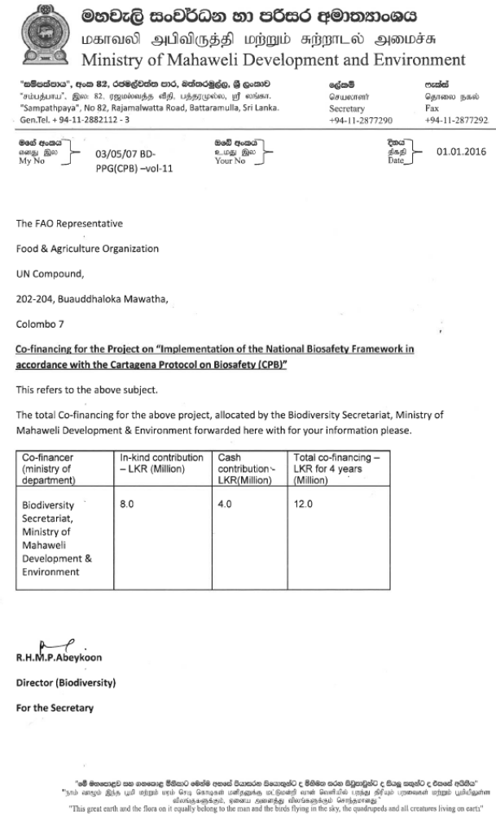
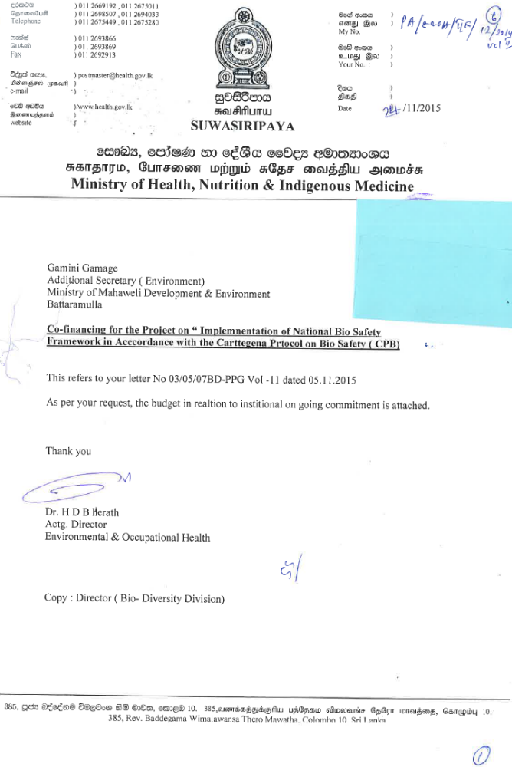
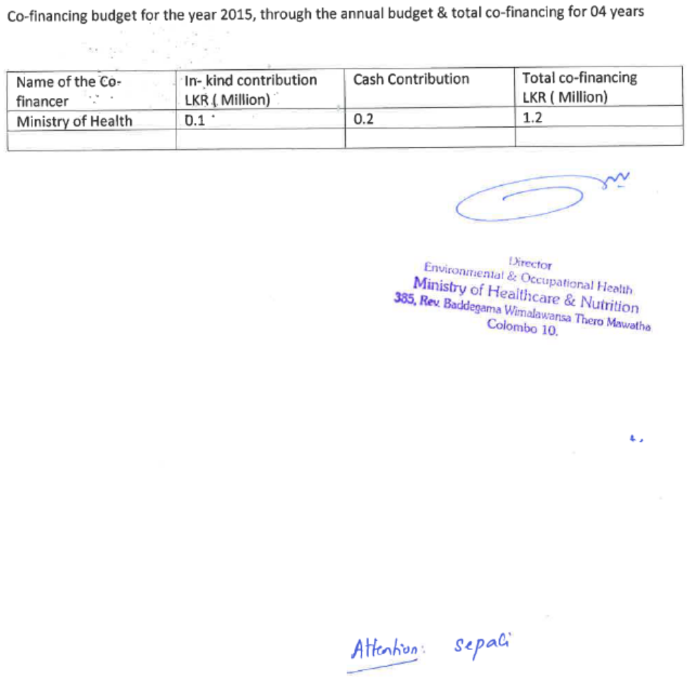

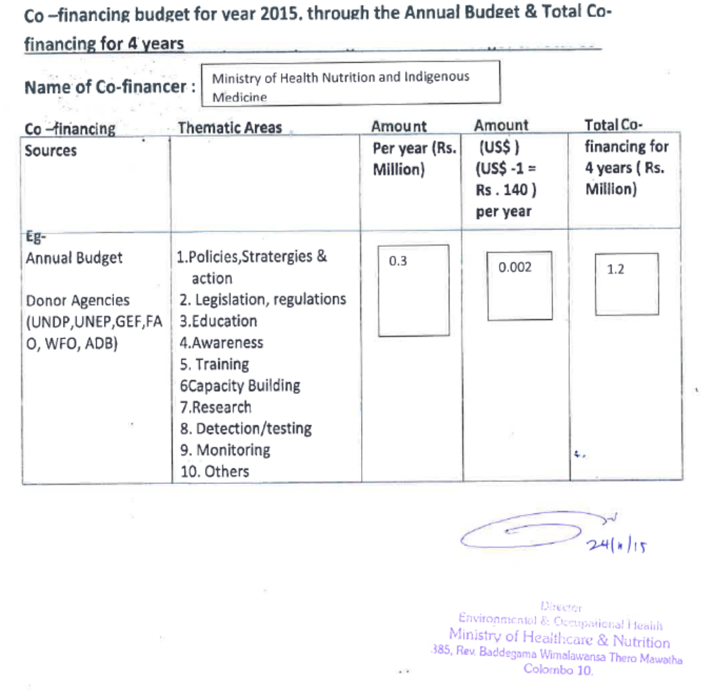

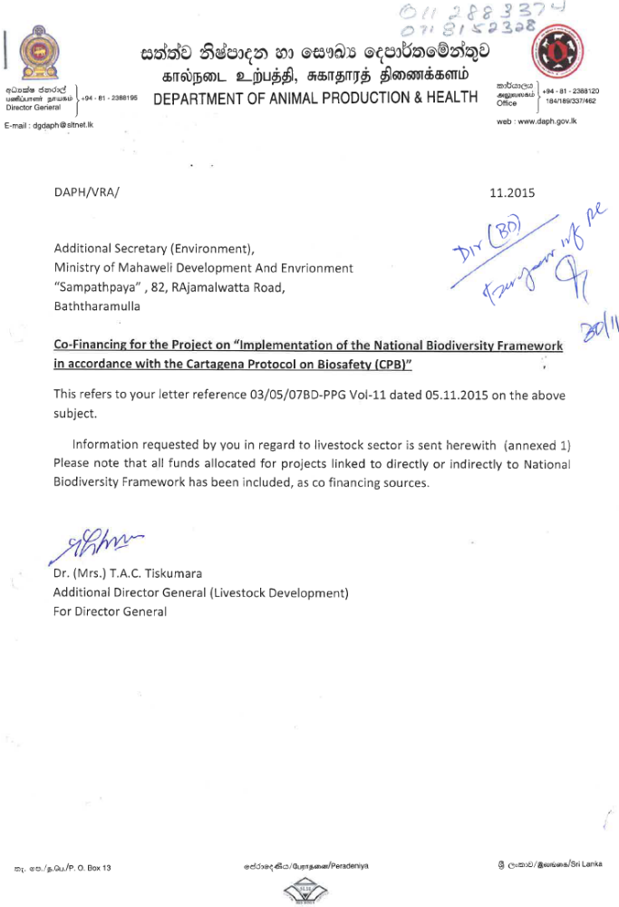

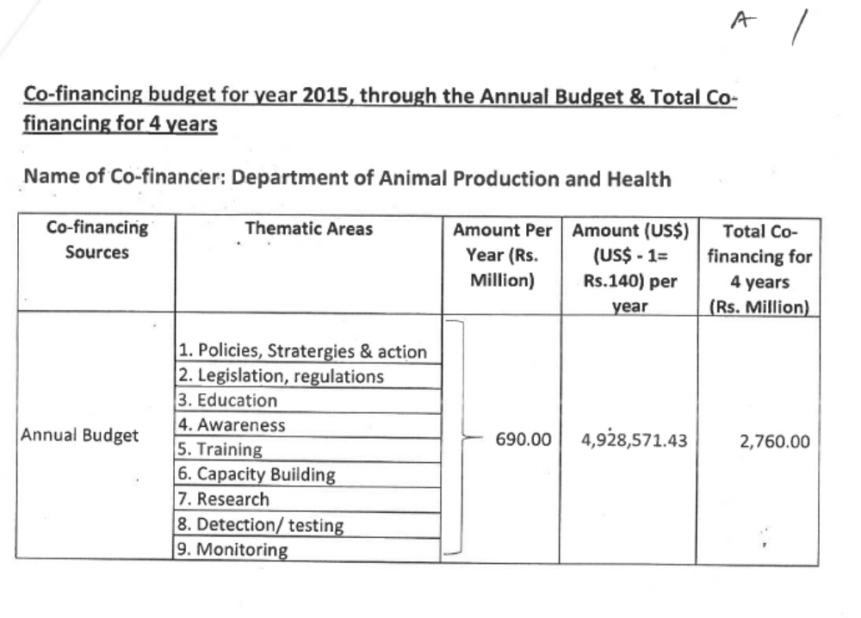
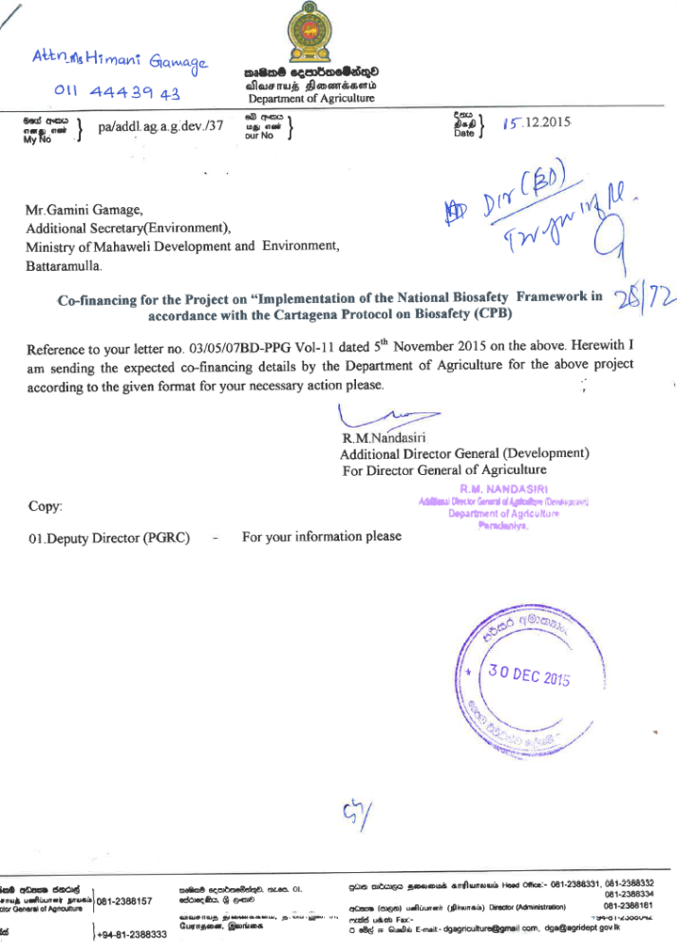
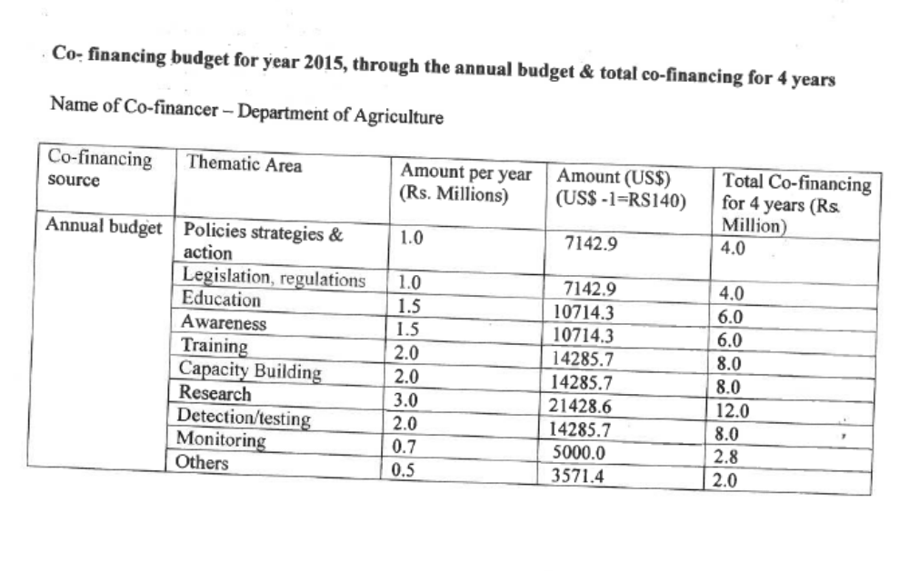
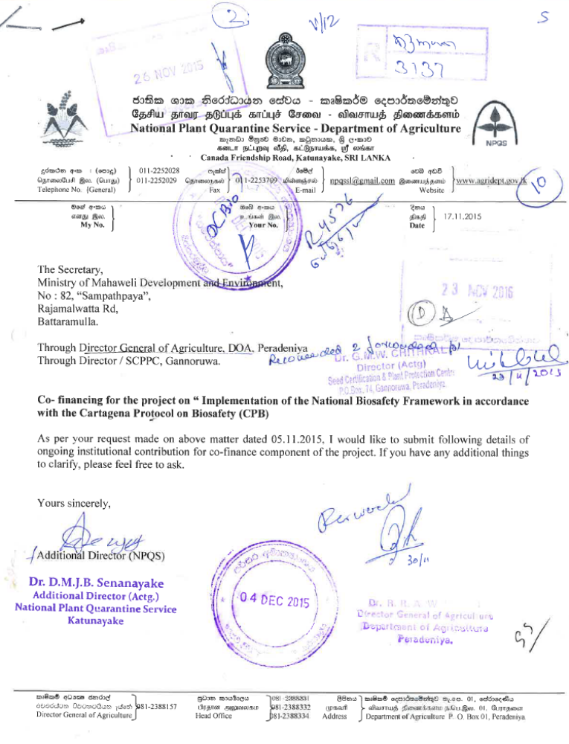
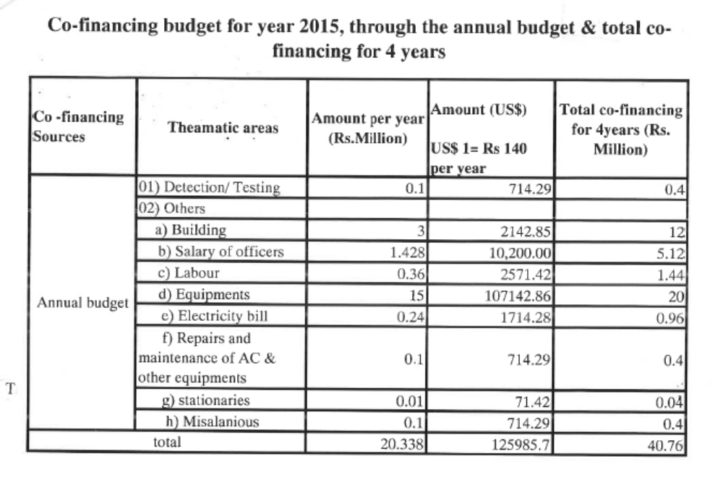
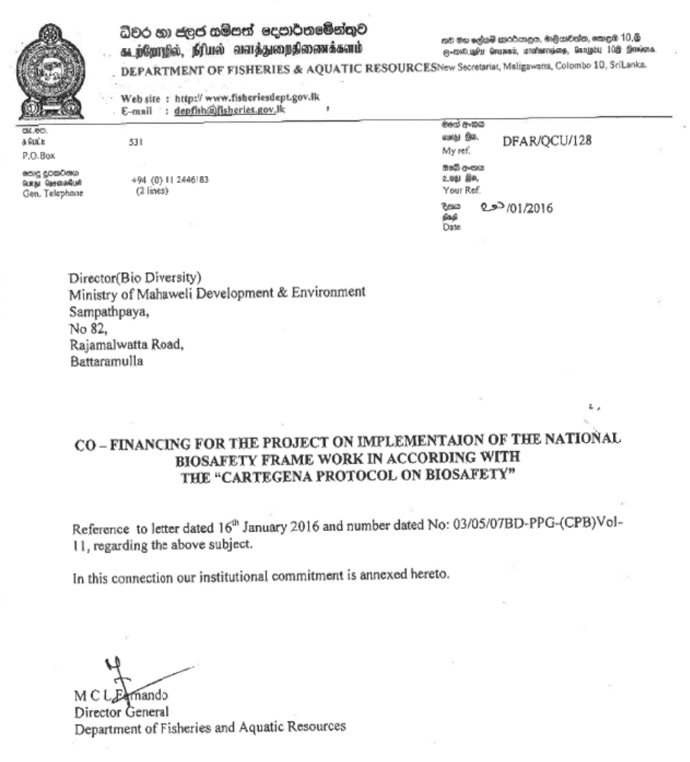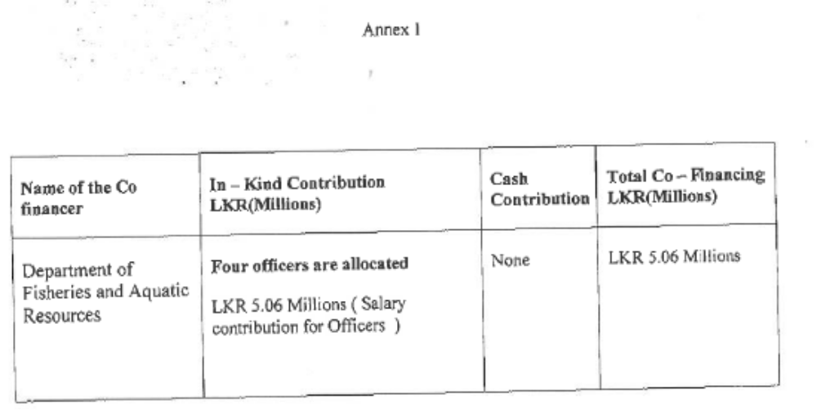

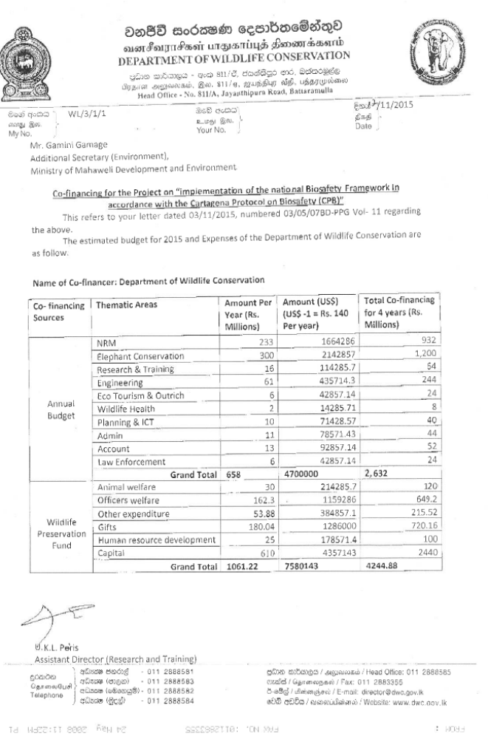
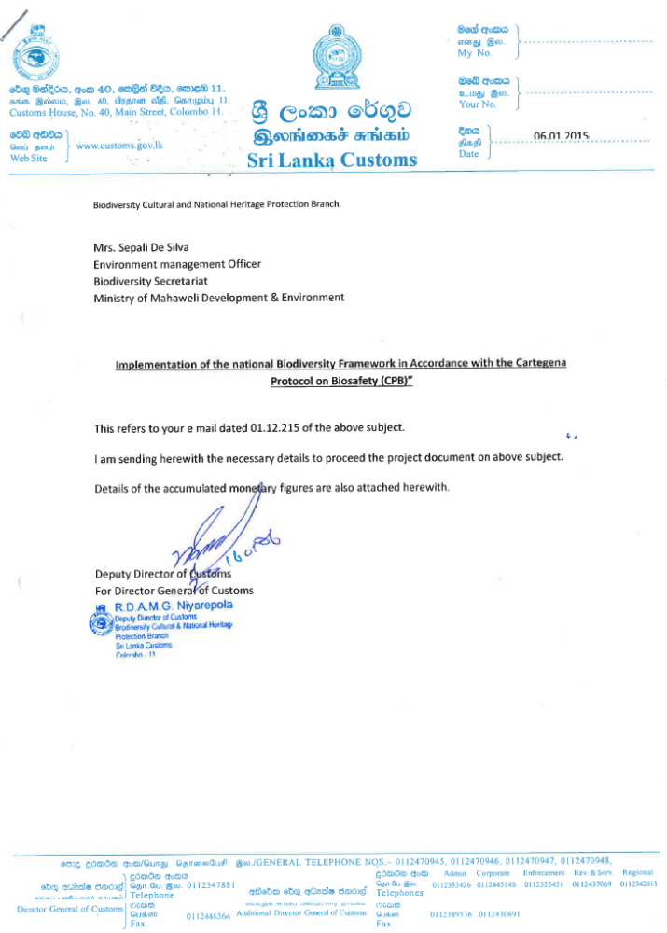
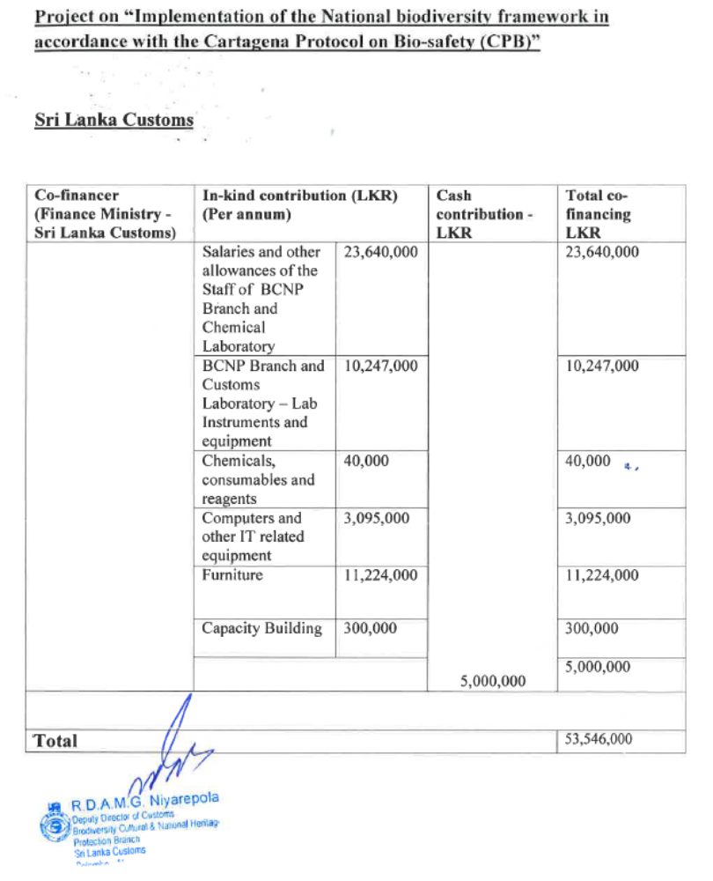
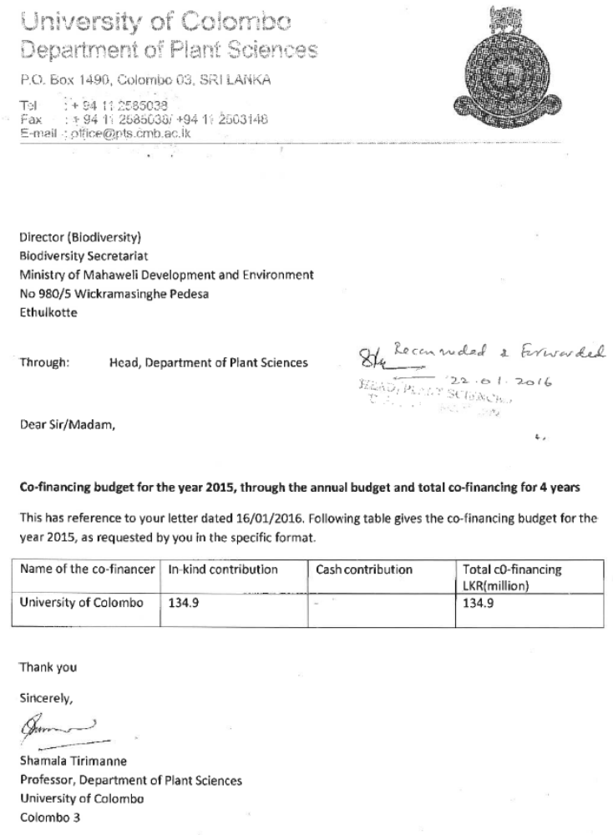
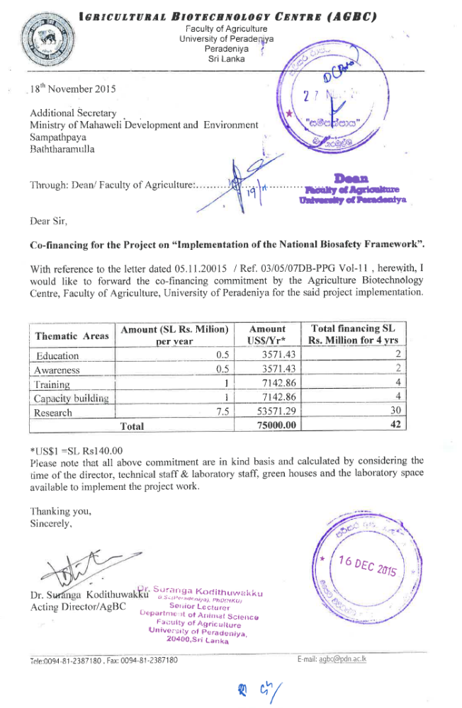
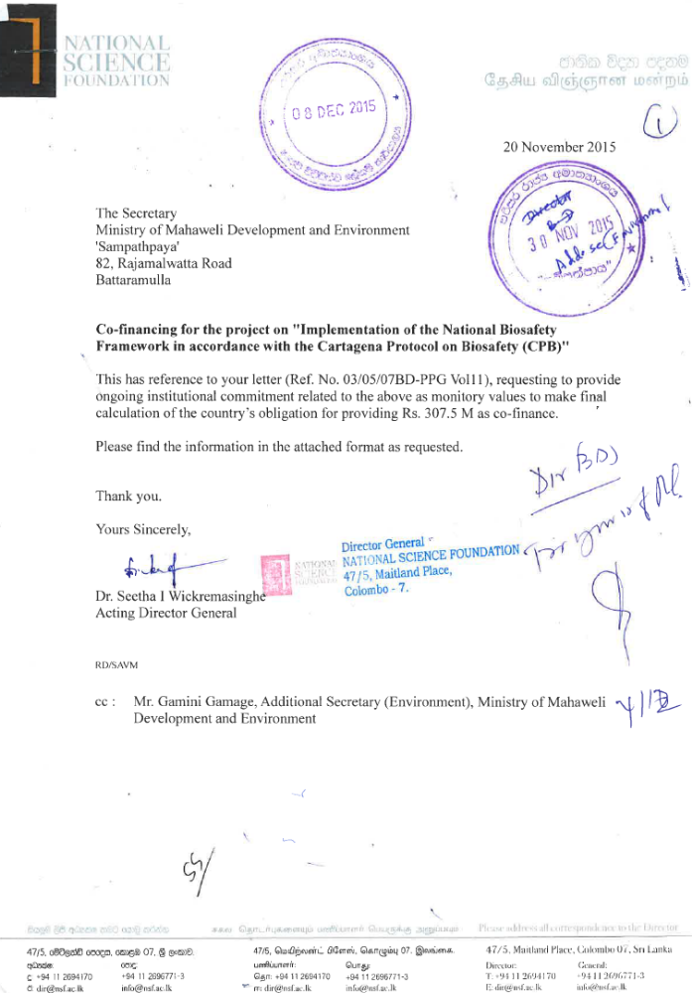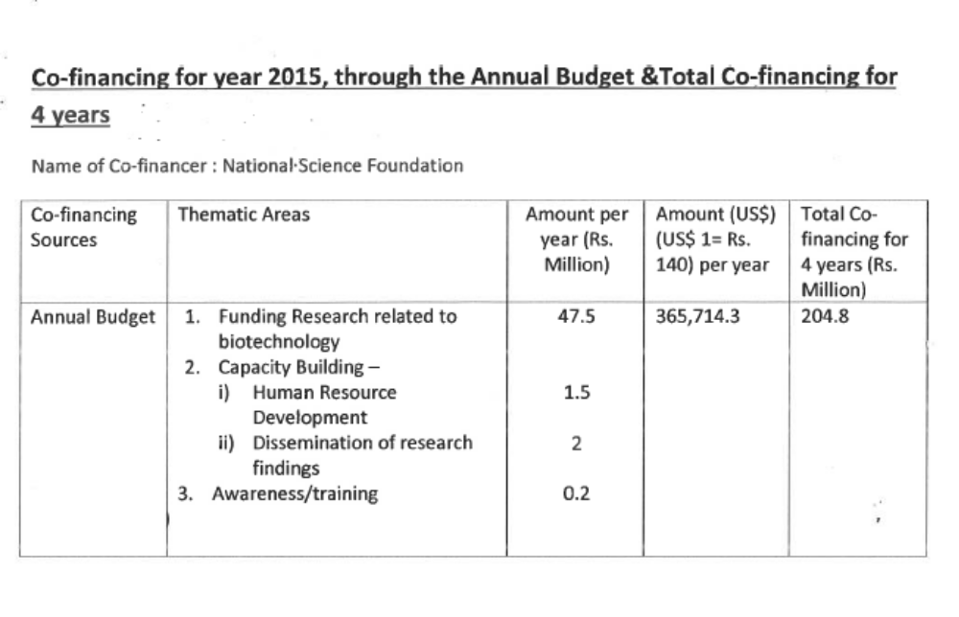

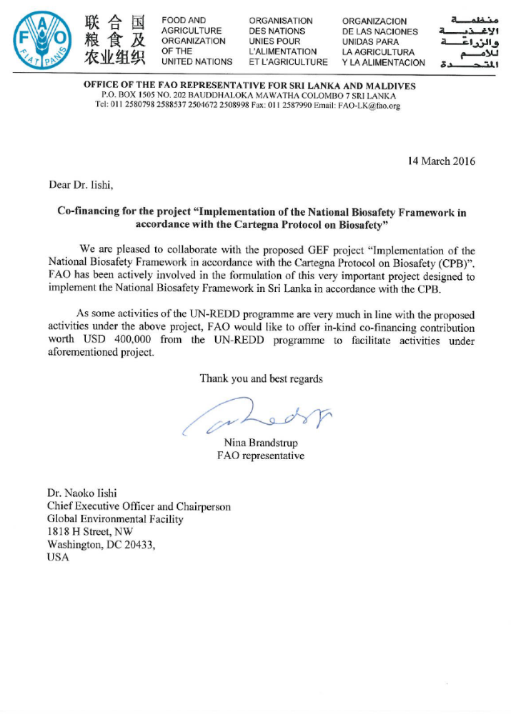

For country office operated projects, link projects in FPMIS at OR level.
National Programme for Food Security, Ministry of Agricultural Development and Agrarian Services (MoAD & AS), Colombo, Sri Lanka, October, 2008.
The apex body for the formulation of agricultural research policy for advising the Government on planning, organization, and coordination of agricultural research.
An insecticide that is specifically targeted against the larval life stage of an insect (e.g. Mousticide).
Second and Third National Report on the implementation of the Cartagena Protocol on Biosafety. http://bch.cbd.int/protocol/cpb_natreports.shtml?country=lk#natrep http://bch.cbd.int/database/record.shtml?documentid=109485
Effective participation in the Biosafety Clearing House: Participation options and impediments to information provision (2008). bch.cbd.int/database/attachment/?id=10339
http://www.fao.org/docrep/014/i1905e/i1905e00.htm
http://www.fao.org/biotech/biotech-add-edit-section/biotech-add-edit-news/biotech-news-detail/en/c/168577/
It will be used for the input of M&E related deliverable (reports etc.).
It will be used for the input of M&E related deliverable (reports etc.)

